The MILLION SOUL Campaign
A Prayer at the Heart Initiative
2026 Report

By P. Douglas Small
www.prayattheheart.org

“It took a great awakening to give birth to the nation; and now we need one to save it!”

A Multi-Year Prayer-Evangelism-Discipleship Initiative

Executive Summary of The Prayer at the Heart 2026 Comprehensive Campaign Report

The Prayer at the Heart (PATH) 2026 Million Soul Campaign aims to awaken and mobilize the Christian church in the United States to fulfill the Great Commission by praying and evangelizing with the goal of seeing one million people come to faith in Christ during a focused 50-day period from Easter to Pentecost. The campaign is framed by sober cultural realities and a compelling spiritual urgency, emphasizing prayer as foundational to evangelistic success and spiritual awakening at a national level.
There is an urgency. Christianity in the U.S. is not keeping pace with population growth, especially given increasing immigration from largely non-Christian nations. This demographic shift is challenging the moral and spiritual center of the nation. The Goal is to inspire a disciplined rhythm of prayer and relational evangelism, transforming evangelistic efforts from sporadic outreach to a lifestyle.
The challenges we face are significant.
- Church Decline vs. Population Growth: Despite a modest growth in Christian conversions and baptisms, overall church growth continues to lag behind population growth, especially fueled by immigration from non-Christian countries.
- Fragmentation of the Moral Center: Social and cultural polarization threaten national cohesion and spiritual values, increasing crime, family breakdown, and societal tensions.
- Gen Z Opportunity: This younger generation is unusually open to spiritual conversations and evangelism, with 77% expressing interest in learning about Christ. They prefer relational, loving approaches to evangelism rather than confrontational methods.
- Need for Spiritual Awakening: A theological and deeply transformational awakening is necessary to realign the nation’s moral and cultural compass, modeled after past Great Awakenings.
Campaign Strategy and Approach: A 50-Day Window
A focused, 50-day mobilization encourages each believer to pray deliberately and evangelize relationally during this defined period, making spiritual engagement concrete and measurable. The Operation Andrew-inspired triplet prayer teams mobilized believers to pray for ten people, care for five, and share their faith with three, aiming for at least one conversion each. The SALTY Guide is a workplace resource for creating a vocational prayer team. The Ambassador training is focused on providing a witness to community leaders and politicians, blessing them, building a bridge, and reminding them of a distinctively Christian constituency.
Prayer and Evangelism Connection
Prayer is not abstract but focused specifically on harvest outcomes—people coming to Christ.
Emphasizes love as the “bridge” for truth to travel, not removing biblical boundaries but highlighting God’s blessing as the first and last word to humanity. Prayer is mission-focused, including praying for neighbors, workplaces, and civic leaders through strategic efforts such as the Ambassador Training to build bridges of prayer and goodwill with authorities.
Mobilization Tactics
Combination of on-the-ground prayer gatherings (state-wide, county, and city levels) and robust virtual/social media outreach were encouraged. Partnerships with organizations like Rooftop Ministries encourage public, prayer services that were designed to ‘see the city.’ In addition, the Bless App facilitates neighborhood prayer.
The monthly SALTY prayer guides assist workplace groups promoting spiritual engagement within daily environments. Ambassador Ministry trains believers to pray for and engage with civic leaders, strengthening the church’s presence in the public square.
Challenges
The ambitious goal of mobilizing 1 million to pray simultaneously during the 50-day window was not fully achieved; awareness and engagement grew more slowly than desired. We needed more robust state and regional leadership training and for that, we needed additional funding. The church’s reluctance and fear to evangelize remains a major obstacle, alongside generational differences in evangelism style preferences.
Prayer at the Heart is simple – One Million praying to see One Million conversions; Prayer at the Heart is complex – it requires fresh evangelism training, massive prayer mobilization, church participation recruitment; discipleship approaches that are relational, that resonate with Gen Zs. The volume and diversity of resources were offered without sufficient orientation. There was a tension between the strategy and tactics. Tacticians: Keep it simple. Tell us one thing we can do. Problem: There is not a single one silver bullet. We need a multi-faceted approach with a plethora of resources. That requires more training than we were able to provide last year.
Fundraising and influencer engagement continue to require growth and strategic focus.
Demographic Insights and Missional Implications
The growing population of Unreached People Groups (UPGs) inside the U.S. (21 million) and non-Christian immigrants (3.5–4 million in the past decade) represent the largest global unreached harvest field accessible without leaving the country. City populations concentrate over 50% of Americans in the largest 40 metropolitan areas, suggesting strategic focus for concentrated evangelistic and prayer efforts. Social research shows only a small percentage of Christians actively share their faith regularly (approx. 21-35%), with Pentecostals showing the highest engagement.
Evangelism must evolve from confrontational and propositional models to relational, love-first approaches, particularly for reaching Gen Z. The largest challenge: youth are spiritually curious but theologically unformed, requiring patient, loving dialogue rather than aggressive pitches.
Ministry Infrastructure and Key Resources
PATH’s infrastructure comprises a Board, Cabinet, State Representatives, and strategic partners. Operations include the following key components. Evangelism as Blessing training emphasizes blessing as the entry point into evangelism. Operation Andrew Prayer Triplets mobilize believers relationally. SALTY Groups support marketplace prayer and witness. Ambassador Ministry to bridge church and civic leadership. Bless App for intentional neighborhood prayer. Strong digital footprint via social media, websites, and promotional videos. Partnerships with churches, denominational ministries, prayer networks, and media ministries. Fundraising tools like Living Room Gatherings help state leaders raise local support.
Communications and Marketing (Infinity Concepts)
Media strategy produced a fivefold return on marketing investment ($1.3 million earned media value). Over 90 media interviews reached potential audiences of 200+ million. Social Amplification via Facebook, Instagram, TikTok, Pray.com, and partner email campaigns. Brand anthem video and short-form content boosted visibility and sign-ups. Future efforts call for stronger alignment in messaging, target audience refinement, and nurturing long-term participation beyond sign-up.
Financials and Fundraising
- 2027 budget projection: $1.6 million, with diversified revenue streams needed:
  - Sustainer partners ($\$25-$99/month)
  - Million Soul Club donors ($1,000+/year)
  - Leader Circle donors ($5,000+)
  - Strategic partners ($100,000+)

We need to engage large networks and our digital conversion strategies are crucial for sustainable funding. A recent partnership added access to 400,000 national ministry leaders. In addition, we have partnerships with fundraising platforms (TELPI, Promising People) support this infrastructure.
Conclusion
The Prayer at the Heart 2026 Campaign marks a pivotal step in a larger movement toward a national spiritual awakening grounded in prayer and relational evangelism. Despite initial challenges and a complex cultural landscape, the campaign laid crucial groundwork through strategic partnerships, diverse resources, and media outreach, setting the stage for scale-up in 2027 and beyond. The vision remains steadfast: a Great Awakening measured not just in numbers, but in transformed disciples who reclaim the moral and spiritual center of the nation and accelerate the global completion of the Great Commission.

Million-Soul Campaign Project

SYNOPSIS
T
his document focuses on the Million Soul Campaign, specifically its first iteration, in 2026, with 2027 in view as well. There are a number of intersecting elements.
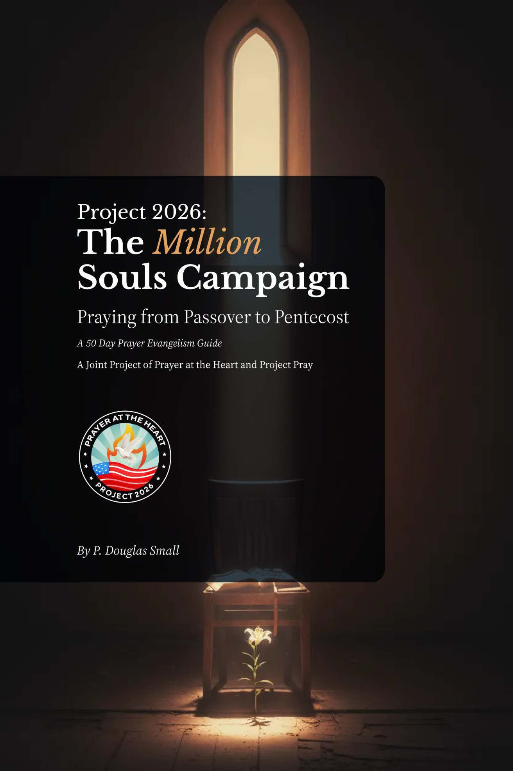
First, this is an attempt to awaken the church to both its obligation and its glorious privilege of bringing friends and family to Christ. Ultimately, only the Holy Spirit can do that. We, however, have a critical part to play. We must pray for prayer; pray for the Spirit to work in the church (revival) and the culture (awakening). Every spiritual awakening is preceded, in some way, by a movement of desperate prayer.
Second, the urgency for evangelism is underscored by several factors.
- The current number of conversions/baptisms/memberships depends on how each sector of the church measures its growth. Currently, Christianity is regressing. It is not keeping up with net population growth. We are falling farther behind each year.
- That net population growth contains high rates of non-Christian constituencies with no connection to Christianity. This is good and bad, first the dark side.
- The growth of the non-Christian population fragments the culture, diversifying its values to an untenable point of tension, and creating parallel societies.
- It is Christianity, in its mature and balanced form, which creates the space for freedom of all religions, and of conscience. Such freedom is not seen in nation-states where the dominate faith is other than Christianity. The center of Christianity is firm, without compromise, a core of absolute truth; but its edge is tender, compassionate, warm and embracing.
- Pluralism of values fragments the center until it can no longer hold, forcing us to the edges until there is no longer a center, or a whole.
- The good news is that the world is here. A significant spiritual renewal among the immigrant population would back-flow to every nation on the face of the earth. To Muslim and Hindu nations. To global Buddhists and Shiek populations. To agnostic or atheistic states.
Third, we need a spiritual awakening to reset the moral center of the nation. Our families are fragmented. Crime is out of control. Homicides are too frequent. Drugs continue to debilitate and destroy lives. Hate and intolerance accompany our political and philosophical divisions. Assassination attempts are up. Conservative Supreme Court justices now wear bullet-proof vests. We are polarized. Those who might quarrel with evangelicalism per se, even reasonable secularists, certainly agree that the nation cannot continue in its current trajectory. We need more than a change of mind. What we need can only come from the ‘finger of God,’ an inner change, the transformation of hearts.
Fourth, as a church, we have an obligation to the 2000-year-old Great Commission. We are nearer now to its completion than at any other moment in history. Numerous movements have set the date of 2033 for reaching the last tribe and tongue among the Unreached People Groups (UPG) of the earth.
Fifth, the Gen Z generation may be the most open to evangelism in recent history. We dare not miss this moment. Sadly, the church is largely silent. According to Barna, 77 percent of Gen Zs are open to “learning more about Christ,” and more than half are “very motivated” to learn more. This generation has been baptized into a secular scientific worldview, one that is hostile to Christianity. Amazingly, from deep inside their souls, a hunger for the transcendent is emerging. Most have never heard a compelling case for Christianity. They are not post-Christian, they are, in some respects, pre-Christian, waiting, while we hesitate.
Sixth, reaching them will require a different approach to evangelism than we have traditionally used, one that is more relational. One that leads with love and then follows with truth. They need to believe – yes; and they need a template for behavior, life-change empowered by grace; but, first, they need to belong. Rejected. Fatherless. Growing up between families. Living in the post-Twin-Towers world, everything seems unstable – and therefore relative. They are spiritually hungry – and among those who are now believers, they share their faith – even as they process their doubts - more than any other generation. They will not be won by confrontational, propositional evangelism.
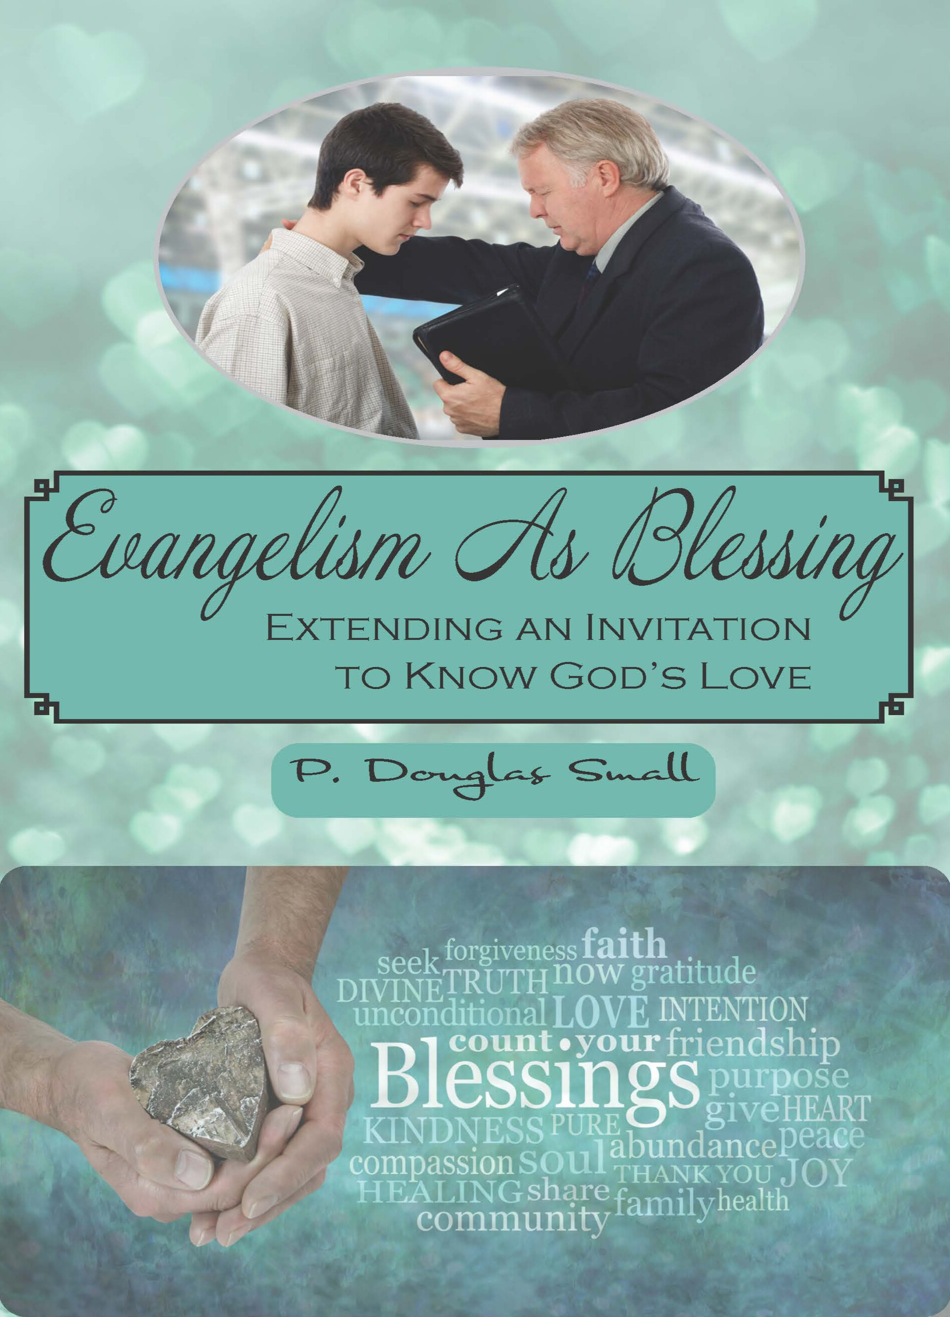
Seventh, the new evangelism is an old evangelism. It is relational. It reaches back to God’s first encounter with humanity – one in which he ‘blessed’ Adam and Eve. We need to use the power of blessing. Not only is blessing the first word of God to humanity, but it is also the last word of Jesus at the Ascension (Gen. 1:28; Luke 24:50-51). From Creation through the Crucifixion and on to the Ascension, God’s disposition toward humanity is that of blessing. Even the cross could not mute the declaration of God’s offer of love and favor. It is that offer that we have the privilege of giving to the unsaved, and leading them through the gate of conviction, repentance, and new birth.
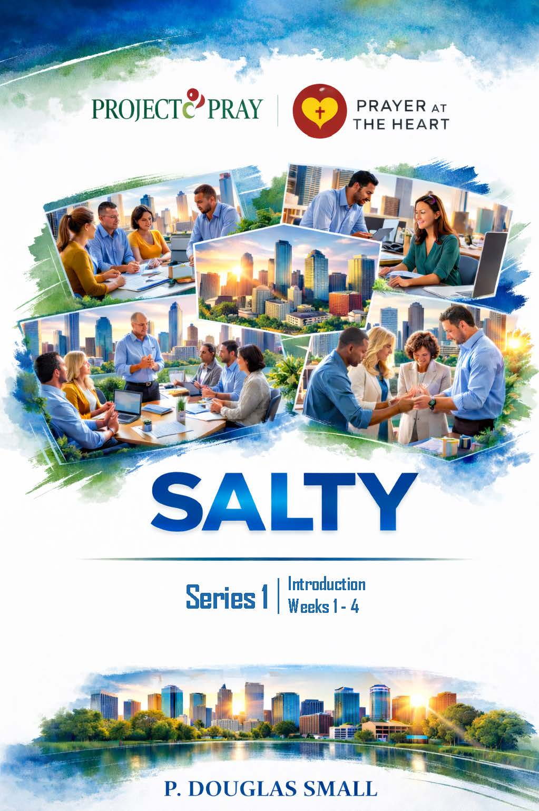
Eighth, we must break our silence. We must pray for neighbors – those who live around us and work around us. We need greater neighbor awareness and prayer for the harvest field next door. The Bless App (now under the Luis Palau organization) helps with that goal. Further, we need to see our workplace as a mission field and join other believers there as salt and light. The monthly SALTY guide we have produced is a downloadable prayer guide with four 30-minute devotionals. There is a fresh guide each month. To this uncredentialed lay prayer and witness movement, we also need credentialed chaplains in the marketplace – Christians who are more formally trained, certified, and credentialed to serve the businesses in which they work as volunteers. Thus, Marketplace Chaplaincy Training and certification are a part of our process with our partner, Dr. Julius Koontz.
Ninth, we are called, actually commanded, by Paul, to pray for kings and those in authority or with influence. Peter tells us to “Fear God. Honor the king” (1 Peter 2:13-17). The king was Nero! Paul likewise tells us to “submit to governing authorities. For all authority comes from God, and those in positions of authority have been placed there by God… Do what is right, and they will honor you… The authorities are God’s servants… serving God in what they do. Give to everyone what you owe them… give respect and honor to those who are in authority” (Rom. 13:1-7). The Ambassador training is to prepare believers to go to community leaders and offer a sincere apology on behalf of the Church, the Christians of the city for our lack of prayer support, and ask how we might pray for them going forward. This is in the context of 1 Tim. 2:1-8, “Pray for kings and those in authority (with influence).” The Ambassador team is specifically designed to give the gift of prayer to community leaders, politicians and influencers. This builds a bridge from the church to the community. In this sense, the church begins to function as an embassy of the Kingdom of God to the governments of this world and its influencers.
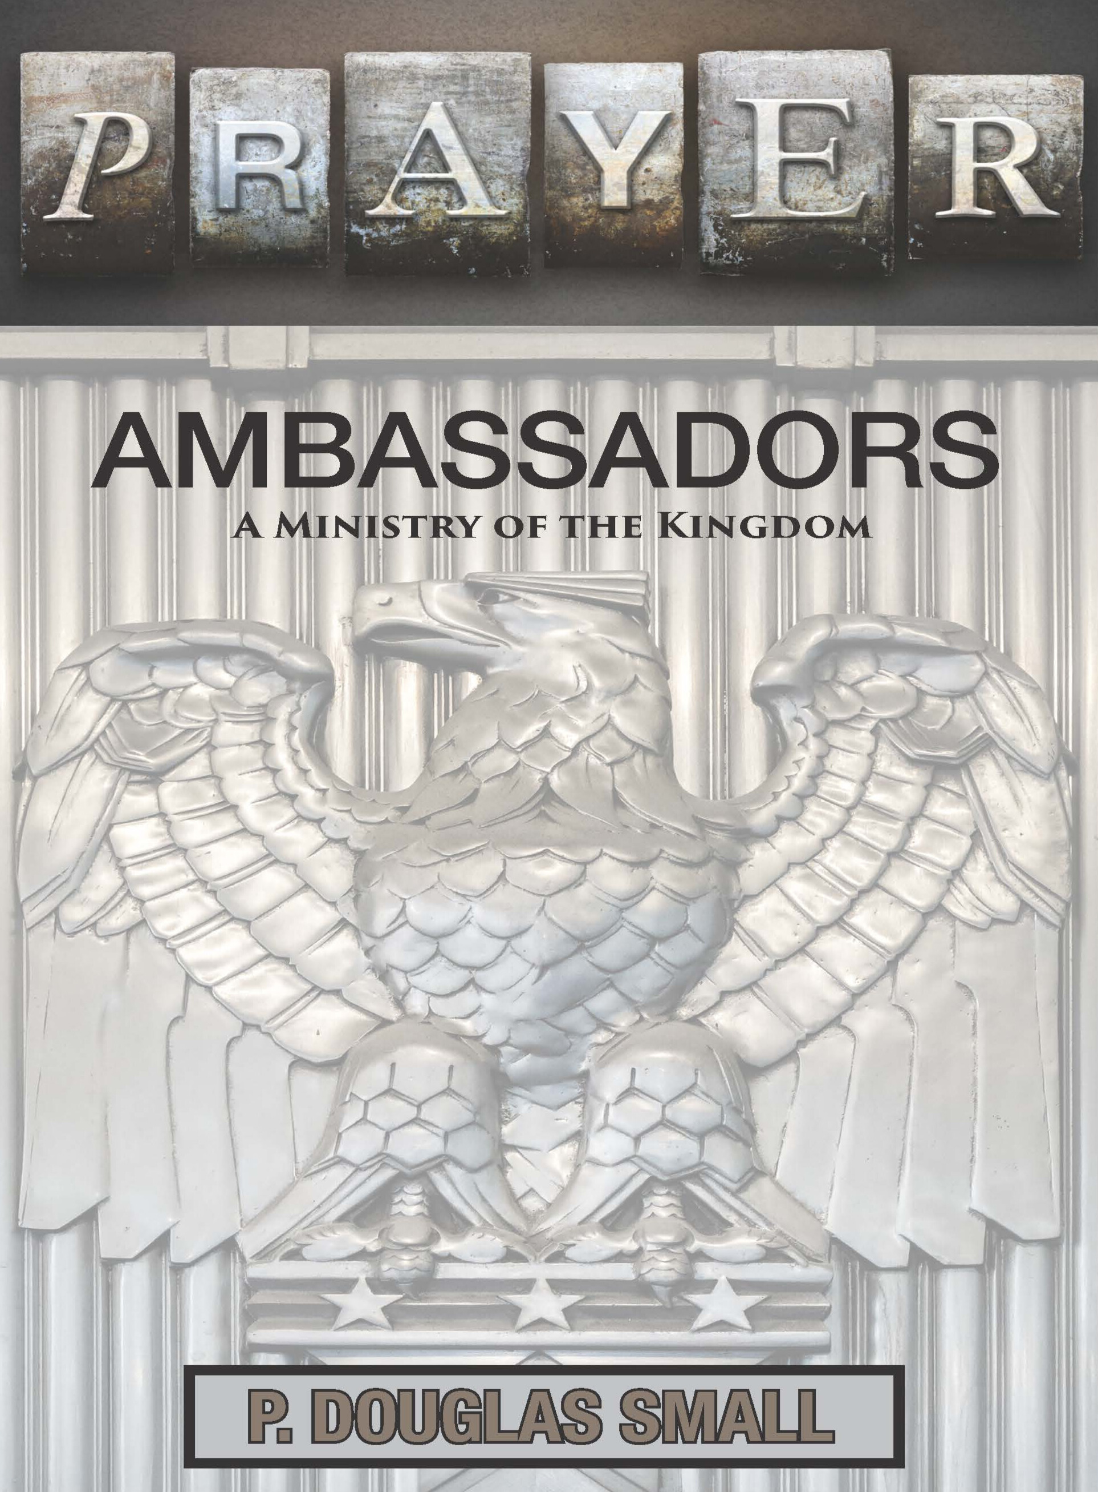
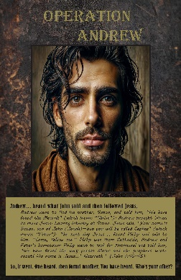
Tenth, a key in Billy Graham’s success in winning millions to Christ was the use of the Operation Andrew tool. Andrew brought his brother Peter to Christ. Operation Andrew then asks, who can I bring to Christ? Believers are urged to make a list at the beginning of the 50-day Easter-to-Pentecost season and then find two other believers who also make a list. That triplet provides mutual support and gentle accountability. Without these triplet covenants of prayer and care, the sharing of the faith fails to take place. We have good intentions, but the first step in intentionality is the formation of this prayer triplet. From the list of unchurched family and friends, which may reach 40-50 names, each person focuses on those they perceive to be ‘most open.’ They review the list at least once weekly, then pray for TEN. They care for FIVE. And Share Christ with THREE, with the goal of winning at least ONE by Pentecost Sunday, three as a team.
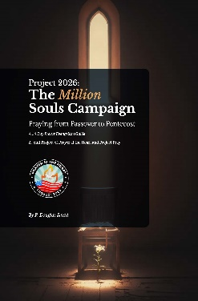
Eleven. This cannot be a private thing. The church needs to focus on lostness during the 50-day window. One method is to lay the names and pictures of lost or unchurched friends on the church altar and to take time in the Sunday service, to pray over them every week. Some post the names and pictures to a cross. Others create a kind of wailing wall. Some churches light a candle on Sunday every week when at least one person has come to Christ through the ministry of members. The mantra becomes, “Don’t let the fire go out.” New converts are introduced to the congregation, and the member who led them to Christ is celebrated. An ethos of witness is cultivated without guilt or pressure.

Twelve. In 2026, we focused first on praying for the lost; and then, at the end of the 50-day prayer-evangelism exercise, we added a call to pray for the nation. This took the shape of a July 4 Sunrise Service. We provided a prayer guide for personal and family use, or even for use by a church or as a community service. We estimate that thousands of gatherings took place. In fact, it was the interest in this idea and resource that resonated most across all age groups, including Gen Zs. We did discover some resistance to prayer for the nation, despite the Biblical imperative to do so. That resistance came under the aegis of Christian Nationalism. We contend that longing for a spiritual awakening that strengthens the moral clarity of the nation is not Christian Nationalism. There is ample evidence of prayer for the nation in the days of its founding. And election day sermons, given by pastors to political leaders, followed by prayer for God’s wisdom, were common 250 years ago. These sermons were printed and circulated, providing guidance from pastors to the public’s representatives. We influence, organically, salt and light. We cannot hide. We must not be silent. Christ himself, and Christ alone, will establish his kingdom at the Second Coming, a geopolitical kingdom. Our call is not to rule, but to relate as servants.

In the following sections, we will give attention to:
- The Million Soul Campaign – An Overview of the Challenge
- The Million Soul Campaign – The Cabinet (Reports and Projections)
- The Infinity Concept Overview
- The Summary/Projections
- Appendices

The Million Soul Campaign

W
e failed.
We are on track to see a million or more saved in the USA in 2026 – twice as many as in recent years!
But we failed forward. Our goal was to mobilize one million people to pray to see one million saved from Easter to Pentecost. By that measure, we failed – as did other organizations that set similar goals.
Last year, as we begin to announce the Million Soul Campaign, at first, the idea seemed unique – and PATH appeared to be the lone voice. At a meeting facilitated by the Global Day of Prayer leadership team in early January 2026, more than 20 ministries showed up at CRU to share special plans and ideas regarding evangelism efforts for 2026 and beyond. John Whaley and I attended, along with Dr. Sean O’Neal, a PATH board member, who was also present to represent the Church of God. We were amazed at how often the number ‘one million’ came up in the meeting. There were other ministries that had adopted the ‘million’ as a goal or were leaning in that direction. Our conviction was that this call was not a private matter with us, but something on God’s heart. The ministries at the table were truly formidable ministries. Yet, no one achieved the goal of a million conversions in the 50-day window leading up to Pentecost Sunday. Collectively, we will certainly meet it, perhaps surpass it for the year.
So, in one respect, we failed. However, we learned a great deal about the mission to which God has called us. About the challenges. About the team needed to accomplish the goal of mobilizing one million to pray, with the result being one million, the first of many millions, who come to Christ in America, and ultimately, around many more around the world. And, as I hinted above, it appears that collectively, we will reach and exceed our goal to see a million saved in America in 2026, though not in the definitive 50-day window we proposed or by PATH’s efforts alone.
With as many as 78 million evangelicals in the USA, it seemed a simple task to mobilize one million who would own the noble goal of praying for one friend to renew their faith or come to Christ. We underestimated both our capacity to gain the attention of the evangelical community, and beyond and the credibility needed to mobilize one million even for a simple 50-day evangelism exercise.

Why 50 Days
Why 50 days? We want evangelism to become a lifestyle, 365 days of the year. But a call for all to evangelize all the time is not effective. A call to evangelize for 50 days, with supporting resources, with a collective numeric goal in mind, is a discipline designed to evolve into a practice. The goal is simple. Encourage each believer to win a friend or family member to Christ. Simple. But the goal is also sweeping. A million others are doing the same thing. The gulf between the one and the one million is too great. It is bridged in a simple way, tens of thousands of times with teams of three - Operation Andrew prayer-evangelism triads. Then by congregations adopting goals, and then by congregations, in unity with others, adopting collective goals for their city or county. The 50-day exercise is designed to urge all of us to adopt prayer-evangelism as a lifestyle. The one is three, then a dozen, then hundreds, then congregations in unity – across a county, a state, and the nation; the one, now a part of a million. God joins such unity.

Connecting Prayer and Evangelism
We underestimated the noise that is in the nation. Among conservative Christians, an array of other voices are calling for prayer for spiritual awakening. What is unique about the Million Soul Campaign is that it is measured not by prayer associated with some affect, but specifically, by the number of people coming to Jesus Christ. Most of the prayer energy of these wonderful peer groups is not focused on conversion, but on some symptoms, the consequence of living in a nation full of unconverted people. Praying only about the effects of sin, without focusing on its cure, on the root of the problem, is itself a problem. It is the lack of a profound encounter and relationship with Jesus Christ by those who behave in immoral ways and promote practices abhorrent to a healthy culture. That should be the top priority in our praying. A Great Awakening, measured by millions of lives, radically changed by Christ, transforms a nation.
The problem of sinful practices is only cured by the transformation of sinful people.
What is unique about the Million Soul Campaign is that its success is measured by the number of people coming to Christ.

We Don’t Do Altar Calls
We also underestimated the resistance in some circles to an evangelistic appeal, due to the embrace of seeker-sensitive approaches that have little space for godly sorrow and conviction of sin. These movements transpose the salvation event into positive life-change aided by the application of spiritual concepts and Biblical ideas.

Decisions Not Disciples
On the other hand, we also underestimated the degree to which some in the church were still attached to confrontational and propositional evangelism – or evangelism detached from discipleship, evangelism as an encounter and not a relationship. The vision of evangelism as a one-time, one-on-one propositional pitch, sometimes high pressure in order to get a quick, on-the-spot ‘decision’ for Christ on the wings of a quick prayer.

Christian Nationalism
The growing resistance to Christian Nationalism in the evangelical church was not something we encountered directly, but it danced at the edges of our effort. We are Christian. And we are pro-American. And we believe that the birth of the nation would have been impossible apart from the First Great Awakening. And further, we believe, as it took a Great Awakening to give birth to the nation, only a Great Awakening can now save it. Yet, we do not believe this nation was founded as a Christian nation for Christians only, but as a nation, by men who affirmed Judeo-Christian values, and therefore, one that could offer freedom for all. We are not advocates for a Christian theocracy. Nor do we believe that our nation can exist if it is not tethered to transcendent values, if it is not ‘one nation under God.’ We believe it is God, not the government, that grants ‘liberty and justice for all.’
It took a Great Awakening to give birth to the nation; now we need one to save it.

A Robust Theology For Spiritual Awakening
The awakening for which we long is not narrowly spiritual. It must be more than sentimental spiritualism, more than personal, individual feelings and affect. It must be robustly theological with sociological and relational implications that inquire of us as did Francis Shaeffer, “How Should we Then Live?” Though not political, it must have political implications. Washington cannot save us, but a Spiritual Awakening could save Washington.
Jonathan Edwards was arguably among the top theologians, if not the keenest mind, of the Colonial era. His theological characterization of salvation is helpful. The salvation encounter was not an affect, an emotion, or a feeling. Experiential salvation characterized the Second Great Awakening. In the first, Edwards emphasized God as being the center of the encounter, not the believer. Salvation was tied to a perception of God as sovereign, holy, as utterly other, as transcendent. This profound impression of God on the soul completely reoriented the life of the sinner. One was drawn to God, attracted, in such a way that his values were converted. That change in orientation drove behavior change. One, despite the ups and downs, persevered. This ‘perseverance of the saints’ was proof of true conversion, of the attraction of the believer to God, of the new orientation. He did not behave differently to be saved; his altered behavior and spiritual determination were the indication that he was saved.
This is a robust theocentric salvation, not salvation as a mere heartfelt thing, but salvation that is rooted in the revelation of God that alters a life.

The Background of PATH (Prayer At The Heart)
Five years ago, 3000 people gathered in a cow pasture next to a simple marker that represents the geographic center of the continental USA. The six-hour event was near Lebanon, KS. Those gathered represented all 50 states. Teams came from the four corners of the nation, and every border north-south-east and west, stopping along the way, pouring out oil and wine, dedicating the land, and conducting 350 prayer rallies in 25 states. One prayer team literally circled the nation, driving from Washington State to Southern California, then on to Florida, before turning north to Maine, and then on to Kansas. They stopped every 100 miles and conducted a brief prayer and declaration service, praying, sounding a shofar, pouring out oil, as if driving a spiritual stake. They were consecrating the nation to God. Another team of 17 traveled from South Korea, 6500 miles, to join in prayer for America. They have now launched a billion-soul initiative out of South Korea led by Dr. James Hwang. The movement has the endorsement of Rick Warren and is connected to his Finishing the Task project as well as to Luis Bush and the Transform World movement and the late Dick Eastman, president of Every Home for Christ.
Under the tent, at the center of the nation, these groups, plus hundreds of others, read the “God language” in every state’s founding document. They reflected on the nation’s founding. They prayed for spiritual awakening in the nation. They repented. And then the goal was to return home to repeat the event in each state. The meeting was for God’s eyes only. Altogether, through satellite distribution, tens of thousands may have seen the event, carried by Integrity TV and the Revival Network TV.
The meeting in the Upper Room on the day of Pentecost was also a meeting for God’s eyes only. The spotlight would have been on the festivities at the temple. In fact, the high moment would been at 9:00 AM, when the high priest waved the two loaves of bread – leavened bread, the finished product from the wheat harvest. Across town, the Spirit descended, and the first harvest of the new era of salvation was reaped: 3,000 converts. As this harvest continued, it would be a ‘leavened’ harvest – one including not only Jews, but Gentiles. Men and women. Young and old. Every nation.
Our effort was indeed, on behalf of a harvest, a ‘leavened’ harvest, recognizing the need to reach the diversely unreached, the entrenched unchurched, perhaps the ‘dirtiest’ harvest the USA church has ever been called to reach.
We began off the grid, as the Upper Room was off the grid. The goal was then to move to each state, again, ‘off the grid,’ mobilizing people in each state – ‘prayer at the heart’ gatherings – with harvest in view. Then in every county, and city. We know, from the book of Acts, and from early church historians, the gospel did not spread evenly throughout the Roman Empire. It spread through churches planted in major cities and then to the surrounding small towns and rural areas.

Reaching An Empire
Take a detour with me for a paragraph or two.
The Roman Empire contained over 1,500 cities, with a population of about 60 million. By 70 AD, Christianity had spread to these major urban centers, with congregations in as many as fifty-plus cities. Keith Hopkins, Rodney Stark, and biblical scholar Bart Ehrman, despite the number of 3,000 converts at Pentecost, place the ‘core number’ of believers at around a 1,000-1,500. This is after all the efforts of Paul in Gentile cities and Peter and the other apostles.
Paul planted churches in 14 specific cities. Of the major population centers - Alexandria, Antioch, Ephesus, and Carthage, each with 200,000 to 500,000 residents, only Carthage was without a church (that was true until the mid-second century). All three Super-Cities: Rome, Alexandria, and Antioch, were unparalleled, and all of them had a church by the end of the apostolic era.
By the end of the first century, out of the Empire’s 18 most significant population centers, 14 had churches. Paul alone had visited or passed through at least fifty cities during his travels. The other apostles had pushed the gospel to the edges of the Empire and beyond. Early churches were functioning eastward, in the Parthian Empire (Mesopotamia), and in Armenia to the north and Ethiopia to the south. They were found as far east as the coastal trading cities of India.
The movement that started small, and seemed insignificant, persisted, strategically, then exploded to transform the empire.

The Explosive Growth
By 100 AD the number of core believers was around 10,000, perhaps less (0.01% to 0.02% of the Roman Empire's total population). All twelve apostles were gone, as were Mark, Luke, Timothy, Titus, and of course, Paul, along with James and Jude and other leaders.
By 150 AD, there were 40,000 Christ followers – the Church had quadrupled. Thirty years later, in the era of Marcus Aurelius, 180 AD, comprehensive historical estimates suggest 200 cities with Christian churches, particularly in the major cities of the Empire. This was the strategy: Plant the gospel in a major city and let it marinate into the surrounding country.
The number of Christians then passed the 100,000 mark, and that number doubled in the next two decades – with an estimated 218,000 Christians, 0.2% of the Empire by 200 AD. By the time of Constantine and the Edict of Milan in 313 AD, 10 percent of the 60 million people in the Empire, 6 million, were believers. Some have suggested that the number was, counting believers inside and outside of the Empire, as many as 12 million.
What started in relative obscurity grew with a focus on metropolitan regions that then permeated the Empire.

The Nation, The State, The Cities
The goal of PATH was to start a national movement of prayer and spiritual awakening in every state, and every county, until everywhere, publicly, diverse groups of Christians were meeting regularly to cry out to God for revival in the Church and Spiritual Awakening in the culture. Revival and Spiritual Awakening measured not merely by conversions, the number of people coming to Jesus Christ as Savior, but by discipleship engagement. We must stop the practice of filling the church with half-converted Christ-followers.
As with the national event, we encouraged believers in every state to gather around the edges and move to the center – in states, in counties, in cities, in towns and hamlets, until everywhere, people were praying outside, for revival and spiritual awakening. Some form of these Prayer at the Heart gatherings took place in more than twenty states. Texas had the largest gathering with more than 5,000 in attendance.
We resist the idea that ‘disaster awaits us,’ that our national security could be tied to our faith practices. So did Israel. And they perished.

Reconsecrating the Nation – Avoiding Disaster
The national gathering took place on July 21, 2021 – the 7th month, and the 21st day, 7:21. The date was randomly chosen, but during the day, one prayer route leader drew a parallel to the national gathering of Israel for both the rededication of the nation to God, and of the temple, recorded in 2 Chronicles 7:21. He felt, and when he finished, all of us felt the verse he read, 7:21, was significant. It was symbolic, like a sign:
“This temple will become a heap of rubble. All who pass by will be appalled and say, ‘Why has the Lord done such a thing to this land and to this temple?’ People will answer, ‘Because they have forsaken the Lord, the God of their ancestors, who brought them out of Egypt, and have embraced other gods, worshiping and serving them—that is why he brought all this disaster on them.’”
We felt, and continue to sense, that the nation itself is at stake for exactly this reason,
“We have forsaken the Lord. We have forsaken His temple and the principles upon which we were founded as a nation. We have forgotten the Lord, the God of our fathers. We have embraced other gods – materialism, science, sports, entertainment, wealth, fame – and they have become our gods, the organizing principle of culture, and the values around which our lives are organized. And now, disaster awaits us.”
The passage is a warning, a reminder of what is at stake. Few in Israel or Judah felt that they would end up seeing the death of their nation. Only in retrospect, do such passages leap off the pages of the Bible. We are generally in denial, as they were. We refuse to believe that the official endorsement of pluralism, not merely tolerance, is treacherous, a slippery slope. We take the embrace of paganism far too lightly. We refuse the evidence that “we have forsaken the Lord…forsaken His temple,” measured by the decline in public Christian worship. We resist the idea that “disaster awaits us,” or that our national security could be tied to our faith practices.
The national crisis is obvious. America needs spiritual awakening. Nevertheless, our efforts at seeing thousands gather in every state and county failed to materialize. We were one of too many prayer efforts. We changed our strategy and focused on one city – Cleveland, OH. The template: Nation, State, County, City was reversed. We would begin with Cleveland, then connect with other cities across Ohio. The effort in Cleveland continues. It was characterized by tents of meetings all over the city, with some groups praying 24-7. All praying for ten days. Worship and prayer in the city, north-south-east-west, climaxed with a gathering in the heart of downtown Cleveland. That gathering was significant in that it bridged the gap between Catholics and Pentecostal-Evangelicals, with all of them sharing the stage. As in Kansas, it also featured indigenous, First Nations peoples.
We then shifted our focus to Charlotte, and for a brief time, we worked at developing a youth component. That vision, though we were not able to fund it at that time, is the essence of what we now see as the Gen Z component. They, if mobilized, will drive our process.
The coming of the 85 Korean Prayer Teams, almost a thousand intercessors, coincidently, on the 49th anniversary of the largest-ever Billy Graham crusade, with 100,000 conversions, one that changed their nation, seemed to be a sign, a promise, that God could also change America.
Our goal in 2027 is Gen Z leadership in every state. One partner ministry has the long-term goal of a discipleship team in every county with a focus on Gen Z leaders – it is the obvious point at which God is moving, and where the great need exists. We must capture the next generation.

World School of Prayer Sends Korean Prayer Teams
Despite our challenges, God was not finished. In 2022, South Korean teams began to come to America to pray. Over a three-year period, 86 teams, each numbering 8-12 Koreans, came (See Appendix T). They paid their own way. They came, not as tourists, not to preach, but to pray! Some closed their businesses to come to America; they were answering a divine call. They visited 24 states plus the District of Columbia. They were stationed at the four corners of the nation – near Seattle, in San Diego, in Miami, and in Maine at the border of Canada. Almost a thousand came from 2022 – 2024 in three waves. First, 21 teams, then 41, and finally 21 teams again.
The first teams came, quite coincidentally, on the 49th anniversary of Billy Graham’s largest ever crusade. The three-day event in Seoul, Korea drew 3.2 million people and saw, according to the Koreans, as many as 100,000 conversions. That crusade, aided by the work of Bill Bright and Campus Crusade, in the following year, changed the trajectory of South Korea.
Suddenly, the children and grandchildren of that crusade came to pray for America. This was “bread on the waters” (Eccl. 11:1). Their message was startling: “The nation of South Korea needs a spiritual revival, but America, even more so, and not for itself alone, but for the world. If America goes, no one stops North Korea, or China or Russia.” For South Korea, revival in America is a national security issue – and that is true of much of the World. For the sake of the nations, America needs a spiritual awakening.
If America experienced a true spiritual awakening, they reasoned, it would impact the world, including South Korea. The coincidence was not lost on those of us who are longing for a national spiritual awakening. If these Korean prayer teams came on the anniversary, the 49th year (seven sabbath years) after the Billy Graham Korean crusade, one that changed that nation, was the coming of the teams a message of God’s desire to change our nation?
For the sake of the nations – all here in America – we need a Spiritual Awakening. A revival that impacted immigrant communities, would flow back to their homelands.
It was during a visit to South Korea, in 2024, in the night, that I felt God challenge me to mobilize one million people to pray to see one million souls turn to Christ in America, from Passover to Pentecost. That midnight spiritual encounter came after a meeting with Dr. Billy Kim, translator for Dr. Graham and the Korean Crusade, and the day before the meeting with Dr. Nam Soo Choi, head of the World School of Prayer, from which the Korean prayer teams came.
The prayer event in the center of the nation had been a signal to God – “We are desperate for your intervention.” The prayer events that followed in various states echoed our sentiment. Then Korean teams, for three years came and plowed the ground of intercession with tearful petitions. There was a special event at the Billy Graham Library to launch the second year of their visit (See Appendix U). They pleaded with heaven, with their feet on American soil in half the nation’s states, and from the four corners of the continental USA. Now, it is time for the harvest. Indeed, the harvest has begun.
Around the Korean event we built a collage of activities, promoting not only Prayer at the Heart and Project Pray (PATH’s Partner), but other significant ministries, believing that together we can make a difference that none of us can make working separately. The goal is not the promotion of an organization, but a Great Awakening for which none of us dares take the credit (See Appendix V).

Population Data
It is difficult to calculate the number of annual conversions in the USA. No data bank exists for verifying that number across both the evangelical and liturgical sectors of the church. Some movements count conversions, others confirmation, still others baptisms, and some membership. The best guess, when we set the million-soul goal, placed the number south of 500,000 annually – conversions and/or baptisms. There is still no data bank, but our interaction with various movements in our attempt to solicit their partnership led us to revise the annual number of Protestant conversions upward to 1.1 – 1.5 million. That’s very encouraging.
In 2021, the Southern Baptists, the largest Protestant denomination in the nation, saw 154,701 baptisms in 47,614 congregations, a ratio of 3.2 baptisms per congregation. By 2025, the number of baptisms had accelerated to 263,075, a 70 percent increase in four years – astounding. That is a ratio of 5.6 per congregation.
The Assemblies of God, with approximately 13,000 USA congregations, saw 571,030 conversions in 2025. That is a ratio of 43.9 conversions per congregation. The Church of God saw 286,409 conversions in 6500 congregations, a ratio of 44 conversions per congregation. If, across the spectrum of PCCNA Churches all of them saw a similar ratio, the total number of annual conversions would leap to three million.
All the data indicates that the number of conversion/baptisms is now trending upward since 2021– a sign of spiritual awakening.
Why is the goal of one million from Passover to Pentecost important?
If, for example, we could achieve the goal of one million converts in 50 days, and that became the norm, the pace of conversions throughout the year, the number of USA converts would surge to 7 million annually. That would truly be an indicator of great awakening. That’s the point – the exercise of prayer and evangelism in the fifty-day window should lead to the practice of prayer-evangelism as normative Christianity.
Why do the numbers matter?
To impact the nation, we need to reach at least a tithe of the nation, 35 million souls. In Damon Centola’s landmark 2018 study, the sociological tipping point was determined to be 17.5 – 31 percent. The definitive mean is 25 percent. At the lower number, the culture might be affected, but at 25 percent, change was more certain. According to the American Worldview Inventory by George Barna at the Cultural Research Center, the number of Christians with an integrated biblical worldview was only 4 percent. However, those who “consistently demonstrate foundational biblical beliefs and behaviors is roughly 6% to 13%.”
Thirty-five million new believers over the next five years would be ten percent of the nation. Add to that number the 15-16 percent who are already in church on any given Sunday, or the 13 percent who ‘consistently demonstrate biblical behaviors,’ and we have moved close to the 25 percent needed to tip the culture.
The exercise, the uncomfortable discipline, of prayer and personal evangelism in the 50-day Passover to Pentecost window is designed to lead to the practice of prayer evangelism as normative Christianity.
In the 2024-2025 period, the U.S. net population gain was approximately 1.8 million, according to the US Census Bureau. From 2016–2025, over a decade, the U.S. population grew approximately 1.3 million people annually. Immigration policies and deaths during the COVID-19 pandemic resulted in a net gain of only 522,000, a 0.16% gain, followed by another year with a 0.35% gain (1.1 million). But in 2024, a whopping 3.3 million people were added to the population, the highest in our history.
The population, in 2026, reached 349 million.
Here is the point. If – and the data is unclear - our conversion/baptism numbers are consistently lower than the net population gain, then each year we are falling further behind. In 2024, of the 3.3 million added to the national population, 2.7 million were by migration.
The year 2024 was the highest international immigration gain in modern U.S. history, and it was attributed to post-pandemic resurgence in global travel, visa processing backlogs, and high levels of border crossings. Net international immigration accounted for roughly 84% of all U.S. population growth that year. This wave surpassed the great immigration booms of the late 1800s and early 1900s, not only by percentages, but in absolute numbers. The average annual net immigration from 2021 to 2023 was roughly 2.4 million people per year, culminating in the 2.7 million recorded in 2024.
Following this 2024 peak, strict immigration policies were enforced, and net international immigration plunged to 1.3 million people in 2025. Approximately 14.8% of the nation is now foreign-born, representing 50.2 million people. The world is here in America. The opportunity to evangelize the world by simply evangelizing the immigrant population here, all around us, has never been greater.
From 2016–2019, growth was balanced. Natural growth represented 55%, and immigration, 45%. During the pandemic low (2021), total growth plummeted, yet immigration still made up roughly 72% of the marginal gain. In 2024, after the pandemic, immigration skyrocketed to a massive 84% of the total population increase, and in 2025, it still accounted for 71% of the annual gain. In the last decade, 17,422,000 people have been added to the population.
Approximately, 14.8% (roughly 1:7 Americans) are foreign-born, 50 million people. The world is here, and half of them, have never clearly heard the gospel.
During that time, the Church – all denominations – may have seen, optimistically, 10 million conversions and baptisms. Which means the church is growing at 57 percent of population growth, falling behind annually. In the same decade, an estimated 35,000 to 45,000 churches closed in the United States, with a net loss, after adjusting for the new church plants of 1,500 churches – perhaps 15,000 over the course of the decade. During the pandemic, small churches temporarily closed, and many never reopened. Some believe we are in the last lap of the eschatological race, with a harvest all around us, but sadly, we are running out of gas.
The National Council of Churches has predicted that as many as 100,000 churches may close, roughly one-in-four, or according to some calculations, one-in-three, before we reach a bottom. An estimated 30 percent of US churches are on what the project called ‘the brink of extinction.’ This is the forecast if the current trend continues and accelerates, and if the congregation or demographic does not shift to capture a younger generation. Our only hope is a spiritual awakening.
Of the 11.1 million net gain in immigrants added to the US population, 32-36% are from nations where Christianity is not dominate, in some cases, where it is invisible.

The World Is Around Us
In the last ten years, 6,303,000 people were added to the U.S. population who were natural citizens. Net Immigration added 11,119,000 people. Thus, for every four natural-born citizens, we added seven immigrants; for every 56 native born citizens, we admitted 100 who were born elsewhere. These immigrants came from 150 nations. Half were from Latin American nations (52%), with Asian immigrants making the second largest share (27%), specifically from India. The Philippines also saw a large number of immigrants. Latin American immigrants came from Cuba, Colombia, El Salvador, Dominican Republic, Guatemala and Honduras. European immigrants made up ten percent of the total, followed by Sub-Saharan Africa (5%), specifically Nigeria and Ethiopia. The Middle East and North Africa constituted 4%.

Non-Christian Immigrants
An estimated 3.5 to 4 million immigrants who arrived in the United States over the last 10 years came from historically non-Christian nations. Another data set notes that of the 11.1 million net immigrants added to the U.S. population in the last ten years, 32% to 36% originate from countries where Christianity is not the historically dominant or majority faith. According to estimates by Pew Research, Hindus comprise 4% of total recent U.S. immigrants, and Buddhists about 3%, alongside a large bloc of religiously unaffiliated secular individuals from mainland China. Muslim-majority nations in the Middle East, North Africa, and parts of South and Southeastern Asia make up roughly 4% of all U.S. immigrants. Twenty percent of the globe’s migrant populations are in the USA.
The migrant population in the USA represents the greatest opportunity for global evangelism – without leaving home – that has ever been presented to us.
The migrant population presents the greatest opportunity for global evangelism that has ever been presented to the Church. And this prospect is being presented to us without our requirement to leave home. While the doors of our nation have been open to the world – whatever your opinion regarding immigration – the doors of the Church have not always welcomed the immigrant. Politics aside, we cannot miss this harvest. God is sovereign, and He has brought the world to us. Yet, eighty percent (76-84%) of US congregations remain rigidly homogeneous – one ethnic, racial group. “Our kind of people,” became the mantra of the church growth movement. That status quo, for the sake of mission, for the soul of the nation must now be fervently challenged.

Revival or Perish
Without massive success in cross-cultural evangelism, the nation may not survive. And if it does survive, it may nevertheless experience a moral, partisan, political, or financial collapse that will render it radically changed, a substantively different nation from the America most of us have known, or yet a collage of parallel nations. No nation can survive with the extremist commitment to diversity that we have espoused and practiced. Such a nation has or will lose its national identity, and its uniqueness. Its core values will be muddled. Its center will fragment, giving way to the edges.

Mapping the UPG in the USA
The Southern Baptists have begun to track the location of the harvest by mapping the Unreached People Groups in the USA and their population centers in each state. They have developed an online interactive map. There are 21 million Americans – a massive ethnic-linguistic-religious enclave of the unreached who have never heard the gospel who live inside our borders.
Lay aside these UPGs for a moment. Consider this:
No nation can survive an extremist commitment to diversity – it no longer knows who it is. National amnesia, like dementia, is a terrible disease.
- Only 7 percent of the residents of Utah are evangelical.
- The number of evangelicals in our Capitol, the District of Columbia, is 8 percent, and in Massachusetts it is 9 percent.
- Over 90 percent in these three regions are non- or nominal Christians.
- In New York, the number of evangelicals is 10 percent – nine in ten New Yorkers hold a non-evangelical worldview.
- Rhode Island and Vermont come in at 11 percent.
- Connecticut, New Hampshire and New Jersey at 13 percent, Maryland at 14 percent, and Illinois, due to Chicago, at 15 percent.
We are in a nation that is rejecting its historical Christian faith. In Vermont, Maryland and New Hampshire, you find the most non-religious people in the nation. By some measures, we are nearing the point that sections of the USA might be considered UPG territories.

Cities as Mission Fields
Barna has gathered data on the unchurched in USA cities. According to his report, 38 percent of the USA population is “unchurched.” These people do not regularly attend church, and they have not attended church apart from a holiday or special occasion in six months.
- San Francisco tops Barna’s list, with 61 percent being unchurched. The statistics include both the unchurched, the never churched and the de-churched.
- Twenty-nine percent of Americans are de-churched. They once attended, but they no longer attend. Nine percent never attended This is a whopping 31.5 million people who live down the street from a church that they have never attended or probably never been invited to attend. Never.
- West Palm Beach-Ft. Pierce, FL led the list for the most ‘never churched,’ with 17 percent of the population, one-in-six.
- Santa Barbara-Santa Maria-San Luis Obispo, CA follows at 16 percent, then New York, NY, 15 percent.
- Then, surprisingly, we find a bastion of the unchurched in the Bible belt. Harlingen-Weslaco-Brownsville-McAllen, Texas, is 15 percent unchurched. Finally Chico-Redding, CA, is 15 percent.
The California Bay Area is where the most de-churched Americans are found, 48 percent. Seattle-Tacoma, WA followed at 44 percent, then another corner of the nation, Portland-Auburn, ME, 43 percent, and down to Boston-Manchester, MA, 42 percent, and across to Albany-Schenectady-Troy, NY, 41 percent.
Around us is an unreached, unclaimed, unengaged, and ignored harvest.

USA Unreached Peoples
The Joshua Project has identified 85 distinct unreached people groups in the United States that are less than 2% evangelical – some 10 million people, with 21 million fitting the profile of being less than 5% Christian. The International Mission Board (IMB) of the Southern Baptist Convention cite 11,946 people groups around the world, with 7,317 that remain unreached, 340 in North America.
Roughly 50 percent of the immigrant, diaspora, and indigenous ethnic groups inside the United States meet the "unreached" definition, being less than 2 percent evangelical. These groups live here, passing by our churches and underneath our steeples. The Christians among them, if there are any inside a given ethnic-linguistic circle, lack sufficient resources to spread the gospel among their own people without outside assistance. In the U.S., these are immigrant peoples, refugee and diaspora communities.
Inside the UPG designation is that of the Unengaged Unreached People Group (UUPG). That means, no denomination or mission on record is attempting to reach that group. Two million such people live in the USA. First generation legal immigrants often in U. S. urban hubs, offer a particularly interesting challenge to the church.

Reaching Across the Barriers
Missiologists now speak of E0, E1, E2, etc. evangelism. E0 is evangelism that does not need to cross a barrier – ethnically, linguistically, religiously, or in terms of national origin and culture. Each barrier adds a number, with the result being a severe divide and cultural-social-religious gap that must be crossed for clear communication of the gospel to occur.
The unreached, unchurched, de-churched, never-churched, whatever the category, are often disillusioned. Wounded. Confused. Angry. Depressed. Some never clearly heard the good news offer. Some misunderstood, confusing faith and works with faith that works, grace with libertinism, seeing discipleship as legalism. Some may have been poisoned by false doctrines in the church or infected by less-than-healthy relationships. Some were caught in the web of personality-driven churches or ministries that failed to protect them. Others were caught in the web of superficial theology, and still others were drawn into cults that they recognized too late as profoundly unbiblical.

The Cost of Relationship
Wounded sheep and maverick sheep require a huge relational investment to restore trust. In our case, we have a whole generation that has been poisoned by an anti-Christian, secular education system, particularly at the collegiate level. That’s when most of them disconnect. We are walking in a warzone, the aftermath of the culture war – and shots are still being fired. There is a strong contingency with a design and determination to dominate the culture. Gen Zs are both their victims and unknowingly agents in the dark revolution. Our goal is not enemy engagement, so much as it is ‘saving Private Ryan.’ The mission is unlike evangelism approaches of the past. It requires discernment, discipline, focus and enormous patience. We will save the culture by saving a generation.

Breaking Our Silence
We are struggling with a church that has been, during this culture war over the last almost seven decades, increasingly silent and reticent, if not fearful to evangelize. Partly as a consequence of our silence, the culture has radically shifted to penalize those who break their silence on matters of faith, particularly conservative voices. As we have retreated and chosen silence before the threats of the liberal elites, they have won the culture war, and now control the high ground of the cultural centers – politics, education, finance, commerce, communications, health-welfare, arts, business, and even on matters of faith, with liberal theologians who defend the Left. Now, the cultural constriction is so severe that there are penalties for the expression of conservative opinions.

Insights from Psalm 39
In Psalm 39, David chose silence in the face of a hostile enemy. “I will guard my ways… I will restrain my tongue with a muzzle” (39:1). Self-imposed silence was his practice in the presence of the wicked. “I was mute. I held my peace even from good,” he would not even say positive things. He was intimidated – as we have been. Silenced. Yet, by choice in order to avoid conflict or social judgment. And how did that work out for David? “My heart was hot within me” (39:3). He was sad, arguably depressed. Reflecting on his dilemma, “the fire burned” within him.
Then he broke his silence. “What am I waiting for?” he asked himself, “My hope is in You!” (39:7). “What am I afraid of?” He was now thinking soberly. “Every man walks about like a shadow … his best state is but a vapor” (39:5, 6). Life is too short, he concluded. It is like a handbreadth, and too fragile to be intimidated into silence. These enemies were only mortals, like himself, he concluded. “I was mute, I did not open my mouth,” and then he realized that he was the subject of God’s dealings (39:9-10). His silence may have saved momentary conflict, but it had a greater cost: “Do not be silent at my tears … hear my prayer” (39:12). His silence before men was tied to God’s silence. It gets worse than that. Note his prayer. “I am a stranger with you!” A distance had grown in his relationship with God, in his attempt to avoid the scorn of cultural adversity. Silence is costly.
Silence is too great a price to pay. It is tied to our fear of man, our lack of the fear of God. Our silence before men runs parallel to God’s silence when we pray.
Over 50 percent of Christians, according to Barna research, “strongly” believe they are called by God and commanded by Scripture to share their faith. But, due to fear, apathy, or a sense of personal inadequacy, many do not share. Increasingly, faith sharing is viewed as optional. Two-thirds of Christians believe it is optional. For them, the Great Commission, the Final Command of Christ, has become the great suggestion. They believe that we ‘should’ share our faith, but it is not ‘required’ of Christians. In three decades, that number has plummeted by 25 percent. We are giving up on evangelism.
Two-thirds believe that their actions substitute for words and are adequate as an expression of their missional obligation to friends. That is not true. More encouraging, seventy percent use a Socratic method, probing the faith interest of others with questions about faith and beliefs as a conversation starter. A bit more than one in three (37%), use scripture in their dialogue with the unsaved or unchurched (down from 59% in 1993).
We should pause to make the point. From Acts 1:8, we learn that witness is a noun not a verb, and that what we are and do, is indeed, a critical endorsement of what we say. Our talk, without a corresponding Christian walk, obstructs evangelism. No quarrel. We agree: Proclamation demands incarnation. But incarnating the gospel, our walk, coupled with silence, without gospel engagement, conceals our faith. It makes our love for God and His love for us a secret. This is not normal – people talk about who they care about, who they admire, who they love - and about what they deeply care about. Can we say that we love Jesus, and maintain our silence on matters of faith? Can we say that we love family and friends and not talk about eternal life and a relationship with God, through Christ?
In Acts 4:17-20, the Sanhedrin commands the apostles, Peter and John, to be silent about Jesus, “not to speak or teach at all in the name of Jesus.” This was a culture hostile to verbal witness, as ours has become. In Acts 4:19-20, the apostles responded, with a firm, but respectful determination, “Whether it is right in God’s sight to listen to you rather than to God, you judge!” – they recognized the authority of the Sanhedrin and their right to judge. Then they stated their conviction, “We cannot help speaking about what we have seen and heard.”
Two-thirds of Christians believe evangelism is optional. The final command of Christ, the great commission, is now only a suggestion.
To be a Christian means you must speak. You cannot be silent. What you have seen and heard cannot be contained within you. Later, in Acts 5:28-29, the apostles stand before hostile authorities again. “We gave you strict orders not to teach in this name.” Peter responded, “We must obey God rather than men!” Silence, even in the face of hostility, is not an option. We are under heaven’s orders. We have been given a commission to proclaim the good news.

Who Shares Their Faith
Surprisingly, 21 – 35 percent of practicing Christians and those who actively attend a church share their faith with those who do not believe, or who do not actively practice Christianity, and they do so regularly, at least once every month. That is very encouraging, but let’s grasp the true scope of that number. It is 21-35% of no more than 15-16% (the number in church weekly) of the population. It may translate to 3% or so of the total population. So, out of 33 friends or acquaintances, only one might be disposed to make sure the others hear the gospel.
One in eight (13%) share their faith a few times each month. One in twelve (8%), share their faith several times each week – these are the nation’s true evangelists. One in three (32%), share their ‘faith story,’ a few times each quarter. Twenty-one percent do so monthly, 13% a few times each month, and, as before, 8%, multiple times weekly. One in six (17%) share their ‘faith story’ about twice a year.
To be a true Christian, we must speak. We cannot be silent.
Pentecostals are the most active in sharing their faith (67% of Assembly of God believers share their faith regularly; and 51% of non-denominational Evangelical-Pentecostals do as well). Forty percent of Baptists share their faith regularly and surprisingly, so do 24 percent of Lutherans (a liturgical sampling).
Lifeway says that 49 million born-again believers shared their faith in Jesus in the past year. That is incredibly encouraging. But here is the sound of the other shoe dropping to the floor. Barna notes that many Christians, while eager to share their faith, are nevertheless not intentional about doing so. Here is the sound of more air going out of the balloon. Only five percent of all practicing Christians successfully introduced someone to faith in Christ outside of a church setting within the past year.
95% of Christians have never led anyone to a profession of faith in Jesus Christ.

Where Are the Fish?
This represents a massive gap between faith sharing and conversions. The gap is wider yet. While the most encouraging surveys show that 55% to 60% of born-again Christians ‘claim,’ using some method, and by some standard, to have “shared their faith” or their Christian story or “engaged in a spiritual conversation” with a non-Christian in the past 12 months, 95% have never led someone outside the church to faith by a profession of faith in Jesus Christ. That’s astounding. There are more hungry fish in the American waters than ever before, and we must catch them. The fish are hungry.
It gets worse. Church leaders are in this group: church staff members, elders, deacons, and more. Sixty-three percent of them have not personally won a single person to Christ outside the church walls in the past two years. Leaders are not modeling evangelism. Only one-in-five (19%) of Christians actively look and work to create intentional opportunities to share their faith in their day-to-day lives.
What accounts for the success of the five percent? Data indicates that when an individual makes a decision to follow Christ, it is not spontaneous. On-the-spot, one-on-one street evangelism, beach evangelism, or door-to-door witnessing common in the past relies on spontaneous conversions. Many current evangelism scripts are designed for spontaneous gospel encounters. But today’s evangelism is not a one-off encounter. It is not the gospel proposition laid out by the Christian; the consent of the seeker, a quick prayer, and a name written on a card. Not anymore. Spontaneous conversions do not seem to show up in the pews.
Some 60% of believers come to faith, not through ambush evangelism or by the influence of someone they have never met, but through the lifelong influence of close family members. Your most effective fishing hole is in your own backyard, in your family – your oikos, as the New Testament describes it. Another 20 percent are close personal, family-like friends.
60% of new believers come to faith through the lifelong influence of godly family members and friends.

Operation Andrew
This is the reason, with their blessing, we borrowed the Billy Graham Evangelistic Association (BGEA) “Operation Andrew” tool and revised it. Andrew, you remember, brought his brother to Christ – a brother named Simon Peter.
According to BGEA, 75-85 percent of the millions who walked forward at a Billy Graham crusade were there at the invitation of a family member or friend. BGEA encouraged the formation of prayer triplets. Connecting prior to the crusade, the team of three would share the names on their Operation Andrew list with one another and pray for unchurched family members and friends.
75-85% of the millions who walked forward at a Billy Graham crusade came to the event at the invitation of a family member or friend.

About Andrew
Andrew appears a dozen times in the New Testament. In contrast, Peter is mentioned about 156 times, more than 200 times if you count his various names and titles. Andrew took the Gospel into Eastern Europe and Asia Minor, especially in regions bordering the Black Sea, the Balkan Peninsula, and Greece. He had the nickname protokletos, “First-Called.” And having introduced Peter to Jesus, Andrew became synonymous with relational evangelism. He traveled to Cappadocia, Galatia, and Bithynia and spent extensive time in Scythia, modern-day southern Russia and Ukraine. He is patron saint of those regions.
He founded the Church of Byzantium, later called Constantinople and today Istanbul. Peter is associated with the Roman Church, but Andrew was clearly the founder and pioneer of the Eastern Church. He appointed its first Bishop. Today, the spiritual heritage of the Ecumenical Patriarch of Constantinople is traced directly to Andrew.
He was martyred around 60–70 AD during the reign of Roman Emperor Nero. He died in the coastal city of Patras, Greece (located in the southern region of Achaea), on a diagonal, X-shaped cross (crux decussata). In Patras, God used him to perform many miraculous healings resulting in the conversion of Maximilla, the wife of the local Roman Governor, Aegeates. The Governor was not pleased. Enraged, he focused his wrath on Andrew demanding that he worship pagan Roman gods. When Andrew refused, Aegeates ordered him beaten and crucified. Historians say Andrew hung on the cross for two days. As he did, he relentlessly preached the gospel to a massive crowd that gathered.
The X-shaped symbol is today called “St. Andrew’s Cross.” It famously featured on the national flag of Scotland, where Andrew also serves as patron saint.

The 10-5-3-1 Model
Using the Operation Andrew guide, believers are asked to list as many unchurched friends and family members, work associates and even acquaintances as possible. The number may be as high as 40-50. The next step is to prayerfully group them as ‘most open’ to the gospel, ‘somewhat open,’ or seemingly ‘closed’ to the gospel. Each believer is encouraged to review and pray through the entire list not less than weekly. No one is written off. However, from the list, from those ‘most open,’ in prayer, each person chooses TEN names. They commit to pray for them daily – simply calling out the names before God in prayer is good beginning. Keep the list where you see it daily, several times a day. When the triplet meets, they share their top ten, and pray for them, at times, discovering the same name on another’s list. They continue to PRAY FOR TEN, then look for opportunities to CARE FOR FIVE. That means having a cup of coffee or reaching out in some way. Next, the goal is to SHARE CHRIST WITH THREE and WIN ONE.
Make your Operation Andrew list. Who are the most open?
Pray for TEN, daily. Care for FIVE.
Share Christ with THREE.
Win ONE.
Each one wins one and/or each team of triplets wins three – working together, yet separately.

Intentional Invitations
This only happens if the praying, caring and sharing is intentional!
Of the 78 million USA evangelicals, 43 million trace their conversion to an event hosted inside a church structure or through the direct counseling of a church leader, for example, a pastor or elder, a deacon of Sunday School teacher. Here is the amazing fact. At one point, a few decades ago, the unchurched seemed closed, hostile to gospel conversations, and though the media and the liberal elite continue in that posture, a remarkable number of Americans are open to faith, perhaps as never before, at least in the last seventy years. A whopping 71 percent of those who are unchurched according to data, would accept a personal invitation to attend a church service from a friend whose Christian life they saw as credible. That’s why the Million Soul Campaign was designed to stretch from Easter to Pentecost Sunday. That provides two invitation Sundays. Easter and Pentecost Sundays.

The Gospel Conversation
Stabilizing the personal evangelism efforts of Christians is important. The culture has shifted and personal evangelism has, in some cases, remained the same, with increasingly mixed and disappointing results. As the culture has changed, in many cases, the church has not adapted its evangelism script. The result is that the practice of personal evangelism has eroded, the confidence of Christians has waned, especially in the face of an emerging demographic of young adults who were not raised in church. Add to that the hostility of educational institutions to faith, and the challenge, for example, of the very concept of absolute truth. All these changes have impacted Christians in their attempts to represent the faith and carry on a conversation about Christ in what might become a hostile encounter.

Gen Z
71% of the unchurched would accept a personal invitation to attend church from a friend whose Christian life they saw as credible.
Amazingly, and gloriously, the generation that most needs a witness of Christ is the generation that is doing most of the witnessing. Generation Z (ages 18–24) is finding the most success in sharing their faith, and they are doing it more frequently. Gen Z is outpacing both the Baby Boomers and Busters in initiating spiritual conversations and sharing the story of Christ. In a six-month window, the average Gen Z Christian shares their faith 6.7 times. That’s not quite the book of Acts, but it is a spark – and that spark needs the breath of the Spirit which comes in prayer.
According to George Barna, there has been a massive “faith surge” among these young adults. They are actively leveraging peer-to-peer relationships specifically for evangelism. Boomers and Busters associate faith sharing with negative emotions, with less than positive outcomes, and with social push-back. And that conditions them to be silent. The Gen Z generation is not closed to uncomfortable, spirited cross-faith discussions. They see “disagreement as a normal part of life rather than a reason to avoid talking about God.” This really constitutes E1, and in some cases E2 evangelism, across a culture and world-view gap. The nation now has a completely different ‘faith’ environment. Here is the caution. Gen Z is sharing more, but they are theologically unsure about the elements of the faith they represent, and beliefs they are still sorting out.
There has been a massive “faith surge” among young adults – and it may just be beginning.

Boomers
Boomers may be wearing battle gear that is no longer necessary. They may anticipate hostile reactions in conversations when the topic of faith or Jesus is mentioned. What was common a generation ago is not generally true for Gen Z. Using old, script-driven evangelism methods, heavy on monologue and loaded with memorized scripture, will be a problem in evangelism conversations with any generation. Though the truth in such an approach was and remains true, what Gen Zs first hear is the absolute tone of such a posture. They translate our confidence as arrogance, as lacking in empathy and compassion.

Millennials
Millennial Christians (Ages 25-40) are also open to faith dialogue at the rate of 62.6 out of 100. That’s almost two-out-of-three, far above the general Christian population. According to Lifeway Research, they possess a high level of confidence in their salvation story. Seventy-three percent are personally gifted at sharing their faith with others – no other sociological group comes close. Strangely, even though they are confident, they are more reticent to actually share or to open a dialogue about faith. The reason? They do not want to offend the non-Christian. In fact, half of all Millennial Christians believe that evangelism is wrong. When they do share, it is not due to their initiative, but at the invitation of the non-Christian, non-churched friend.

Busters
Among Generation X Christians (Ages 41–56), also known as Baby Busters, 57.7 of a hundred, share their faith. They favor relational evangelism. Their evangelism-mission comfort zone is with family, friends, and coworkers. They are less comfortable with organic, non-church-related evangelism, more like Boomers than the younger generations.
Half of all millennials believe that evangelism is wrong!

Prayer Without Gospel Engagement
Boomers and Elders are the least likely to share their faith, and yet, the most blessed of the generations. They are the ones who should share their faith, who are the most likely to remember the ‘nifty-50s’ when America’s faith was at high-tide and 51 percent of the population was in church on any Sunday (down now to 15-16%). In a six-month window, they share their faith 2.7 times – every 67 days, less than once in three months. Though they remain committed to personal Christian beliefs, two-thirds prefer public silence about Christ. Blessed, they suppress courage and truth telling, in favor of superficial courtesy and compassion. They pray for evangelism more than all the other sociological groups, but they share Christ less. They prefer to look like a Christian over truly acting like one. They love – or that is their claim- but not enough to cross uncomfortable cultural-social boundaries and break the silence and have a faith and destiny conversation with a friend. It is a sad contradiction.
Why the silence?
- The emphasis on spiritual gifts has created an ‘out’ for some Christians. Evangelism, they claim, is not their gift and therefore the responsibility of others.
- Similarly, many believe that evangelism is a specialized task best reserved for those with formal training – “pastors, missionaries, or uniquely charismatic personalities.” The role of ordinary Christians is supportive. They don’t have the “gift.”
- Calvinism has, according to some, had an impact with believers resting in their belief that God has sovereignly marked the saved – and their efforts are not necessary.
- Lifestyle or incarnational evangelism has convinced others that their verbal witness is not necessary. And that being a “light shining before others” (Matthew 5:16), fulfills their obligation to evangelism. Here is the correction: While a “good life validates the gospel, it cannot explain it.”
- Believers, especially Boomers, but also Millennials and Busters, are fearful of the awkwardness or outright rejection that might follow a conversation about sin, and the call to repentance.
- That preference for peaceable, serene conversion conversations, devoid of the negative language of sin, conviction, and the call to repentance and brokenness before God, not to speak of impending judgment, ignores biblical truth and Christian history. It refashions both evangelism and conversion into a narrow cultural chasm devoid of struggle. It avoids the mention of the death of sin and self, or victory over Satan. It is pedantic, sanitized, and lacking authenticity.
- The preference for a salvation “cross encounter” without the blood and thorns has been encouraged by churches that have created “highly polished, seeker-sensitive weekend services designed to welcome outsiders.” Stripped of biblical language, those churches offer a new life in Christ, a new beginning, and one’s best life with Christ – who is now the lucky charm, not the crucified Christ, the enthroned Lord.
- In these churches, “Go and Tell" has become, "Come and See." Christians have been released from the obligation of faith-sharing, and that suits the fancy of 80% of believers – “Come and See,” the music, the spectacle, the weekly religious show.
- In these churches, Christians are recruited as “marketers for mega-churches —inviting a friend or coworker to a church event, concert, or sermon series where a professional expert (the pastor)” is expected to deliver a compelling, slick, and flawless presentation of the good news and an invitation to join and return for a weekly uplifting celebration.
- Another obstacle is that in the modern era, love has displaced truth. Boomers were raised to present the gospel in a propositional manner, complete with scriptures, and with a certainty that they were right. In a culture that has grown radically relativistic, we are quickly told, in response, ‘Your truth’ is not ‘my truth.’ Neither a hostile response, doubling down on truth, nor walking away are options. A bridge of love is needed. Yet love, though it may be a demonstration of truth, is not itself the truth – it is not the gospel proposition. The gospel is found at the crosshairs of both love and truth. And there, we also meet God’s saving, liberating power. There, the Holy Spirit works to convict, convince and convert. Love, truth and God’s power converging for salvation. The great truth is the love of God; and truth without love is not truth, only a wrapping for a lie. But salvation is neither a feeling or a mere act – it is freedom in Christ, freedom from sin’s guilt and grip, freedom to say “No,” freedom to surrender and serve, freedom to be and to become – it is a liberation event.
- In the Boomer generation, gospel engagement was a contest of logic. Some evangelism methods seemed to wrestle the sinner into complicity. Winning a soul meant winning the gospel argument. Now, pluralism resist the gospel’s truth claims.
- Further, the cultural definition of love creates, in the mind of some, a cultural value defined by “respecting boundaries and avoiding offense” at any cost, all out of a disposition of misguided love.
- Finally, this false perception of love moves us from being polite to other faiths, to silence in the face of their false claims. The Barna Group notes, that a “high percentage of practicing Christians feel that telling someone of another faith that they are wrong is inherently intolerant or unloving.” They have lost confidence in the gospel.
- Passivism, peace at any price – is too high a price to pay. To avoid feeling judgmental or preachy, today’s Christians remain silent under the theological guise of keeping the peace, a peace that can never hold against the tide of divergent values and conflicting faiths whose center is not tolerance.
- The purity threshold. Some believers look at their own sins and examine their doubts, their lack of biblical knowledge, and rather than repent and commit to a deeper level of discipleship, they exempt themselves from evangelism, concluding that they are not qualified to witness. They conclude that with their imperfections, they discredit the cause of Christ if they witness. They avoid not only witnessing but also repenting and turning to God with their whole heart. They are, in the end, only models of self-deception.
How do we respond to these obstacles?
- We must insist that though some are indeed equipped by God for evangelism, they are meant to serve as models for all of us, leaders. Pastors model care that all of us are called to replicate. Teachers press us deeply into Scripture, and that pursuit should become a part of our daily devotional life. Some are endowed with a bent toward giving, but all of us are called to be charitable. Some are gifted exhorters, and yet all are called to be encouragers. The gifted and supernaturally graced are not to exempt us, but to exemplify for us a more robust Christianity. Everyone is commanded to share the good news. Those with the gift of evangelism are to lead the way.
- Calvinism is a view overlaid on Scripture – it is not itself Scripture. Many revere Calvin, but his writings are script, not scripture. The command is clear, “Preach the gospel; share the good news.” That’s our part; and then we must trust God to do His part. Our part, Calvin made clear, was to present, to preach the gospel to all, since we could not know whom God has chosen.
- Preach – is verbal. We cannot sidestep the command to tell the story of Christ – out-loud, orally, voiced. Silence is not an option. In fact, our silence provokes God’s silence. We are called to be able to ‘give an answer.’ By doing so, we ‘explain’ the gospel, while our lives exemplify it.
- We must overcome the fear of man, the fear of rejection, the fear of failure – and simply obey God.
- Peace at any price is too high a price for peace, especially with eternity in view. A friendship that fails to engage a loved one with the good news is not a friendship at all.
- We cannot amend scripture. Repentance, testimony, and confession are critical and important elements in every courtroom. One enters a plea; one that is honest. Our plea, in the courtroom of heaven, and under the arrest and conviction of the Holy Spirit, is that we are sinners, and we have offended the holiness of God, but we desire mercy and grace.
- Stripped of conviction and truth, and reduced to cheap grace, we are seeing far too often a fake gospel that will not and cannot save.
- The gospel is relational. Attendance at a weekly Christian event that fails to engage us in community is less than desirable. It is not the picture of a New Testament church.
- We are called to follow Christ, not merely attend a church. The goal is not conversion, but discipleship. A church that fails to engage us in healthy spiritual growth toward Christlikeness and missional engagement is not a healthy church.
- The Holy Spirit is Comforter, but he also convicts, convinces, and converts.

The Good News
As noted, the national gathering took place in July 2021. Then, Korean Prayer Teams came from 2022 – 2024, 83 teams, a thousand intercessors, distributed to 25 states. Prayer at the Heart events were also occurring. Many organizations were mobilizing prayer for revival.
In 2024, I met with Dr. Billy Kim and Dr. Nam Soo Choi in South Korea, and sensed God calling me to mobilize One Million people to pray to see One Million saved. Dr. Choi asked me, if I could see movement – and I confessed, that there was – at that time – in 2024, no clear evidence of revival outbreaks. He was, I am sure, disheartened as I was.
Now, in the last 18 months, the whole nation has watched outbreak after outbreak of revival reports. Phenomenal gatherings, especially in the Gen Z population. In downtown San Diego, there was a moment of mass evangelism reported on social media (June 22, 2026) depicting people on their knees in the street, with their hands raised, and in prayer – a massive crowd, young and old. A group of Christian artists during a recent tour counted 50,000 conversions in a three-month period.
A Florida church reported a baptism of 2552 people in the Atlantic ocean, publicly declaring their faith in Jesus Christ. On slightly more than a dozen university campuses, there were 130,000 collegiates who gathered to pray. This is not purely a USA phenomenon. The 24:14 Coalition is now tracking more than 2000 ‘kingdom’ movements worldwide. They are claiming 250 million conversions – and they think that number is conservative. Their growth rate projects a doubling every two years – this is incredible growth. They have planted more than 8 million organic churches that are engaging over 200 people group clusters. Further, 90% of the new movements they are tracking, were started by existing movements – it is not institutional growth, but relational and organic.
In the USA, key Gen Z leaders are UniteUS, a campus outreach that saw 13,000 decisions for Christ last academic year. Mercy Culture, and the Healing Wells tour, registered 3270 salvations. The Brandon Lake King of Hearts Tour saw thousands saved. One source, tracking the ‘water baptism’ events reported 28,000 baptisms in 600 or more churches and a thousand baptism events.
We appear to be on the front edge of what some have called a 50-year revival rhythm going back to the First Great Awakening, and then forward to the Second Great Awakening (Campmeetings, Haystack Revival, Finney’s ministry), touching the Laymen’s Noon-time Revival of New York that spread across the nation. Then, the Azusa Street Revival, and the impact on the USA of the Wales Revival. The latter impacting evangelicals, and the former, launching the Pentecostal movement. Then, in the 60’s-70’s, the Jesus Revolution and the Charismatic Renewal – again side-by-side. One touching staid and formal churches, and renewing Pentecostal movements, and the other, garnering a harvest out of hippie and drop-out culture, an extraordinary youth revival. It is happening again. (See Appendix K). And this may be the biggest renewal yet – as impactful as the First Great Awakening. That one gave birth to the nation; now, we need one to save it.

The Faces of PATH – Cabinet Reports
PATH has a board. But the ministry is driven by Cabinet Members who lead the various aspects of the prayer-evangelism-discipleship effort. In the following section, we will do a quick overview of these areas, with a look at 2026, and some anticipation of how we might move forward in 2027.
We were fortunate to have an endorsement from Franklin Graham, head of BGEA and Samaritan’s Purse. In addition, Dr. Ronnie Floyd, former President of the Southern Baptist Convention, was the honorary chair of the effort. Dr. Tom Phillips, longtime Crusade Director for Billy Graham and former Vice President, was the Senior Advisor. (See Appendix A for Endorsements). Key denominational leaders from the Church of God and the International Pentecostal Holiness Church, Dr. Sean O’Neal and Bishop Garry Bryant (Vice President of PATH and Chairman of the Board), respectively, served on the board. Dr. P. Douglas Small served as Executive Director. Gerard Long, former Executive Director of PATH and head of the USA Alpha program, continues to serve as international advisor.
Two charismatic Catholics serve on the board as well: Joe Soltis as Secretary-Treasurer and John Miranda as an Executive Board Member. The board is structured with three officers, five executive board members, and then the general board. There is also a slate of PATH Advisors and a Cabinet of key leaders, plus collaborating partner ministries. (See Appendix B for the Organization Flow Chart).

The Strategy
We planned a two-pronged strategy, on the ground and virtual. We committed to mobilizing believers in each state around the idea of statewide, regional, county, and city Prayer at the Heart events. Outside, unified prayer is an important value to the ministry.
Early this year, in 2026, PATH developed a partnership with Rooftop Ministries International. John Whaley, the Rooftop pioneer for the USA, became the COS of PATH. Prior to his taking on that role, he served by developing Strategic Partnerships with other organizations and PATH. It became clear that Rooftop had a vision that was parallel to that of PATH. They too sponsor outdoor prayer gatherings based on Acts 10, a call for believers to see their city, and to see within it the lost, the disenfranchised, the utterly unreached. This has its roots in Peter’s rooftop vision that led him to the house of Cornelius, the Gentile, and the conversion of that house. Rooftop represents a different, and yet the same vision of PATH, prayer-evangelism-discipleship. The partnership, beginning with outdoor, united prayer-evangelism experiences seemed natural. In the fall, and perhaps, Spring, Rooftop and PATH will combine resources to reach multiple cities with the goal of beginning a prayer-evangelism-discipleship movement by unified believers and churches.
This is the ground game. We also planned to mobilize people using an online social media strategy. One million online followers, praying for their family, friends and neighbors, though an important goal, required more. We could not be a true movement by being virtual alone. We needed boots-on-the-ground, a relational construct of people, united, with a focus on spiritual awakening in each specific location. We needed networks that crossed denominational lines and yet included them. We needed embodied prayer on site. These are demonstrations to heaven of our sincerity and the community; they are visuals of our unity. They are the first step in evangelism-mission, the art of presence. Incarnation precedes proclamation, and consecration precedes everything.
The quickest and most cost-effective path to mobilizing one million is through social media; but a movement needs boots on the ground. It needs to be incarnational.
A mere ten cities comprise 27% of the USA population. Add the next largest 30, and you get half the nation’s population. Where do we need movements? Cities! (See Appendix C)
And then, of course, in today’s world, we needed a social media presence. We needed an online movement as well.

Support Resources
PATH created a plethora of resources (See Appendix D). The number of resources was overwhelming to some. The ‘main thing’ was mobilizing one million to pray to see one million come to Christ – and that goal was scalable. In a small community church, the goal might be to mobilize 25 to pray to see 25 come to Christ. In a larger church, the number might be 250. In a small city, the collective goal of many collaborating churches might be 2,500 conversions altogether.
But, how, with what tools would we evangelize? Old failed models – at least for this generation? And how would prayer be mobilized? Simply by saying, “Now – y’all remember to pray?” We know that doesn’t work. And how will we teach missional prayer? The exhortation to pray for neighbors, though sincere, falls on unresponsive people. The idea of beginning a prayer group at work with other Christians from other churches – that stops most Christians cold, but add a simple SALTY Group prayer guide, and that is empowering. The need to pray for kings, for leaders, for the mayor, indeed, the command to do so, is one we have ignored – who will take on that role? Many, perhaps, most, are intimidated. But given some training and a script and placed in a group of 3-5 mutually supportive people, the task becomes an adventure. This is helped by our Ambassador tools and training.
We knew the challenge of a million souls praying and the vision of a million coming to Christ was compelling. But the resources were the bridge. Resources were not the objective – what we created, we gave away virtually. The goal remained the same – simple. Mobilize. Pray. Share the faith. Watch God save the lost. Own a share of the harvest.
Here is a short list of some of the resources:
- A downloadable 50-day prayer guide with a calendar of when and how to use the resources. (See Appendix E).
- Evangelism As Blessing – a collection of 26 daily readings designed to help Christians in “extending an invitation to know God’s love.” The book is free as a download, but hard copies are purchasable at www.projectpraypublications.org. It also has a companion review guide, with a built-in leaders guide for a group version of the training. It has support videos as well. And there is a condensed, one-evening video-driven Evangelism As Blessing download option. (See Appendix F).
- The Operation Andrew triplet prayer-guide is a resource to pray for friends – characterized as open, somewhat open, or closed. You pray daily for ten, care for five in intentional ways, share the gospel with three, and win one; win three as a team of three. (See Appendix G).
- SALTY guide. A simple workplace prayer guide. It provides a weekly structure for four 30-minute gatherings, once weekly. This is prayer, at work, prayer on site for fellow workers who are unchurched by three or more Christians most often from different denominations. A fresh guide is produced monthly. (See Appendix H).
- Ambassador Training Materials – the book and study guide are designed to prepare Christians to pray for people in positions of power. (See Appendix I).
- An array of discipleship materials.
- Access to the BLESS app to identify and pray for neighbors and track prayer, care and share activities with them. (See Appendix J).
Despite the desire of Christians and churches to simplify everything and create a low threshold for both preparation and participation, there is no single tactic or resource that is adequate to effectively energize and change the church to reach the nation. The strategic is found at the intersection of its multiple tactical arms. Each tactical program in our arsenal is important, but ultimately optional. Their presence brought confusion to some leaders – we gave some of them too much, too fast.
It pointed out the need for better orientation to the resources and how they related to one another and to the whole. There were videos that introduced all the resources for use generally, and another series that introduced the resources to pastors and explained how they might be implemented.
The key resource was the 50-day prayer guide. It not only contained fifty daily devotionals, but it also served to direct the week-to-week, unwrapping of the Passover to Pentecost prayer experience. (See Appendix E). It showcased various resources and when they might be used. A limited number were printed and distributed. Most were distributed electronically.
One of the resources introduced was ‘Evangelism as Blessing,’ a fresh and non-confrontational approach to evangelism. A Meet Jesus website was also created (https://meetjesus.prayerattheheart.org/) with an invitation to salvation given by Billy Graham. The site featured the Crisis and Referral Prayer line that manages almost a million calls annually for prayer, thousands who call for salvation. They have a robust follow-up model. The Crisis and Referral Line is connected to the Radio Training and Prayer network that resources cluster of Christian radio stations (Joy FM, His Radio, the Wind, 102 stations in seven states) impacting millions. The prayer line for PATH (844-500-2121) and Project Pray interfaces with this network. They are critical partners each year during 21-days of prayer broadcast that we do in January. That broadcast reached a quarter of a million cumulative listeners last year.
As noted, the SALTY group prayer resource focused on the workplace and was promoted by Dr. Julius Koonce as a partner to his Marketplace Chaplaincy Training. The partnership with the BLESS app, now under the ministry umbrella of the Palau Evangelistic Ministry organization encourages and facilitates neighborhood prayer. The ambassador training is designed to get prayer teams in front of mayors, community and state leaders, as well as cultural influencers, to give the gift of prayer. An array of discipleship materials was intended to offer different options for post-conversion follow-up. The goal was never a million conversions, but rather, a million disciples. Lay Chaplaincy training was added to credential workplace volunteer chaplains and ready them to serve the marketplace.
See the complete list of resources in the appendices section.

Virtual and Incarnational

State Representatives
With a short runway, Gloria Ross, leading this team, was able to identify state representatives in 45 states, the ultimate goal being a team of representatives to honor the diversity of the body of Christ in each state. Then, the goal was to support a team of diverse leaders in every county. Several state representatives brought existing networks into the process as partners. Some of these were networks of seasoned intercessors. Others were evangelism-prayer efforts focused, for example, on college and university campuses. (See Appendix K).
We were able to identify representatives in 45 states. But they lack training, and they need a team around them.
What did not occur, that is critical, going forward, was state and regional training events across the nation. There was neither time nor resources for such events. We could not fund the state representatives or offer the robust training they so needed. We provided them with a detailed organizational guide and a helpful resource manual. We subsidized some to attend training in February 2026, at the Billy Kim Hall on the campus of the Billy Graham Headquarters in Charlotte.
We developed digital support materials, video training, and press releases. Dr. David Estrado, the assistant to Gloria Ross, developed press releases, promotional materials, and assisted with social media specifically directed to state leaders.
Francis Schaeffer: If the church is what it should be, young people will be there… but they will not just ‘be there’ – they will be there with horns and high-sounding cymbals, and they will come dancing with flowers in their hair.
Our model, going forward, still calls for on-the-ground, incarnational leaders. Not a single representative, but a team of three-to-five in every state, with denominational, ethnic, gender and age variation. They should represent the church of the state, not one sector. They will double as pioneers for Rooftop Ministries and PATH, as advocates for strategic partner endeavors.
Despite our being more successful at recruiting through social media, our effort needs a ground game, embodied leaders who can contextualize the movement to their state and region. The movement needs to be owned by real people who are grappling with the need for spiritual renewal in their cities and churches.
With 3,244 counties or county equivalents, we have a long way to go to cover the entire USA. One of our partners also has the goal of mobilizing a discipleship group in every county. Our philosophy is not to compete, but to cooperate and collaborate.
To reach our goal of mobilizing one million, we need an average of 300 disciples per county, 20,000 in each state. Or an optimistic goal of 1% of the population – mobilized, praying to see 1% come to Christ.
As noted elsewhere in this report, the largest ten metropolitan regions in the nation are home to 27 percent of the population. Ten cities – that’s astounding. With the 40 largest Metropolitan Statistical Regions, we have identified the home of half the nation’s population. The strategy then is to begin with the larger cities in each state and solicit their participation in the Million Soul effort.
A participating city would be defined at a relatively low threshold of 25 collaborating congregations. Across the nation, an optimal goal would be 250 or more cities in the collaborative process. That’s five cities per state. That would be impossible with staff – paid or volunteer or self-funded, the ideal ratio would be a catalyst-resource person for every five cities. That would be a movement. Across the nation, the goal would also be 25,000 partner churches – that’s eight congregations per county. We would rely on County-led teams to resource the churches.
To reach our goal, we need to identify some 300 people in each county to pray to see 300 come to Christ. In each state, we need to identify 20,000 people to pray to see 20,000 conversions. If each county and state saw 1 percent of their population come to Christ, the total number saved would be 3,500,000 – three times our current 50-day goal.
In bite sizes, this is doable.
Since State Leaders may have expenses, a fundraising tool was developed for their use: Living Room Vision Meetings, a low-cost relational way to both cast vision across a state and raise support for the effort. A guide is available to state leaders, along with video support. (See Appendix L).

Prayer Wall
From the beginning, we felt a need to build prayer support for our effort. The goal was an hour of prayer for every state, led by someone from that state. Using the same Free Conference number (518-318-7117 – no code), our goal was to create a seamless ongoing prayer effort for the nation.
The dream, as stated by Elana Stockman, Prayer Wall organizer, is “to participate with our God to develop a movement of prayer that might draw His presence to America again and make way for the greatest awakening the world has ever seen.” The ultimate goal is 24-7 prayer, seven days a week, a kind of rolling thunder across the North American continent.
In April 2025, we began the prayer wall with ten states. By the spring of 2026, forty states were conducting statewide prayer calls. Elana Stockman began to produce a devotional guide to assist the state leaders with content for their hour of prayer. Saturday night, a nation-wide call – America’s Prayer Meeting - is led jointly by Ron and Elana Stockman, along with Arnie Klemm. The devotional prayer guide has found usage far beyond the prayer wall teams. (See Appendix M).
In a relatively short time, the prayer wall grew to 40 states – that’s 40 hours of prayer weekly, across the nation.
One of the challenges has been to connect the prayer wall leaders with state leaders, and with the national leaders of PATH. And with limited funds, we lacked resources for national, or even regional face-to-face gatherings. The numbers on the Prayer Wall calls remain small, but they are, as prayer calls go, still significant. PATH is now in dialogue with other ministries to expand the Prayer Wall to serve their ministry, as long as it is consistent with our Million Soul effort, and our desire for real-time, physical prayer gatherings focused on spiritual awakening.
The positive reports from the Prayer Wall include a sense that the revival being seen in the nation is connected to ongoing prayer, as is the rise in church attendance and the number of conversions. Friendships have been established across the participating states. After the initial 2026 Million Soul effort, some groups lost focus, but at least 30 remain active. These groups believe that the wave of prayer, of which they are a part, is worthy of their time. They believe a great awakening is possible. They believe that only God, through prayer, can change our nation.
Each state needs not only a prayer call facilitator, but a team of leaders. Across the nation, at least five regional, multi-state leaders are needed. In addition to states, it is conceivable that major cities could join the prayer call. Ten cities in the USA comprise 27% of the population. If the next 30 in size are added, we are half of the US population. A Spanish language call is imagined, as well as a call for Koreans, other languages as well, including native Americans.

Celebrity Endorsements
One of the key components imagined as a part of the Million Soul campaign has been the testimony of well-known celebrities – from sports, entertainment, music, as well as national corporate leaders, politicians, and social-media personalities.
The goal is to have these persons donate a one-minute video introducing themselves, but then adding, “What you may not know about me is my deep love for Jesus Christ. He changed my life…” – and whatever else they might add in a brief 60-90 second video that we would release, inviting people to pray to receive Christ. Forty to fifty of these videos would be released, at least one each day, during the fifty-day prayer campaign from Passover to Pentecost.
Mike Looney has been spearheading this effort. These luminaries are difficult to access, and despite their claim to faith, they or their agents, want – at times – thousands of dollars for them to publicly declare their allegiance to Jesus Christ. We have struggled with such values. Without a national spiritual revival, liberty, including their freedoms, may be severely curtailed impacted their personal wealth. We are praying for a handful of these celebrities to come forward and help us identify others. Meanwhile, Mike has had some great opportunities, including time on the ‘red carpet’ at the National Bible Reading marathon in Washington, DC. He has made connections with several celebrities. He has been engaged in an ongoing dialogue with a major Christian television ministry. He recently interfaced with Fox News anchor Dana White as well as Peter Doocey. He connected with David Barton, Bunni Pounds, Todd Scroggins and Alveda King while in Washington, DC.

Chaplaincy and Salty Groups
Dr. Julius Koonce led the Marketplace initiative, specifically, the promotion of SALTY GROUPS (See Appendix H).
SALTY – stands for Supplication, Anointed for business, Love and Light. Truth engagement, and a life Yielded to the Holy Spirit. PATH is producing four simple 30-minute weekly prayer guides monthly for use in the marketplace by three or more believers who meet onsite at their workplace to pray.
The coming revival must engage the workplace. The Bureau of Labor Statistics reports that the average worker spends 39 hours in the workplace each week, that number is upward of 115 million adults. There are 972,000 corporate or shared office structures in the nation, almost a million, with another 79,000 that host a major national corporation, all of which have tens of thousands of branch offices. There are almost 350,000 factories in the nation.
These are mission fields – most with at least a handful of Christians whose faith is often silent, whose light is hidden, whose salt is not salty enough.
There are 6,100 hospitals, but 238,700 healthcare establishments across the nation altogether. In addition, there are 5,760 colleges and universities. Of those, only about half have a formal Christian ministry presence on the campus, perhaps less. Christ and his witness are absent from far too many university and college campuses. Christian ministries tend to focus on mid-size to large colleges and universities, leaving a spiritual desert in small colleges, community colleges, and trade schools. Churches are being encouraged to ‘adopt a campus’ for prayer and outreach, particularly churches whose property is adjacent to the campus. The next generation must be reached with the gospel.

Campus Ministries
More than one in four colleges and universities have Muslim ministry student groups on campus (28%). There are over 600 active Muslim Student Association (MSA) chapters across North American campuses, many with deep-pocket sponsors. Public universities are more likely to have an organized Muslim Student group (40%), but the MSAs are also working on smaller campuses. Surprisingly, about 27% of private Christian colleges also have some form of minority religious presence.
It is difficult to track Marxists-Socialist groups on campuses. The philosophy is so widespread, it does not seem to need a club to nurture its growth. Key organizations and local campus groups are present, including the Young Democratic Socialists of America (YDSA). They have dozens of active college chapters nationwide, including at universities like Stanford University and the University of Texas at Austin. Another group is the Revolutionary Communists of America (RCA) actively organize “Marxist Societies” now present on over 50 university campuses including the University of California, Berkeley, which one might expect, but also at the University of Iowa. One of the fertile areas for culture creation are Graduate & Faculty Working Groups who run well-funded selective, Marxist and materialist study fellowships networking with, for example, the Marxism Working Group at New York University and the Marxism and Cultural Theory group at Yale University. This is university salaried, U.S. taxpayer funded, left-leaning, Marxists professors who use their position to promote this deadly philosophy.
All of this is to indicate the unreached harvest field, the field to which we must go. They will not come to us. This will be the most challenging harvest in American history.

Gen Z – A Paradox
The Barna Group notes that half of Gen Z (52%) identify as non-Christian. They say, bluntly, “They do not know of Jesus.” Here, in the US, we have an unreached harvest of 35 million young adults who have never heard a compelling case for Jesus Christ. These are not strangers. These are our children, grandchildren, nephews and nieces. Their great-grandparents would be horrified to know of their disconnect from the Christian faith.
We have a harvest around us of 70 million plus, half of which have never heard a reasonable and compelling case for Christ, from some who they sensed loved them. They are our children.
Of this group, though some claim to have “never heard,” a vast majority, Barna claims, up to 74 percent, are spiritually open and curious about the Gospel. Almost one-in-three, 31 percent, identify as religiously unaffiliated, and remain spiritually curious. Frankly, it appears that they “haven't deeply considered the gospel yet.” They are not, as some have assumed, ‘post-Christian,’ but rather ‘pre-Christian,’ waiting and ready to hear the gospel.
74% of Gen Zs are spiritually open and curious about the gospel.
According to Impact 360 Institute and Barna research, only 4% of Gen Z hold a biblical worldview. That simply means, 96 percent do not default to a biblical framework. A compelling case of Creationism is likely something the clear majority has never encountered or deeply explored. Unlike older generations who often viewed science and faith as an either/or battleground, Gen Z approaches the topic with a different mindset. Studies by Theos and the Faraday Institute reveal that 64% of Gen Z believe it is possible to believe in both God and evolution. We should not be surprised by such contradictions. We should enter the partially open door and dialogue. These young people appear to be reaching for a transcendent meaning to human life. The Creation Research Center in their 2026 American Worldview Inventory saw a 10 percent increase in Gen Zs belief that they were "created by God in His likeness." That number is now 50 percent. Half of the Gen Z population is shifting, realigning with a creation world view. That’s huge. They are looking for evidence, but already shifting, prior to hearing a formal, robust apologetic defense of Creationism.
How can we not encourage churches to reach out into the marketplace, to schools and universities? How can we not promote lay-chaplaincy and SALTY groups?
The harvest is ripe, but we must respond; it will not gather itself into our barns.

Social Media
Tom Konecny has managed the Social Media outreach of PATH. In the first half of 2026, since his joining PATH, website traffic has increased by 1,500 percent. Half-a-million people have seen the PATH brand video. National media exposure crossed 45 or more media markets. The social media reach of 120,258 users across four platforms is an increase of 16 percent in 2026, and 248 percent increase across Instagram, TikTok and X. This is due to robust posting on all social media channels.
Half a million people saw the PATH Brand video.
PATH has cultivated partnerships with the release of major faith-based films including A Great Awakening and That They May Be One.
Website traffic expanded to 172,207 views, with 95,940 active users, a 949.51% and 1036.86% respectively. Over the course of three months, from April 1, 2026, to June 8, 2026, four major press releases were sent to 23,000 Christian and secular media outlets. The open rate was 22 percent, and the result was a request for 91 media interviews. The estimated, potential audience was 211 million listeners. The earned media estimated publicity value was $1,374,557.00. Huge.
Infinity Concepts was a huge part of this media effort. We continue to engage with our sign-ups and the media. New sign-ups get a welcome message; three emails and three SMS messages sent over a week. Only the final message solicits a donation. A prayer partner who is also a donor demonstrates commitment and value. The dollar amount aside, that conversion is critical to our success.
Short-form content is seen as most advantageous going forward. Highly shareable content that can reach larger audiences faster. Podcast audiences are built over years, not months. Exceptionally compelling guests are helpful. Using existing partners is also valuable for cross promotion of purposes and mission.

Friend Raising
Tonya Skelly leads the friend/fundraising effort a PATH – a mammoth task. The ministry sponsored a Million Souls Fundraising Dinner where $35,000 was raised to help with the effort. (See Appendix O.)
Recently, we signed a three-year contract with DonorSearch to identify and prioritize high-capacity donors. A ministry booklet has been produced to present a clear and compelling case for giving to PATH.
Over the past six months, P. Douglas Small has reached out to twenty-five nationally know Christian businesses to promote the PATH Million Soul effort. Tonya made a special trip to Nashville and to South Carolina to meet with key donors. Mike Looney has engaged in conversations with potential donors who could easily underwrite the entire PATH Million Soul budget. Board members continue to open conversations with potential donors solicit their support. Each state leader has been provided with a Living Room Fundraising tool kit, for informal state or regional funding gatherings.
TELPI and the Promising People Partnership are partners in the fundraising effort (See Appendix N).
The budget for the PATH Million Soul Campaign for 2027 is 1.6 million dollars (See Appendix P). There are five revenue sources for the ministry effort.
1) Partnership Sustainers [$25-$99];
2) The Million Soul Club [$1000 annually, or $100 monthly];
3) The Leader Circle [$5000 – 99,000];
4) Strategic Partners ($100,000 or more);
5) Sponsor Donors and Ministry Partners (including Telpi and Promising People).
Each of these levels, given time and attention, which also requires funds, could generate the 1.6 million needed.
- The average gift to Project Pray, the partner non-profit of PATH, is $50 monthly per partner. To reach our goal, we would need to mobilize 2,833 sustainers. We have 40,000 registered on the PATH site, or 120,000 on our primary Facebook site, plus another 20,000 on Project Pray’s ViewSpark site. Surely, we can develop a strategy to convert 3,000 to sustainers.
- The Million Soul Club was a key strategy in our launch before a generous benefactor assisted us with funding. From that point forward, we focused almost exclusively on a matching gift, and we continued that effort. Meanwhile, finding 1,000 people who will give $1000 to assist seems crisp and attractive. Challenging such donors to give annually and developing incentives for them seems a positive strategy.
The MILLION-SOUL Club. One thousand, thousand-dollar donations = One Million dollars.
3000 SUSTAINERS = Our 1.7 Million budget.
- Ten ‘Leader Circle’ donors who contribute $100,000 each would get us to the million-dollar marker.
- And three Strategic Partner gifts of $500,000 each would get us almost home, fulfilling our budgetary needs for the years.
Altogether, consider this scenario going forward:
- 500 Sustainer Partners @ $50 monthly - $300,000.
- 50 Million Soul Club members - $500,000.
- 5 or more Leader Circle Members - $200,000 ($50,000; 2 @ $25,000; 10 @ $10,000).
- Three or more Strategic Partner Gifts - $700,000 ($500,000; $200,000).
- Sponsors and Ministry Partners, Congregations – Undetermined.
Generally, donor conversion rates are abysmally low - 0.1% - 0.3%. With warm, targeted lists, the response rate only rises to 1 – 2%. Still disappointing. Even with a fishing hole of 100,000-plus emails, a 2% rate would only generate 2,000 responses. Those are likely to be small, one-time donations that will then need to be cultivated into faithful financial partners. Only 1 percent of non-profit website visitors convert to contributors or subscribers during their initial visit. The key is to give them an incentive to visit the site frequently. Once a subscriber clicks through a dedicated donation page, the conversion rate increases to 12-17%, with highly optimized platforms achieving a 22-28% conversion rate. That is promising.
Out of 40,000 who have registered on the PATH website, a conversion rate of 15% would produce 6,000 potential donors. With a monthly gift of only $25.00, the PATH budget would be met. Of course, even this is optimistic. PATH must develop a plan to convert those who sign up on the website to pray, to share their faith, and to support the effort. One-time donors disconnect with the ministry effort after 1.7 years. The recurring donor stays with the ministry for 7.7 years. We obviously need invested partners.
As noted earlier, State Leaders are asked to raise their own support. The One-evening Living Room Vision guide (Appendix L) was developed to assist them with reasonable support materials. The one-evening event is a combination of both vision and fundraising.

Strategic Partnerships
John Whaley led the Strategic Partnership effort before also taking on the role of COS of PATH. In his effort, twenty-four denominations or national-regional ministries joined the Million Soul effort as partners. Many of these are strategic prayer and/or evangelism ministries with a reach of millions. Bott Radio (120 Stations in 16 states) and the Radio Training Network (Joy FM, His Radio, the Wind, 102 stations in seven states) impact millions daily. The International Pentecostal Holiness Church and the Church of God collectively represent almost 10,000 USA churches approaching 3 million members. Intercessors for America have mobilized the nation’s intercessors more thoroughly than any other prayer ministry. The National Prayer Committee has a membership of more than 100 prayer organizations, many focused-on revival, evangelism, and spiritual awakening. Several partners represented rising youth prayer-evangelism movements. The BLESS network has already mobilized 170,000 households to pray for the salvation of their neighbors.
Twenty-four denominations and/or national-regional ministries joined as partners in our effort. These are formidable partners.
These are formidable partners (See Appendix Q).
All of these groups loaned their logo, and many displayed PATH materials on their website and promoted the project. Going forward, the plan is to renew a partnership with as many of these ministries as possible and expand the list. However, we need to also be clear about partnerships. Some may choose to be an “Endorsing Partner,” loaning us, as this year, their logo, and the influence it provides. The “Advocate Partner,” would allow the use of their logo on our website, but also, pledge to ‘advocate’ for the Million Soul effort, by asking those in their sphere of influence to become one of the million praying for and engaging one million people with the gospel through their website and other media. Finally, the “Strategic Partner” would join the million-soul effort, bringing their unique expression of the effort to the table. They would incorporate the million-soul effort into their prayer-evangelism-discipleship efforts. They would run some component of the Million Soul campaign as a key strategy in their effort to impact the nation, though they might brand it in a unique manner.
Going forward, we need to develop a digital toolbox with digital assets (logos, graphics, press releases, etc.), that can be shared with these sponsoring partners.
Among PATH’s partners are two strategic partners – par excellence. These fit into a different category – they are Project Pray and Rooftop Ministries. First, Project Pray is the parent to PATH and is led by P. Douglas Small, who also serves as the Executive Director of PATH. Second, Rooftop Ministries is another strategic partner on the level with Project Pray. A formal partnership agreement was signed between Dennis Pethers and the international Rooftop Ministries board and PATH’s president, P. Douglas Small. The two ministries, in terms of their DNA, are fundamentally aligned by their emphasis on prayer, evangelism and discipleship.
In the fall of 2026, a multi city tour will take place, with both ministries meeting with pastors, city leaders and intercessors to encourage a city-wide prayer-discipleship endeavor. The cities are, at this time, being selected.
Moving forward, state leaders of PATH will be encouraged to serve as Rooftop pioneers – moving the church to venture outside the walls and see the lost in the city. And Rooftop Pioneers will be encouraged to be PATH leaders.

Evangelism-Discipleship
Earlier, I alluded to the effectiveness gap of the older approach to evangelism, used by the Boomers. It is heavy with proposition, and it is loaded with memorized scripture. At times, it is confrontational and argumentative. That approach, with this Gen Z generation, is tired and ineffective. It needs a bridge – and that bridge is named love. It allows the other, the one with whom we desire to share the faith, to lead, to explore, and to control the dialogue. It turns the old talking model upside down. Though they will not admit it, Gen Z needs love before they will understand truth.
Evangelism is certainly about truth – believing. It is also transformational – evidenced by new behaviors. A new life emerges. New values. Joy. Peace. A changed life. But there is a third leg that evangelism needs to be complete. To belief and behavior, we must add belonging. This generation has a hole in their heart. They are often fatherless. They were not raised in intact families. They were not raised with a faith that presented them with a loving God, a heavenly Father, or Jesus – as model for life, and a Savior. They only have a vague sense of such ideas.

Extra Innings – The Fourth of July Sunrise Service
As we considered our late start with the Easter to Pentecost Sunday 50-day call to prayer, we begin to honestly sense that God was calling the nation to a special time of prayer on our 250th birthday. Cameron Mattingly, former Coca-Cola executive, joined the team as an advisor. He suggested the idea of extending our fifty days; and releasing a daily video call to prayer between Pentecost Sunday, in anticipation of the 4th of July “Sunrise Service.” (See Appendix R).
In the very first year, with limited promotion, thousands of July 4 Sunrise services took place across the nation.
The theme was taken from the sunbeam crest on the back of George Washington’s chair during the continental congress. Franklin rose to observe the crest, saying he could not ascertain as to whether the sun was rising or setting. He hoped, he declared with conviction, that the sun was rising on a new global empire.
At the 250th anniversary, we must ask the same question, “Is the sun rising or setting on America?” And our prayer is that it is rising! Dr. David Estrada created a colorful and comprehensive downloadable prayer guide for the occasion. We estimate that some 4,000 July 4 prayer events took place. We plan now for the July 4 Sunrise Service to be an annual call to pray for the nation, with a special emphasis on fathers, men, praying with and for their families, telling the story of our national heritage.
The effort was so successful, that we believe – as long as we are struggling for the soul of the nation, and spiritual awakening – that the event has merit as an ongoing feature of the Million Soul Campaign. In 2027, the Million Soul Campaign will take place from Easter to Pentecost, as this year, giving congregations two invitation Sundays. The dates are March 28 – May 16, fifty days of prayer. But, adding July 4, gives us an additional fifty days of prayer for the nation and spiritual renewal.

Missing Parts
Because of our short fuse for the 2026 Million Souls Campaign, there were a number of roles that we projected, or saw, in the process of our first-year activity as needed. These include:
- Evangelism Coordinator/Trainer. This staff member would promote the Evangelism As Blessing training, and other options, building a team to encourage relational evangelism across the nation.
- Discipleship Coordinator. This staff member would work on follow-up, discipleship options for converts, and resources for congregations. They would create a network of discipleship agencies and options.
- State/Regions. We need regional networkers to work with and resource the state leaders. We had three individuals assisting with this, but they were not able to give themselves fully to the project, and they were not contextual to the regions.
- Prayer Network Representative. There are a hundred other national prayer movements in the USA, most are members of the National Prayer Committee. These prayer movements could easily add a prayer-evangelism element to their effort and partner with the Million Soul project. We need a liaison to work on partnerships and facilitate collaboration.
- City-Coordinator. If we are to reach the cities, we need someone focused on cities, working to discover, connect with and resource, existing city networks – and many of these exist. The Rooftop/PATH partnership will focus on five or more cities this fall, perhaps more in the Spring. That will be the first step in making our effort a city-focused effort.
- Congregational Coordinator. If we believe that congregations should be involved with a goal of seeing 25,000 congregations participate, we need our first congregational resource staff member who builds a team. Of course, denominational partnership will help with this process. We will resource them, and they will resource their participating congregations. In the PCCNA alone, there are approximately 40,000 (38,500-43,000, including Canada and Mexico). The denominations would direct congregational involvement.
- BLESS APP coordinator. With our partnership with Palau and the Bless App, we need a champion promoting neighbor prayer through church networks, city movements, congregations, etc.
- Gen Z Coordinator. We really need a team, a national team, and then a team in every state. We need a liaison to Gen Z organizations and ministries. This was a front-burner desire for us in 2026, but it did not materialize. If, in conjunction with the Gen Z effort, we had a Gen Z non-residential discipleship program, that would be a driver for our entire movement.
- Youth Ministries Coordinator. The Youth Ministries Coordinator might be a Junior Partner to the Gen Z Coordinator, above, work with some independence but in collaboration with the Gen Z Coordinator and team. This position would be designed to work with youth ministries, integrating the Million Soul vision into their paradigm, with denominational prayer ministry efforts.

Infinity Concepts
Infinity Concepts, a leading Public Relations firm, skillfully guided us through the maze of being virtually unknown to establishing Prayer at the Heart as “a national faith movement” capable of “engaging Christian leaders, media, influencers, and supporters around a shared vision: one million believers praying for one million people to come to Christ.”

Media Initiatives
Infinity took the lead in public relations on behalf of the campaign, in digital amplification, influencer engagement, strategic partnerships and generating opportunities for media interviews. Members of the PATH team gave 92 interviews, with a potential audience reach of 200 million listeners or viewers. We could not have done that alone. And the full fruit of that effort is yet to come. They garnered, on our behalf, 1.3 million dollars of publicity, a five-fold return on our investment. They assisted in motivating 43,799 to sign up to pray for their one to come to faith – to collectively see a million people come to Christ. Among those driven to the website were two-thousand media professionals.
Our estimate going into the campaign was a media spend of $8-$10 dollars per sign-up. The noisy world and the crowded virtual space in the nation demands a forceful presence to gain attention and garner engagement. We were delighted when the cost-per-lead was $2.32, on average. That is not only an indication of Infinity’s effectiveness, but also an indication of openness in the culture, the resonation of the idea of the Million Soul Campaign and the desire to participate.
Infinity concluded, “There is significant receptivity among Christians and influencers to participate in an interdenominational movement centered on prayer, evangelism and spiritual awakening.” Infinity released four press statements. (See Appendix S). They also released a series of Facebook Ads, Instagram Video and TikTok Video ads. Among the major outlets that picked on the campaign and assisted were The 700 Club, TCT (Total Christian Television, 60 million viewers), CTV (Catholic TV), K-Love, Crosswalk, GL45 (Good Love, Orlando), Newsmax, the Baptist Press, Pray.com and the World Catholic Report, as well as the Diocese of Cleveland that serves 600,000 Catholics across Northeast Ohio. Some outlets circled back for a second interview, showing their strong interest in the endeavor. Infinity observed, “the campaign proved that Prayer at the Heart has the ability to capture attention and inspire action at a national level, creating a strong foundation for future engagement and movement growth.”
Members of the PATH team gave almost a hundred media interviews, a potential audience of 200 million listeners.
Though the support developed late, Infinity secured a proposal from Carmel Communications, a Catholic influencing agency with established relationships with well-known Catholic leaders. This openness is promising, not only for the Cleveland area, but for partnerships across the nation.
There is significant receptivity among Christians and influencers to participate in an interdenominational movement centered on prayer and spiritual awakening.

Response Rates: A Sampling
The Prayer at the Heart Brand Anthem video, asked “What if one million believers prayed for one million friends to follow Christ?” The 90-second video was released in multiple formats on the website, in influencer toolkits, on social media and in ads, in horizontal and vertical formats.
- In April, there were 9,195 signups to join the movement, at a cost of $2.64 CPL.
- In May, there were 10,691 sign-ups at a cost of $1.89 CPL.
- In June, as we ended our effort, we were just getting started. We had 23,809 sign-ups at a CPL of $2.40.
- On Facebook, the first ad released was, “America Needs Prayer.” The signups numbered 5,930 at a CPL of $1.96.
- The second Facebook ad, “Hope is Found in Christ,” was not widely promoted and saw only 22 signups, at a CPL of $2.49.
- The third Facebook Ad was “One Million Prayers/What If?” It generated 10,188 signups at a CPL of $1.63.
- The final Facebook Ad saw 13,019 signups at a CPL of $1.63 – we were just beginning to get traction as we came to the end of our campaign. Our late start crippled our efforts.
Having funding in place earlier will aid us in getting momentum going into the campaign in 2027.
We also dabbled in Instagram, where we saw 6,564 signups at a CPL of $1.87. On TikTok, we saw 5,070 signups with a CPL of $2.12. At Pray.com, we invested $8,000 and saw 2,079,240 impressions – impressive, but only 2,131 signups at CPL of $3.75 – our highest CPL on social media platforms. Partner emails were the least effective recruitment tool, with only 875 signups, and the high CPL we had earlier anticipated, $11.59.
Altogether, the total impressions from video, ads, and emails were 12,522,062. The total signups, 43,799, an average CPL of $2.32, far below what we had anticipated. That means, theoretically, if we were only relying on social media and virtual engagement, for every $2.32 donation, we could secure another partner in the million-soul effort. Actually, Infinity attained a CPL of $1.26 in some sectors.
Who signed up? On Facebook, it was women, Builders and Boomers, concerned for the nation’s future, age 65 and older; and then the next demographic was women 55-64, late Boomers and early Gen X. The final demographic was men, 55 and older.
The Sunrise service, according to Infinity attracted the most diverse demographic. It was still more weighted toward an older demographic and women, but the 18-54 age category explored the information, but were reticent to sign up.
Infinity advises, “Prayer at the Heart’s next phase of growth will depend less on proving audience interest and more on cultivating long-term relationships… and developing a sustainable movement strategy around the more than 43,000 supporters now engaged.”

Influencers
Mike Looney worked toward engaging Influencers as a Cabinet member with PATH, Infinity opened conversations with Chris Tomlin, Roma Downey, CeCe Winans, Jaci Velasquez, Ricky Skaggs, Avalon, and others. They also connected with Dylan Novak (Celebrity Evangelist), Bryce Crawford, Christian evangelist and social media creator, and David Henrie, Catholic actor, producer and filmmaker. Dylan graciously joined the PATH effort, though late in the effort. His willingness to lend his support may develop into a stronger partnership in the 2027 season.

Movie Partnerships
Infinity reached out specifically to 25-plus Christian media platforms and potential partners, distributing Digital toolkits and developing personal relationships on behalf of PATH. The movie, That They May Be One made use of the PATH Brand Anthem as a movie trailer, resulting in 13,000 views in two nights. The movie’s social media accounts reshared the PATH message and content, to a separate audience of several thousand.
A partnership with the Sight and Sound movie, A Great Awakening, resulted in a dedicated email sent by their team to 868,000 – almost a million. It had an open rate of 40%.

Takeaways
The takeaway notes of Infinity Concepts include:
- The message of PATH resonates.
- Awareness has been established – a foundation on which we can build.
- To sustain the movement a deliberate investment is required to cultivate additional supporters, to promote the movement, to align the various elements and engage strategic partnerships beyond the use of their logo, to diversify fundraising and build and strengthen the relational infrastructure necessary to advance, sustain the movement and accomplish the goal.
- Alignment of messaging, brand expression and the digital experience needs more congruence. Young audiences and the liturgical sector, according to Infinity, “did not always align with the introductory experience of the organization.” The movement raised expectations not met and not supported by the toolkits. Thus, greater consistency and cohesion need to be built into the messaging. The movement must build greater credibility across a broader sector of the church and the demographic it attracted in 2026.
- The 2027 effort must not be primarily about growing the PATH audience and expanding it numbers, but more about cultivating a sustainable movement, strategic partnerships, with a clear strategy and resources to engage, support and retain, as a part of a broad movement, diverse communities who respond to the message and desire to be involved in The Million Souls effort.

Summary
- There are a lot of moving parts in our effort. We will have to discern between tactical thinkers for whom over choice is a problem, and strategic thinkers who can see the complex in a single frame. The big picture is that of a Great Awakening measured bv millions coming to Christ. The big picture plan is the strategy, or how all these pieces fit together. The tactical is the deployment of the parts and pieces, the programs and the areas of ministry, one by one. Example: No plumber gets the master set of blueprints, only what is necessary for his role. And the same is true for the HVAC and electrician. But someone needs to see and orchestrate the whole. Further, no one can see their role merely as plumbing or electrical work. We are working on the Kingdom of God. One laborer was asked, “What are you doing?” – “Laying bricks,” he responded. Another replied, “I am building a cathedral.” Everyone has to catch the big picture vision.
- The Great Awakening we seek is measured by the millions who come to Christ and become disciples. Disciples, not decisions, are our goal.
- The Great Awakening here in America is related to the global Great Commission – the final 3 billion to be reached. A ‘great awakening here,’ among our 50 million immigrants, the 21 million who are members of a UPG, could jump-start and drive the final harvest.
- We are Christians. We love America. We want to see it revived and saved from the shackles of paganism into which it has fallen. But we are not ‘Christian Nationalists.’ We see America, as a result of a Great Awakening, as being the optimal platform for our obedience to Christ’s Final Command.
- A Million Soul harvest is the floor, only the beginning point. One million conversions in 50-days, as a norm, would give us 7 million annual conversions – and that would move us to see 35 million, a tithe of the nation, come to Christ in five years. That number, with those who are core believers, would put us near the cultural tipping point of 17.5 – 25%. A more radical number would be 70 million. That would claim almost the entire Gen Z group, an amount nearly equivalent to the number of children lost to abortion in the last fifty years. Then, we would be at a place of true cultural change.
- To do this, we must bring lostness back to the church as a worthy focus. We must redefine prayer, moving away from self-interested prayer (prayer requests), to prayer that is at its heart worship (worth-ship, value recalibration, focused on the holiness and beauty of the Lord), and prayer that is at its edge, mission (intercessory prayer for the lost). In between such prayer God meets our needs. We put ourselves at the center of prayer. Healthy prayer begins with God at the center, and He draws our attention to the lost, calling us to stand between Him and the never saved, and in that place of mission and otherness, He meets our needs. We need a healthier theology of prayer.
- We must, as a missional community, take the position of blessing. To pray or pronounce, to say a blessing, is to present God as good. And it is the ‘goodness of God that leads to repentance.’ God’s first word, and Christ’s last word were those of blessing. To be like Christ, to be like our Father, we need to speak blessing. By doing so, we invited the lost to meet a God, a Father, of love. To many, love seems too weak, but the love of God is the most constraining force in the world. In Matthew 5, love replaces the law – it is stronger than the law. Love draws; the law drives. Love reveals God, the law sees lines, only the boundaries. Love sees the beauty of God; law sees the penalty for sin. We bless – we do not curse. It is the foretaste of salvation.
- This does not mean that we articulate a characterless Christianity. In Genesis 1, God blessed, and in Genesis 2, he set boundaries. There can be no blessing without boundaries, there can be no freedom without self-management and governance. Christian liberty does not mean libertinism. True liberty never ask what is sin, where is the line that must not be crossed, how far away from God can I wander and remain true? Rather, it asked how close to God can one be and still be mortal? It focuses not on the edge, but on the center. Its orientation is freedom for, not freedom from.
- Ours is a message of grace – but not grace and faith alone. Our message is one of grace that works, that transforms, that creates the cocoon to grow and become.
- We believe that we must engage the culture. That we have responsibility, as agents of the Kingdom of God to represent that kingdom to the kings and kingdoms of this world. We are ambassadors, agents of reconciliation, who bless our communities.
- We are salt and light, to be integrated into the darkness and the decay. We make a difference, though we cannot make the thing perfect.
- Our SALTY groups pray onsite, with insight, inviting Christ to show up at work, to walk with them, to make the extraordinary, ordinary people carrying a supernatural joy and peace, evidence of love. The posture is not confrontational, but conciliatory. To the marketplace SALTY groups, we have added the credentialling for lay and professional chaplaincy in our partnership with Dr. Koonce.
- In our partnership with the Palau organization, we are promoting Neighborhood prayer, specifically, the BLESS app.
- Next year, the dates of the Million Soul Campaign will be March 29 to May 16. Following that, we will challenge the nation to pray on July 4 for Spiritual Awakening. The Easter-Pentecost, and Pentecost to July 4, gives us a whopping 100-day prayer exercise.
- We will kickoff the year, with 21 Days of Prayer, with strategic partners assisting us in the one-hour daily prayer call, from January 10-31.

APPENDICES

Appendix A - Endorsements
Additional Endorsements can be accessed here: https://prayerattheheart.org/about/leadership-team/endorsements/
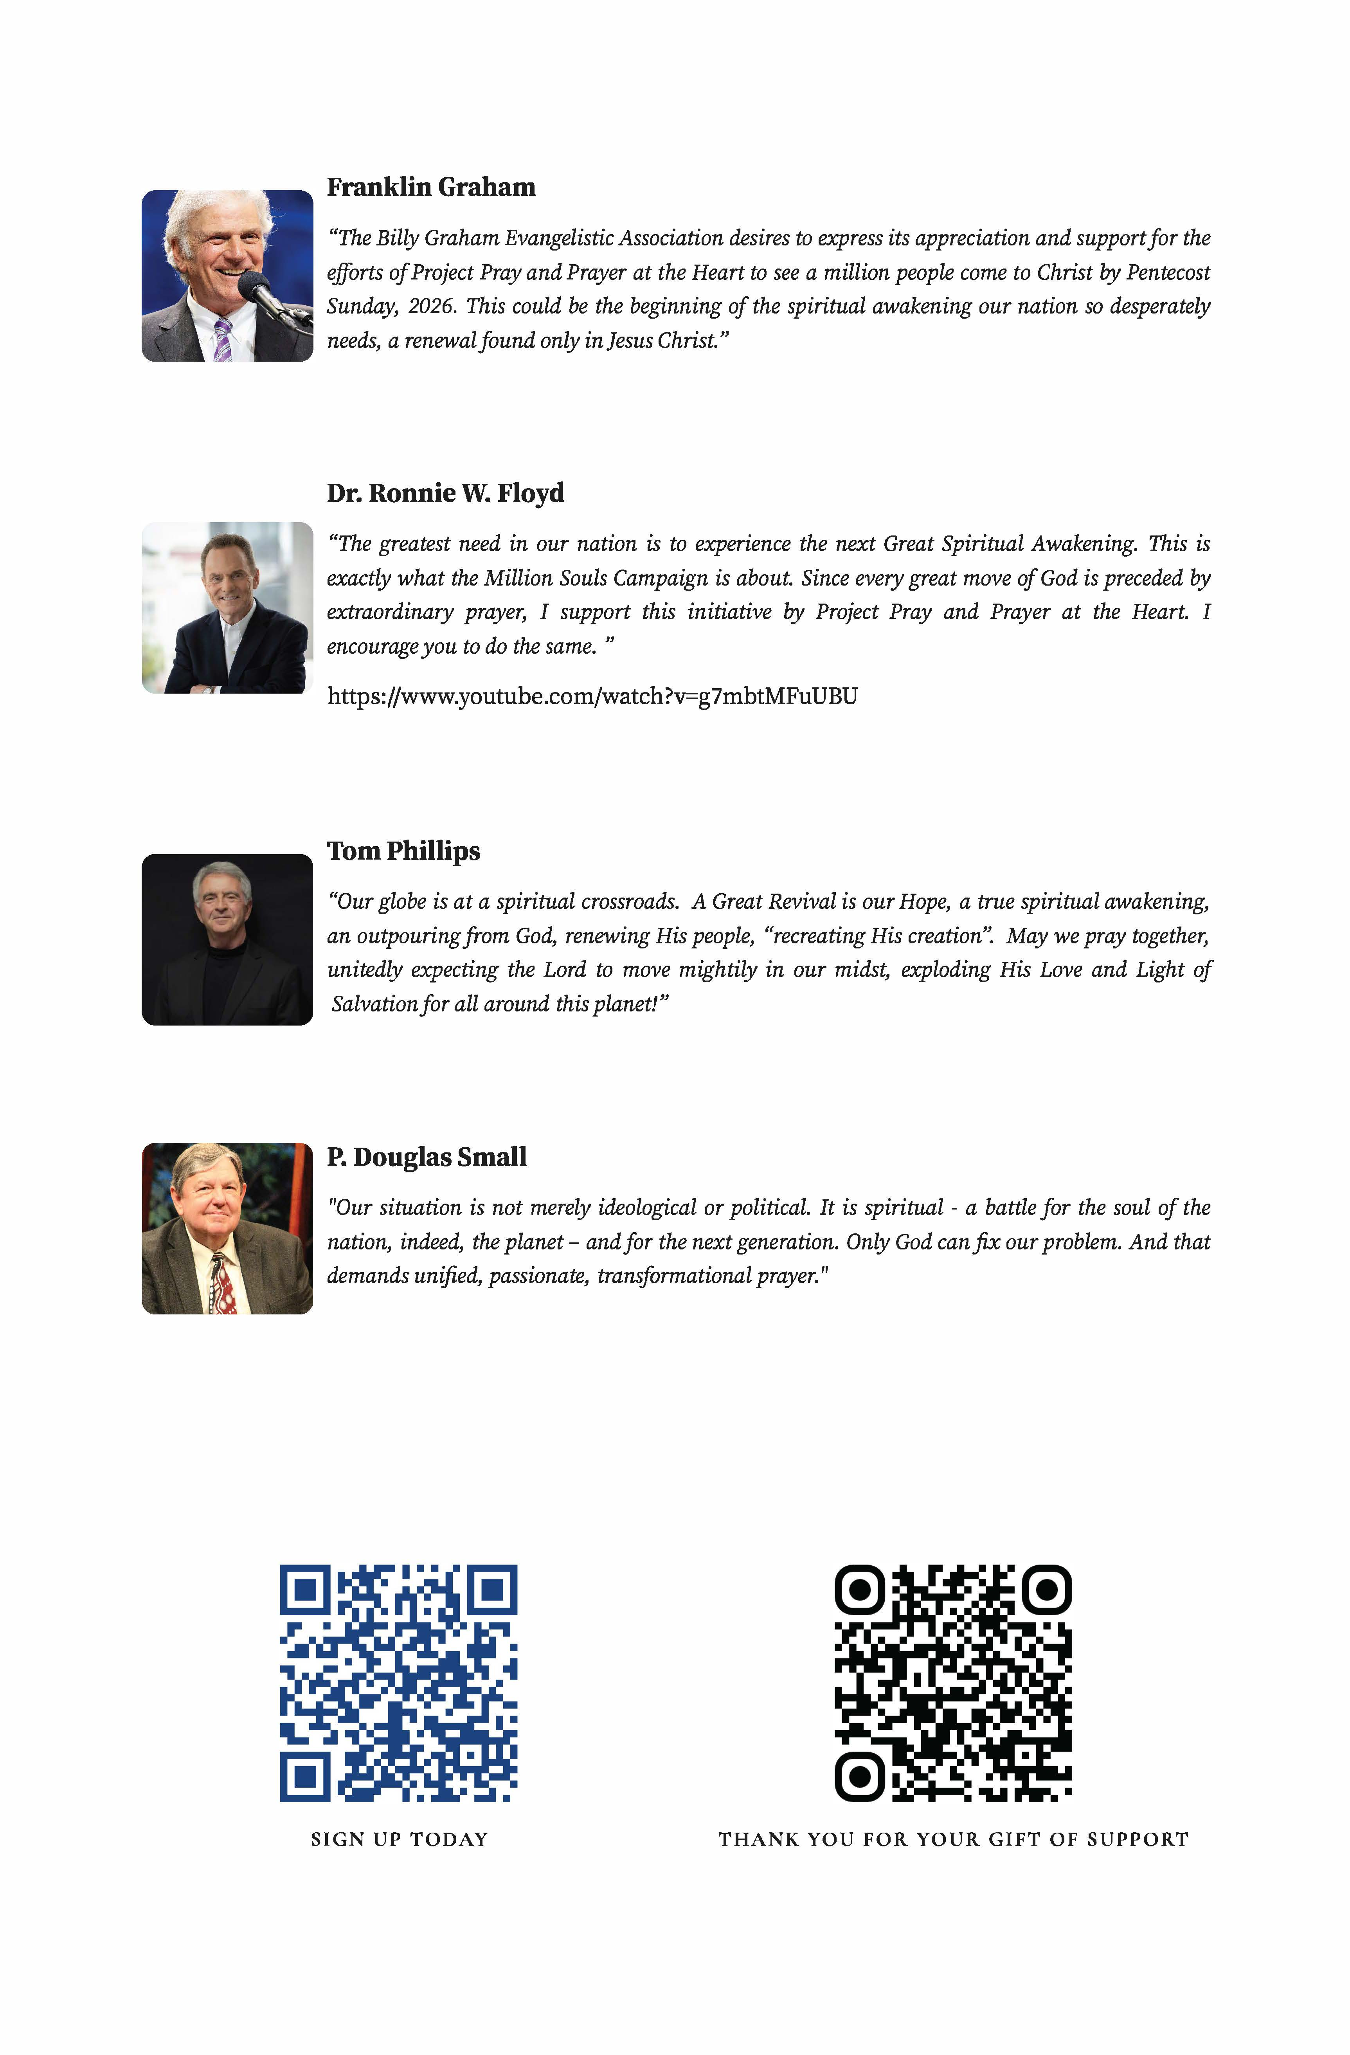

Appendix B – PATH Flow Chart
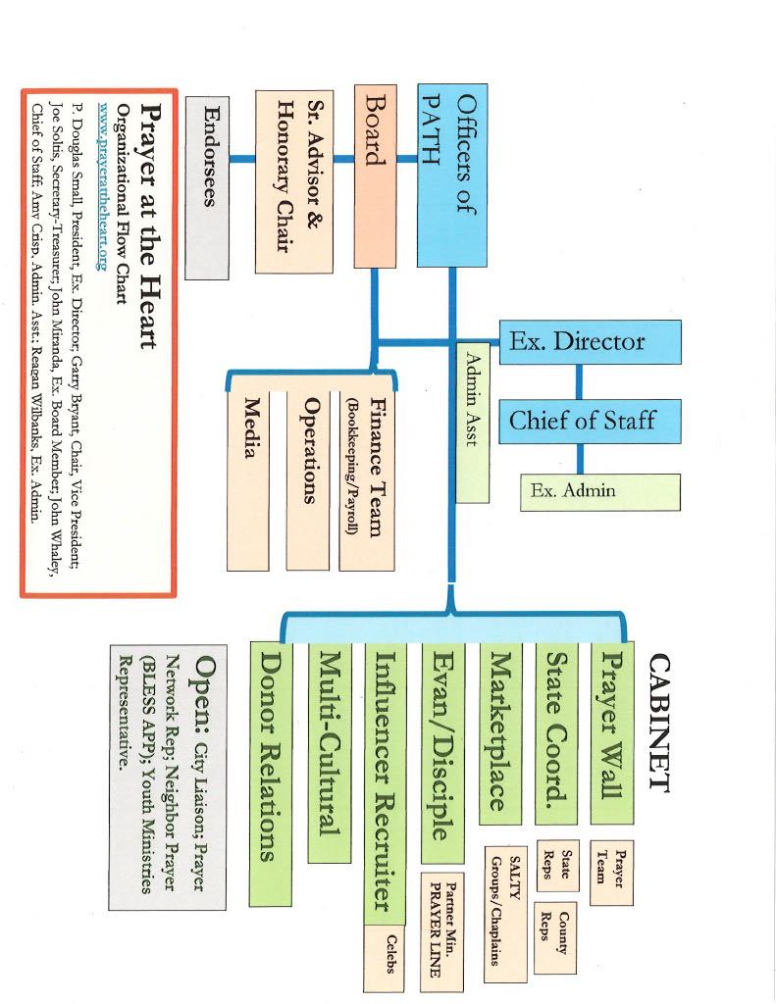

Appendix C – Top 40 Cities in the US 2026
https://en.wikipedia.org/wiki/Metropolitan_statistical_area
New York–Newark–Jersey City, NY-NJ MSA | 20,112,448 | 20,081,935 | +0.15% | +30,513 | New York–Newark, NY-NJ-CT-PA CSA
Los Angeles–Long Beach–Anaheim, CA MSA | 12,844,441 | 13,200,998 | −2.70% | -356,557 | Los Angeles–Long Beach, CA CSA
Chicago–Naperville–Elgin, IL-IN MSA | 9,434,123 | 9,449,351 | −0.16% | -15,228 | Chicago–Naperville, IL-IN-WI CSA
Dallas–Fort Worth–Arlington, TX MSA | 8,477,157 | 7,637,387 | +11.00% | +839,770 | Dallas–Fort Worth, TX-OK CSA
Houston–Pasadena–The Woodlands, TX MSA | 7,904,627 | 7,149,642 | +10.56% | +754,985 | Houston–Pasadena, TX CSA
Atlanta–Sandy Springs–Roswell, GA MSA | 6,482,182 | 6,104,803 | +6.18% | +377,379 | Atlanta–Athens-Clarke County–Sandy Springs, GA-AL CSA
Washington–Arlington–Alexandria, DC-VA-MD-WV MSA | 6,465,724 | 6,278,542 | +2.98% | +187,182 | Washington–Baltimore–Arlington, DC-MD-VA-WV-PA CSA
Miami–Fort Lauderdale–West Palm Beach, FL MSA | 6,391,072 | 6,138,333 | +4.12% | +252,739 | Miami–Port St. Lucie–Fort Lauderdale, FL CSA
Philadelphia–Camden–Wilmington, PA-NJ-DE-MD MSA | 6,329,118 | 6,245,051 | +1.35% | +84,067 | Philadelphia–Reading–Camden, PA-NJ-DE-MD CSA
Phoenix–Mesa–Chandler, AZ MSA | 5,228,938 | 4,845,832 | +7.91% | +383,106 | Phoenix–Mesa, AZ CSA
Boston–Cambridge–Newton, MA-NH MSA | 5,034,221 | 4,941,632 | +1.87% | +92,589 | Boston–Worcester–Providence, MA-RI-NH CSA
Riverside–San Bernardino–Ontario, CA MSA | 4,769,007 | 4,599,839 | +3.68% | +169,168 | Los Angeles–Long Beach, CA CSA
San Francisco–Oakland–Fremont, CA MSA | 4,630,041 | 4,749,008 | −2.51% | -118,967 | San Jose–San Francisco–Oakland, CA CSA
Detroit–Warren–Dearborn, MI MSA | 4,390,913 | 4,392,041 | −0.03% | -1,128 | Detroit–Warren–Ann Arbor, MI CSA
Seattle–Tacoma–Bellevue, WA MSA | 4,161,883 | 4,018,762 | +3.56% | +143,121 | Seattle–Tacoma, WA CSA
Minneapolis–St. Paul–Bloomington, MN-WI MSA | 3,790,295 | 3,690,261 | +2.71% | +100,034 | Minneapolis–St. Paul, MN-WI CSA
Tampa–St. Petersburg–Clearwater, FL MSA | 3,418,895 | 3,175,275 | +7.67% | +243,620
San Diego–Chula Vista–Carlsbad, CA MSA | 3,282,248 | 3,298,634 | −0.50% | -16,386
Denver–Aurora–Centennial, CO MSA | 3,092,037 | 2,963,821 | +4.33% | +128,216 | Denver–Aurora–Greeley, CO CSA
Orlando–Kissimmee–Sanford, FL MSA | 2,957,672 | 2,673,376 | +10.63% | +284,296 | Orlando–Lakeland–Deltona, FL CSA
Charlotte–Concord–Gastonia, NC-SC MSA | 2,938,830 | 2,660,329 | +10.47% | +278,501 | Charlotte–Concord, NC-SC CSA
Baltimore–Columbia–Towson, MD MSA | 2,857,781 | 2,844,510 | +0.47% | +13,271 | Washington–Baltimore–Arlington, DC-MD-VA-WV-PA CSA
St. Louis, MO-IL MSA | 2,814,421 | 2,820,253 | −0.21% | -5,832 | St. Louis–St. Charles–Farmington, MO-IL CSA
San Antonio–New Braunfels, TX MSA | 2,813,140 | 2,558,143 | +9.97% | +254,997 | San Antonio–New Braunfels–Kerrville, TX CSA
Austin–Round Rock–San Marcos, TX MSA | 2,620,945 | 2,283,371 | +14.78% | +337,574
Portland–Vancouver–Hillsboro, OR-WA MSA | 2,542,282 | 2,512,859 | +1.17% | +29,423 | Portland–Vancouver–Salem, OR-WA CSA
Sacramento–Roseville–Folsom, CA MSA | 2,477,274 | 2,397,382 | +3.33% | +79,892 | Sacramento–Roseville, CA CSA
Pittsburgh, PA MSA | 2,421,992 | 2,457,000 | −1.42% | -35,008 | Pittsburgh–Weirton–Steubenville, PA-OH-WV CSA
Las Vegas–Henderson–North Las Vegas, NV MSA | 2,407,226 | 2,265,461 | +6.26% | +141,765 | Las Vegas–Henderson, NV CSA
Cincinnati, OH-KY-IN MSA | 2,312,858 | 2,249,797 | +2.80% | +63,061 | Cincinnati–Wilmington, OH-KY-IN CSA
Kansas City, MO-KS MSA | 2,270,682 | 2,192,035 | +3.59% | +78,647 | Kansas City–Overland Park–Kansas City, MO-KS CSA
Columbus, OH MSA | 2,242,028 | 2,138,926 | +4.82% | +103,102 | Columbus–Marion–Zanesville, OH CSA
Indianapolis–Carmel–Greenwood, IN MSA | 2,205,695 | 2,089,653 | +5.55% | +116,042 | Indianapolis–Carmel–Muncie, IN CSA
Nashville-Davidson–Murfreesboro–Franklin, TN MSA | 2,197,416 | 2,014,444 | +9.08% | +182,972 | Nashville-Davidson–Murfreesboro, TN CSA
Cleveland, OH MSA | 2,165,775 | 2,185,825 | −0.92% | -20,050 | Cleveland–Akron–Canton, OH CSA
San Jose–Sunnyvale–Santa Clara, CA MSA | 1,984,473 | 2,000,468 | −0.80% | -15,995 | San Jose–San Francisco–Oakland, CA CSA
Virginia Beach–Norfolk–Newport News, VA-NC, MSA | 1,797,213 | 1,780,059 | +0.96% | +17,154 | Virginia Beach–Norfolk, VA-NC CSA
Jacksonville, FL MSA | 1,785,500 | 1,605,848 | +11.19% | +179,652 | Jacksonville–Kingsland–Palatka, FL-GA CSA
Providence–Warwick, RI-MA MSA | 1,708,161 | 1,676,579 | +1.88% | +31,582 | Boston–Worcester–Providence, MA-RI-NH CSA
Raleigh–Cary, NC MSA | 1,595,720

Appendix D – Resources
- Seven Promo Videos: https://prayerattheheart.org/resources/promo-videos/
Videos to promote the 50 Days of Prayer encouraging individuals and congregations to sign up to pray and lead someone to Christ.
- Eight Pastoral Resource Videos: https://prayerattheheart.org/resources/pastoral-resource-videos/
The Pastoral Resource Videos collection is designed to equip and encourage church leaders as they guide their congregations toward deeper prayer, renewed evangelistic passion, and unified engagement in God’s mission. Each video offers clear, biblically grounded insight on themes central to Project 2026—from evangelism as a blessing, to persistent prayer, to mobilizing believers for community impact. Whether you’re preparing to lead your church into a season of focused prayer or seeking practical tools to strengthen your ministry, these resources provide accessible, pastor-to-pastor encouragement for the work God has entrusted to you.
- Project 2026 Organizational Guide: https://prayerattheheart.org/resources/
If you’d like to join us in our mission to bring the power of prayer to millions, we’ve provided a handy organizational guide in PDF format. You may download the complete guide. or a particular parts.
  - Complete Guide
  - Introduction
  - State Representatives
  - County/City Representatives
  - Congregational Representatives
  - Personal Participation Guide
  - Post Campaign Follow Up and Reporting
- Partner Events: https://prayerattheheart.org/partner-events-and-resources/
Resource page to keep up to date with happenings with our Strategic Partners.
- Promotion of the new film released near Easter 2026 entitled “A Great Awakening”: https://prayerattheheart.org/a-great-awakening/

- Promotion of the new film released in May 2026 entitled, “That They May Be ONE”: https://prayerattheheart.org/that-they-may-be-one/

Appendix E – 50 Day Prayer Guide
PDF Download Available: https://prayerattheheart.org/resources/
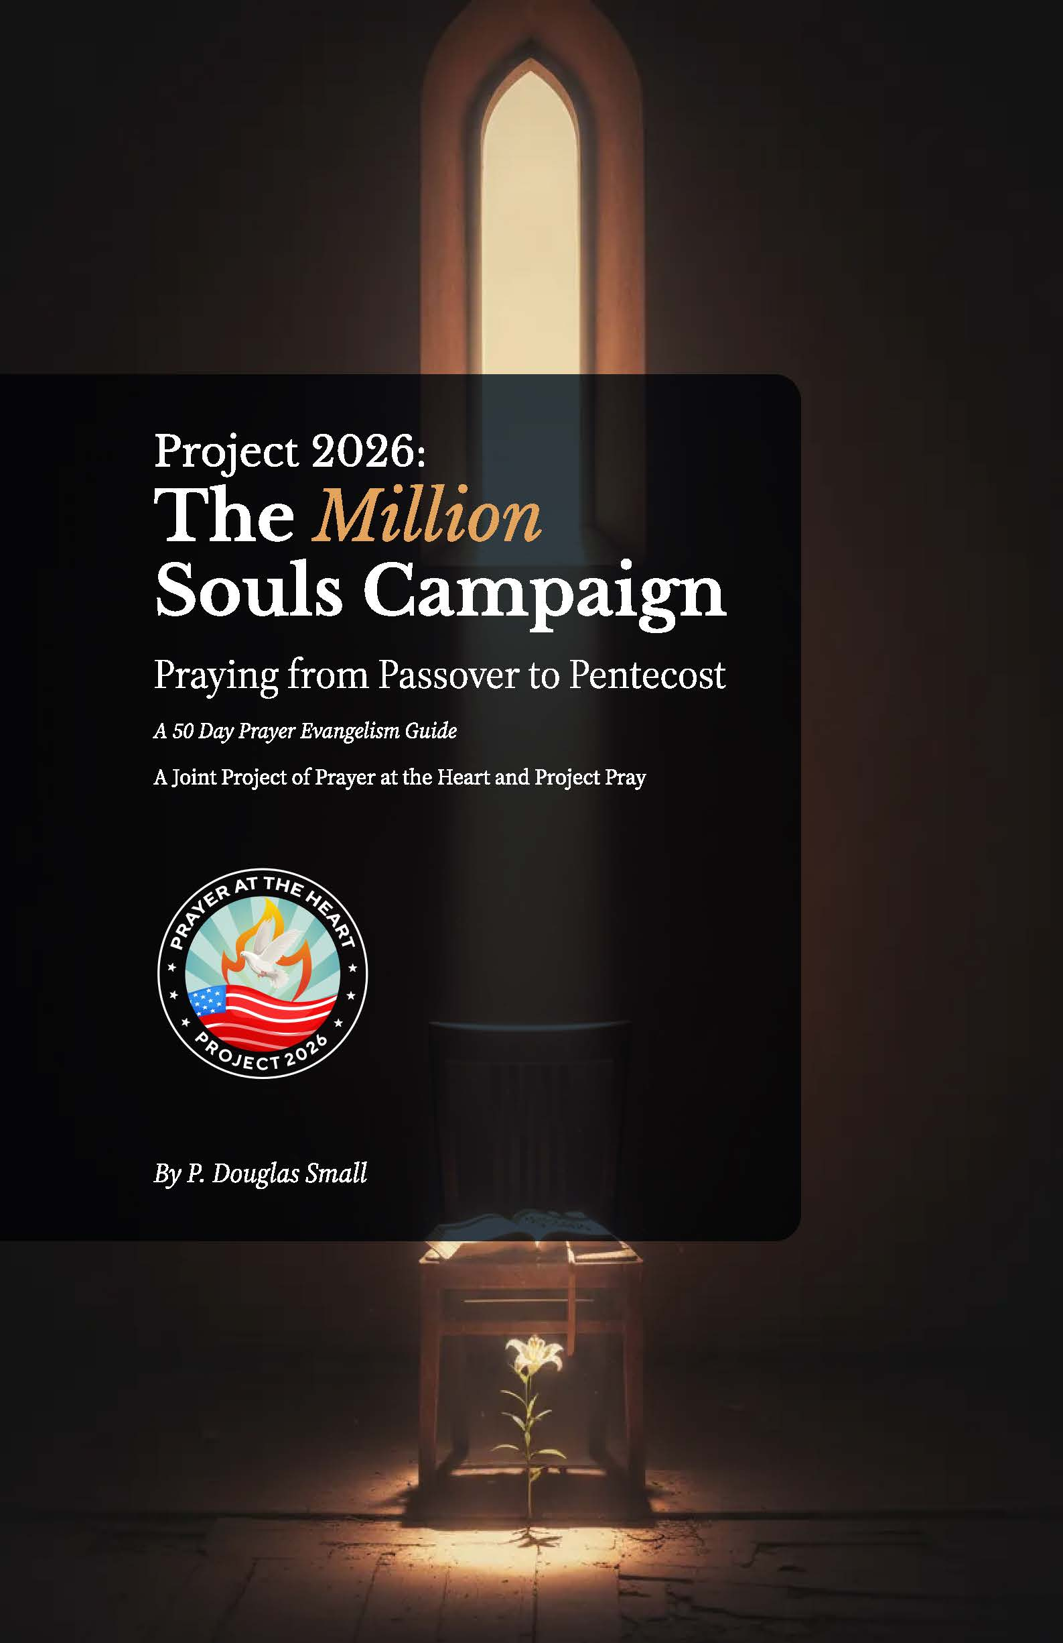

Appendix F – Evangelism As Blessing
PDF Download Available: https://prayerattheheart.org/resources/
Evangelism As Blessing Session 1 Video: https://youtu.be/cjdSBgQJ_90 and https://youtu.be/9jVxljoZkSY
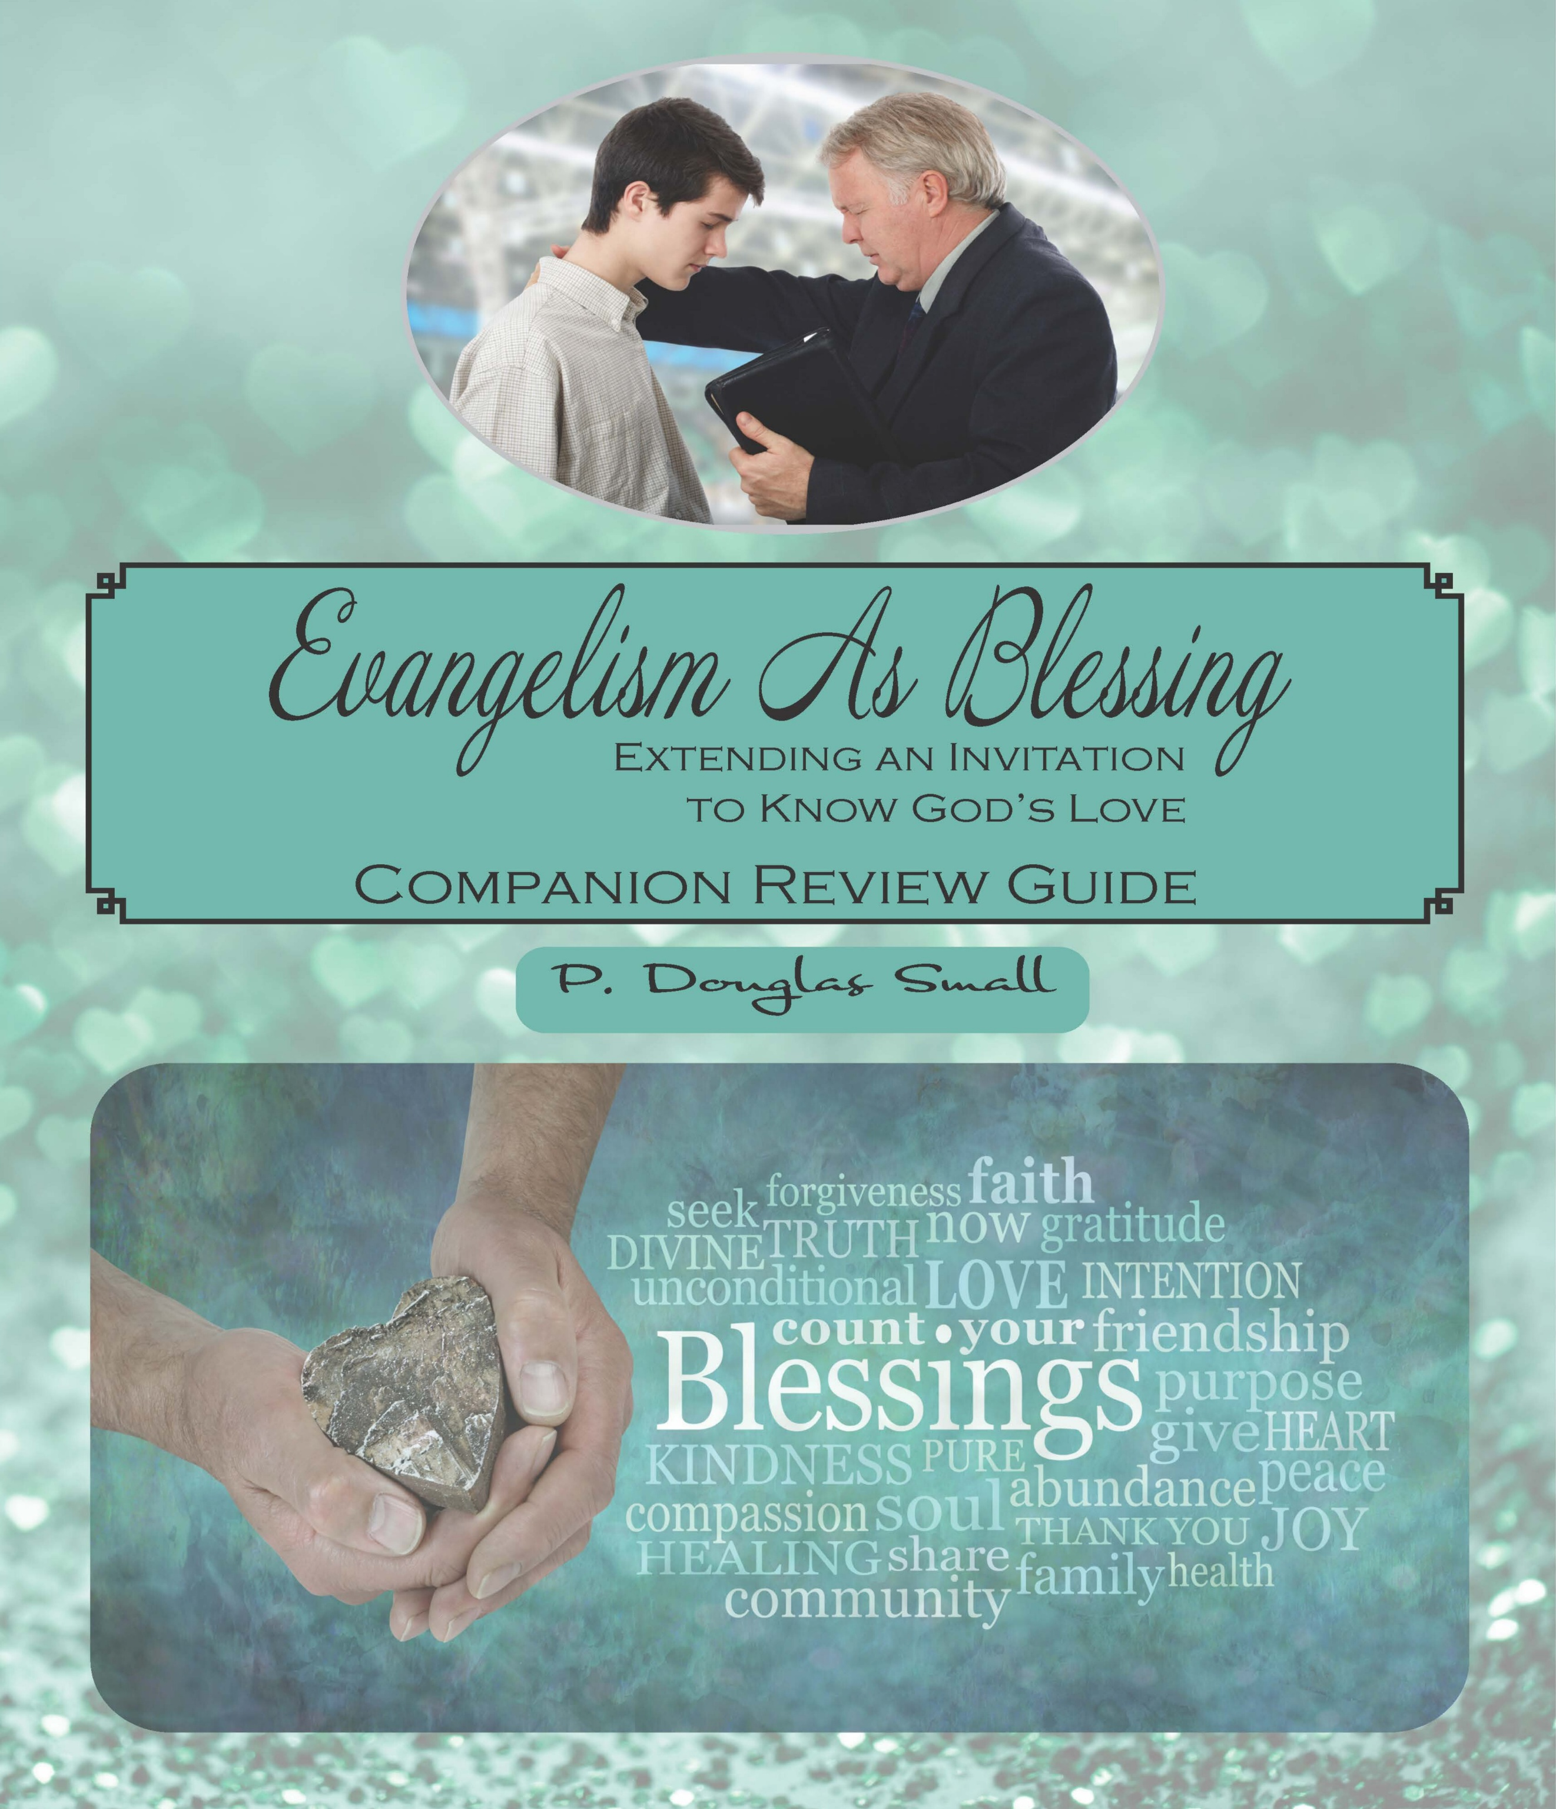

Evangelism as Blessing is a new approach to evangelism, yet an older, tried and true approach borrowed from God Himself. Have you ever noticed that the first word of God to humanity was that of blessing? And it was the last word Christ spoke as he ascended. The blessing is an expression of God’s enduring love. It is an offer of grace. It is what the priesthood, and now, the pastoral ministry is to speak over congregations and cities. It is not love without truth, but it is unconditional love laced with compelling truth. At the intersection of love and truth, one encounters redemptive power. Here is the call to evangelism that listens before it tells. It is story-based, testimony-inspired evangelism. It is slower, more relational, more natural. Anyone can offer a blessing - and open up a conversation about the goodness of God - and the goodness of God, the Bible declares, leads to repentance. The Companion Review Guide is also available for individual use or in a small group setting.

Appendix G – Operation Andrew Guide
PDF booklet is available for download: https://prayerattheheart.org/million-souls-campaign/operation-andrew/
Prayer at the Heart is using the Operation Andrew model utilized by the Billy Graham Evangelistic Association to identify those who are relationally near to us to need to know Christ more fully. This method is essential to the success of Project 2026.
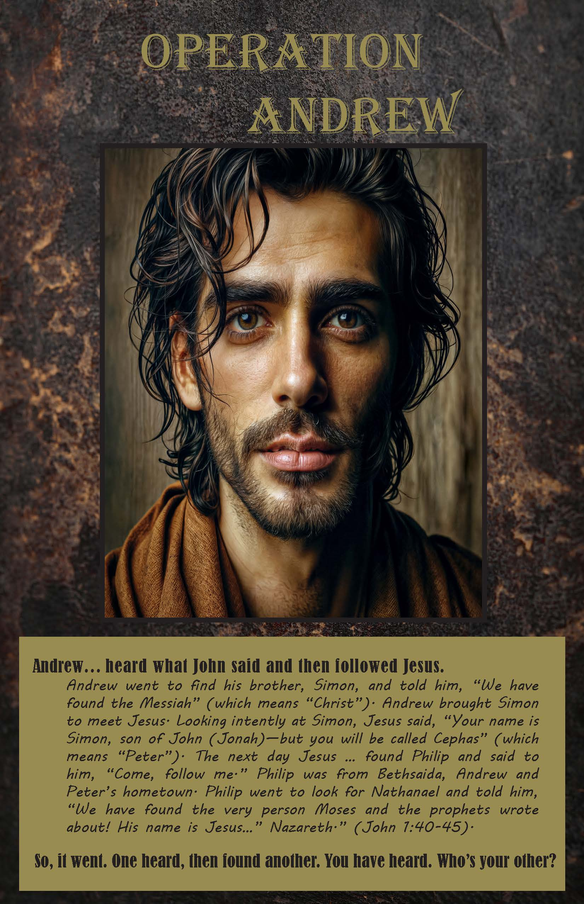

Appendix H – Salty Guides
To Download a PDF of a sample Salty Guide visit: https://prayerattheheart.org/million-souls-campaign/salty-groups/
SALTY groups are an expression of the Christian unity that Jesus prayed for (John 17:21 & 23), which will prepare the way for a great awakening.
WHEN AND WHERE:
At the workplace, in a conference room, an office or a place off the radar screen and notice of others. Do so before work or at lunchtime.
HOW:
Start with two or three. The groups are not meant to be large – with 6-8 regular attendees, consider starting another group. See the meaning of the SALTY acronym to understand the missional purpose of the group.
S – Supplicating, prayer Support group, interceding for one another and their workplace peers, sincerely praying to be sweet incense the marketplace.
A – Asking God for a spiritual Awakening at their workplace, for an Anointing to carry the presence of God at work, to be Aware of the spiritual environment of their workplace, to hold one another gently Accountable to be a godly witness.
L –Loving others, praying for grace to Live a Christ-like Life, to be a Light in what might be a dark place,
T –Truthing, telling the Truth, speaking the Truth in love, Talk (speech) be seasoned with salt, Tempered Christians, all the while,
Y – Yielding to the Holy Spirit, Yearning for a Great Awakening, the day God came to work with them, and the workplace became a alive with His Presence – SALTY!
WHAT:
SALTY guides are produced monthly, but they can also be used over again. They are a simple guide for a 30-minute missional prayer experience for believers who gather to pray onsite for insight. To inspire each other to be salt and light at the workplace.
VISION:
Prayer at the Heart sees prayer groups embedded in every segment of the culture–businesses, schools, university campuses, hospitals, even neighborhoods until we see a great awakening sweeping across America and around the world like a mighty Tsunami wave.
Record your SALTY group and/or interest by completing the segment below. In doing this, you will receive access to a fresh SALTY guide to use for your prayer group each month.
The guide will feature prayer models. As the movement grows, you will learn how others are using the SALTY guide to impact the marketplace in which they work.
GUIDELINES:
- Keep it simple, be courageous – go for it!
- Unity – pray with Christians at your workplace. The guide can also be used in schools, even in neighborhoods. Ask God for opportunities to invite others to pray. Holiday editions are also available.

Appendix I – Ambassador Training
Paul called the Corinthian church to be ‘ambassadors.’ This is an extension of the ministry of intercession. The ambassador stands between kingdoms or nations. In our case, we represent the kingdom of God to leaders, both political and secular. The church is the visible expression of the invisible kingdom of God. Commissioned by the church, ambassadors interface with mayors and councils, governors and senators, building bridges of understanding and cooperation. Every community needs a handful of trained, stately Christian representatives who speak truth to power. This role is critical to the success of Project 2026 and our overall mission at Prayer at the Heart.
Dr. Small wrote a book and a study guide to train individuals to serve as Ambassador’s. The PDF version can be downloaded here: https://prayerattheheart.org/million-souls-campaign/prayer-ambassadors/
The Ambassador Training 1 Intro and Discovery Video can be accessed here: https://youtu.be/QHHUjrVXhO0
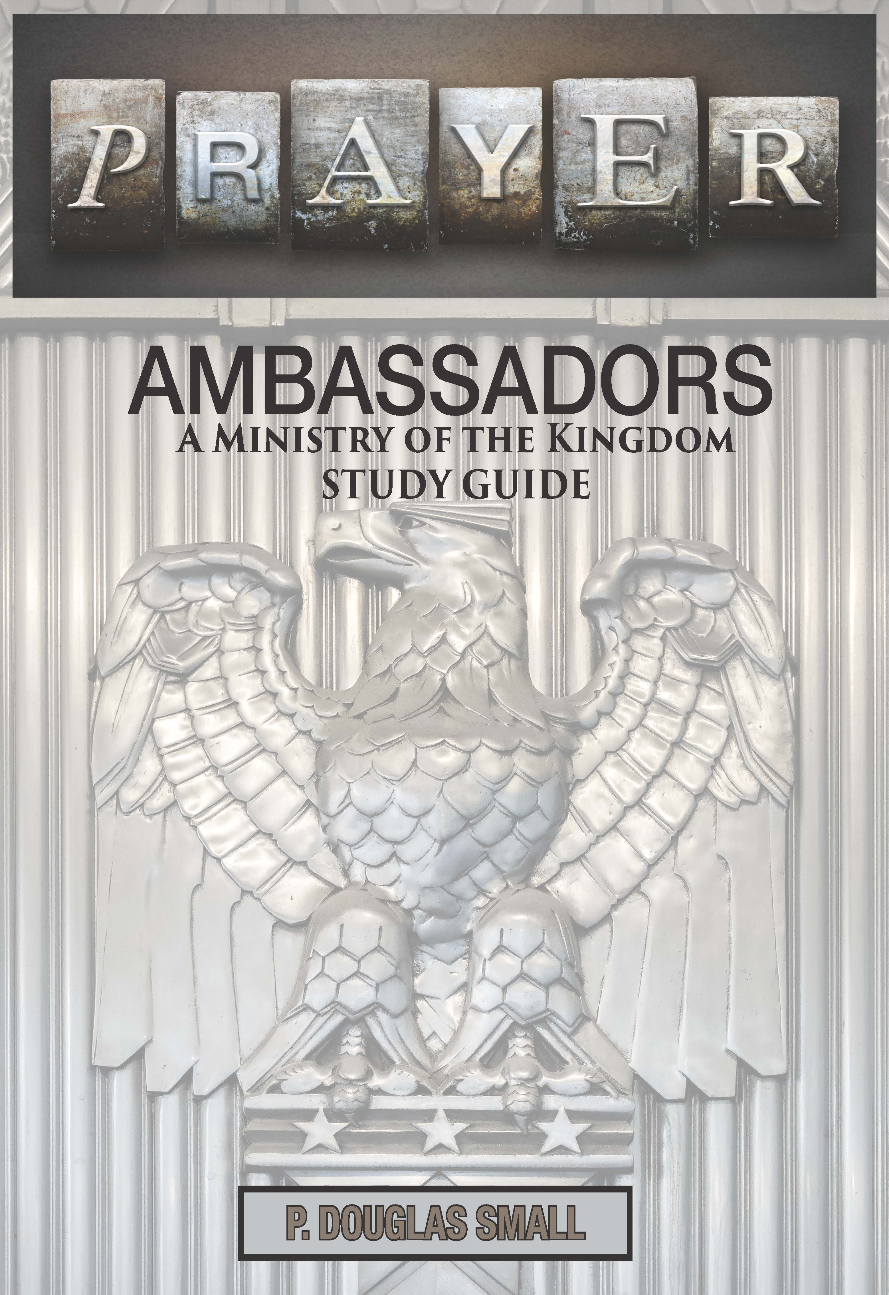

Appendix J – The Bless App
As we mobilize 1 million Christians to pray for—and share the Gospel with—1 million people who do not yet know Jesus, we must not forget those closest to us. Every one of us lives among neighbors who are near to us but far from God.
The Bless App equips you with the names, insight, and practical tools to pray intentionally for your neighbors and to help followers of Jesus live as a BLESSing in their everyday relationships. It is a simple, powerful way to reclaim the lifestyle of Jesus—guiding believers into five timeless rhythms that strengthen discipleship and expand missional engagement.
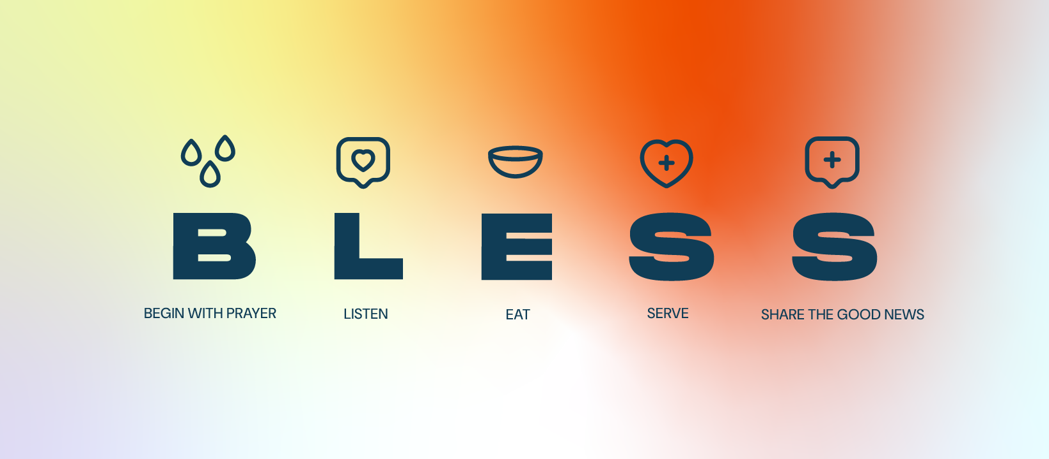

Download the BLESS app and sign up to be a “Light” to your neighborhood. You will receive a list of your 50 closest neighbors.
Each day, the app sends a reminder encouraging you to pray for and BLESS 5 of them by name. You can also add the names of friends and family. Each day, two of them will be added to your list of 5 neighbors. A new feature is the GROW section with videos from national leaders to help you live out the 5 BLESS rhythms.
When you click on MORE at the bottom of the screen, click on Local
Movements and add Prayer at the Heart.
Sign up using the QR code or the link below, and you can join the
Prayer at the Heart group when you sign up.


Appendix K – State Representative’s
Our goal is to develop a strategy that sustains a movement of prayer and evangelism, resulting in revival in the church and a great awakening in the culture. Pick out the things you can do immediately but always keep the long-term strategy in view.
Visit: https://prayerattheheart.org/million-souls-campaign/general-information/ to learn more about the role and function of being a State Representative.
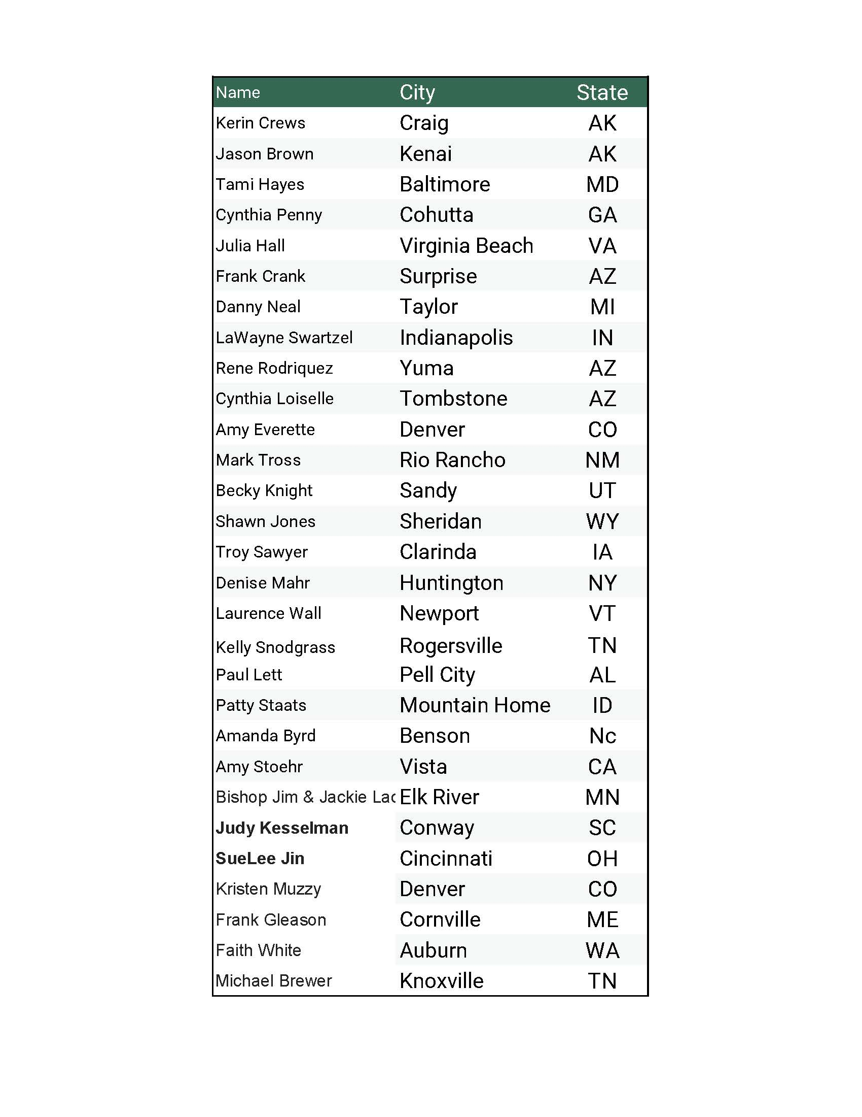

Appendix L – Living Room Gatherings
The purpose of the Living Room Gatherings was to not only share the vision for prayer between Passover and Pentecost but also to gain collaboration with others for financial support and/or promotion support.
The Living Room Host Guide can be accessed here: https://drive.google.com/file/d/1boTjGt7MwuW6Lhu_1tYB6XmY_LSDGH4H/view?usp=sharing. The outline of the Host Guide and the Outline of the evening are shown below.
Two videos were also shared about the Living Room Meetings that the host could show when they had individuals come to their home. They can be located at the links below:
https://drive.google.com/file/d/1o-5ma8pTA7Jb5LfvX75HnFLpvKX3xeSz/view?usp=sharing
https://drive.google.com/file/d/1uNDt4eCdecMk-Axjm_-sxCMVclTKa_GE/view?usp=sharing

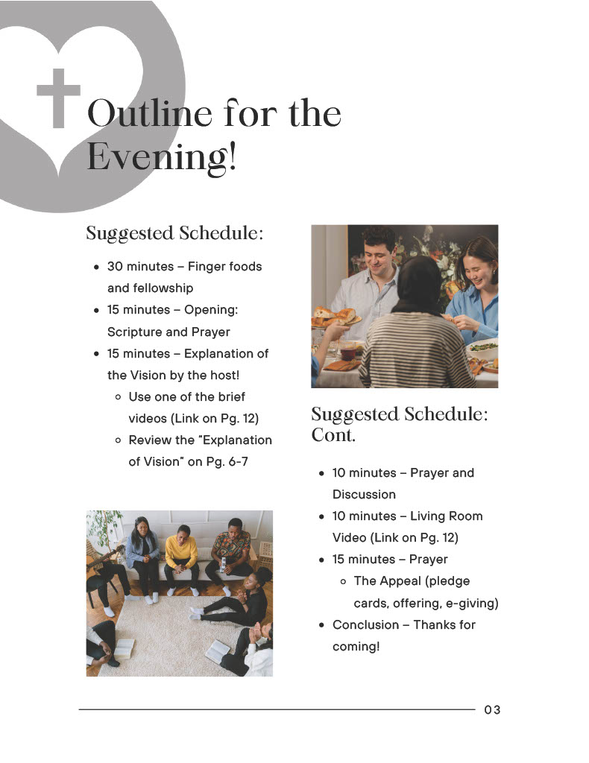
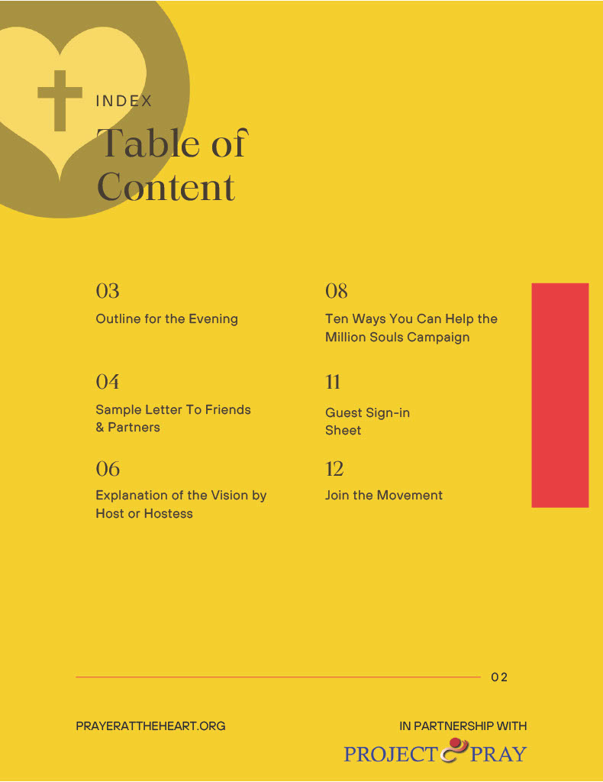

Appendix M – The USA Prayer Wall
Intercessors and prayer warriors are encouraged to cover fifty hours a week in prayer. How does Prayer at the Heart’s USA prayer wall work? Each weekday, Monday—Friday, is divided into one-hour time blocks 7 am—7 pm. The 50 states naturally fall into 5 regions of about 10 states each according to the usual time zone for each state. One day of the week is set aside for each region:
Monday, PACIFIC REGION—(Pacific Time Zone) Alaska & Hawaii;
Tuesday, MOUNTAIN REGION—Mountain Time Zone;
Wednesday, CENTRAL REGION—(Central Time Zone);
Thursday, EASTERN REGION—(Eastern Time Zone);
Friday, NEW ENGLAND—(Eastern Time Zone.)
Prayer facilitators in each state select one hour for weekly prayer on the day of the week reserved for that time zone. For example, Minnesota, in the Central region, prays on Wednesday @ 10am CT. Everyone uses the same conference call number. Anyone in the country–or the world–can join any prayer meeting any day. See the Prayer Wall Schedule Below.
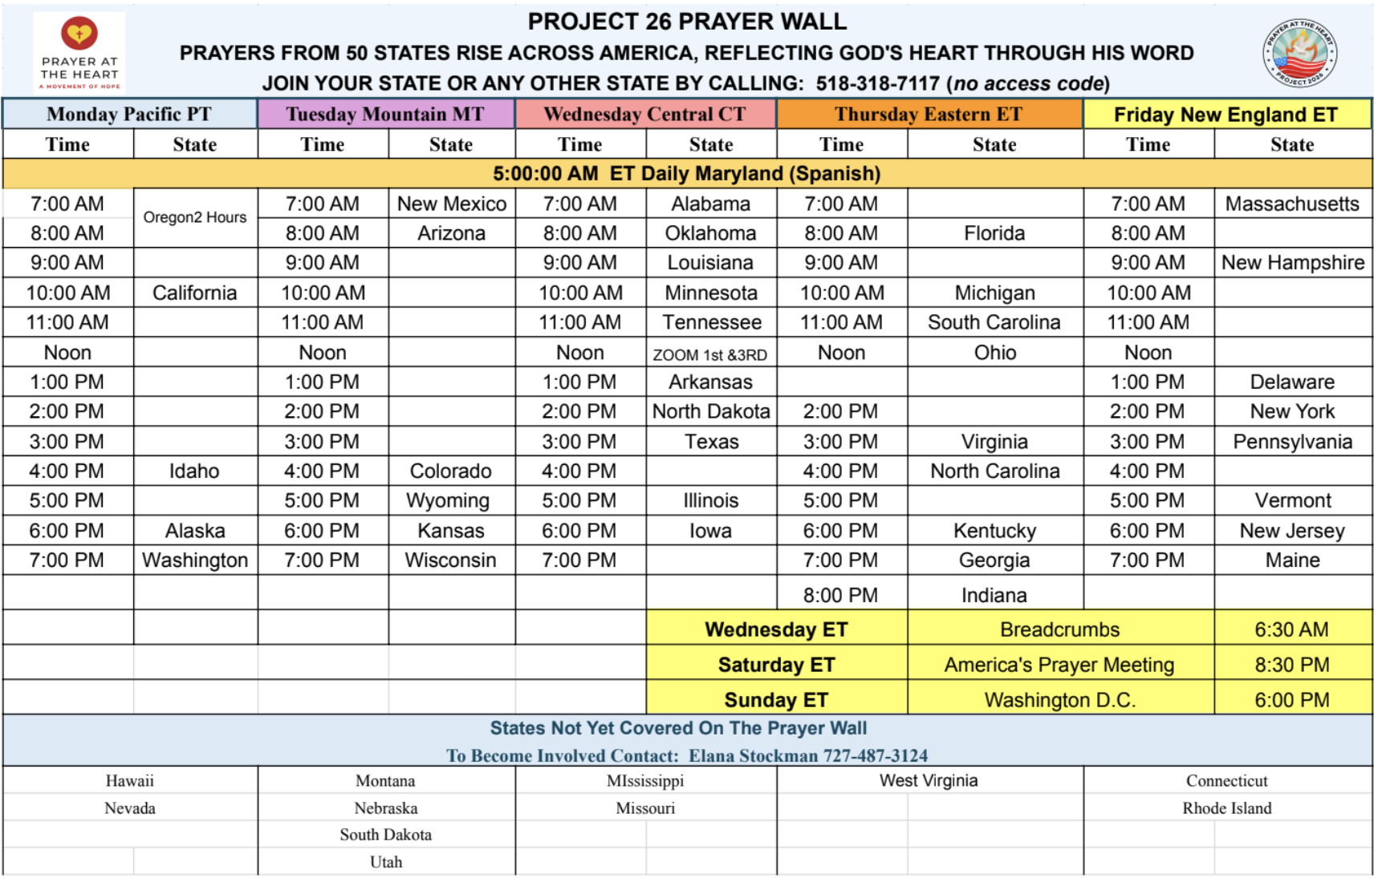

A weekly Devotional with Prayer Points is also sent out from Elana Stockman. To view a sample devotional, click here: https://prayerattheheart.org/million-souls-campaign/usa-prayer-wall/

Appendix N – TELPI Fund Raising Efforts
Prayer At The Heart has partnered with TELPI and Promising People to assist with the fundraising effort for The Million Souls Campaign.
To learn more about TELPI, visit: https://telpi.net/
See below or click this link to learn more about the PATH and TELPI collaboration: https://drive.google.com/drive/folders/1AeiCQ4Yq0FiBeCalWs8w9C-6tlNE9V2H?usp=sharing
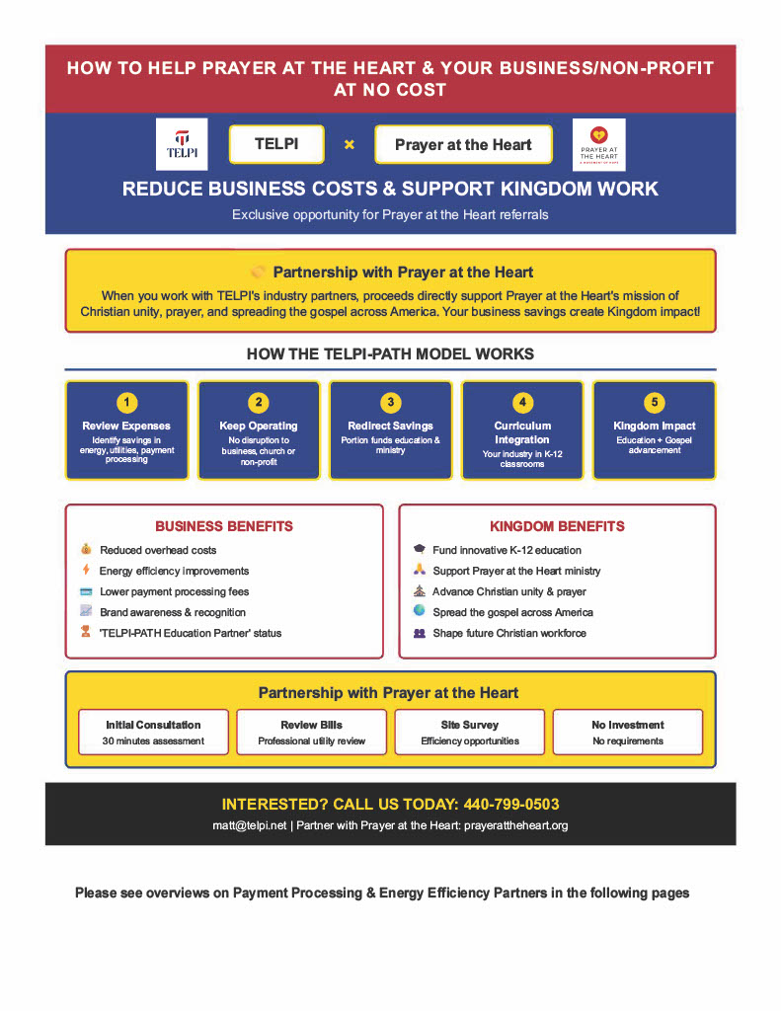

Appendix O – Fundraising Effort
Tonya Skelly serves as the Donor/Public Relations Representative for PATH. She has developed the following Donor Partnership Booklet that she shares with donors through mail, phone calls and personal contacts. The booklet can be accessed here: https://drive.google.com/file/d/1JDacIlMpK1IgnqIEgR5cmgiPIRPGeqdv/view?usp=sharing
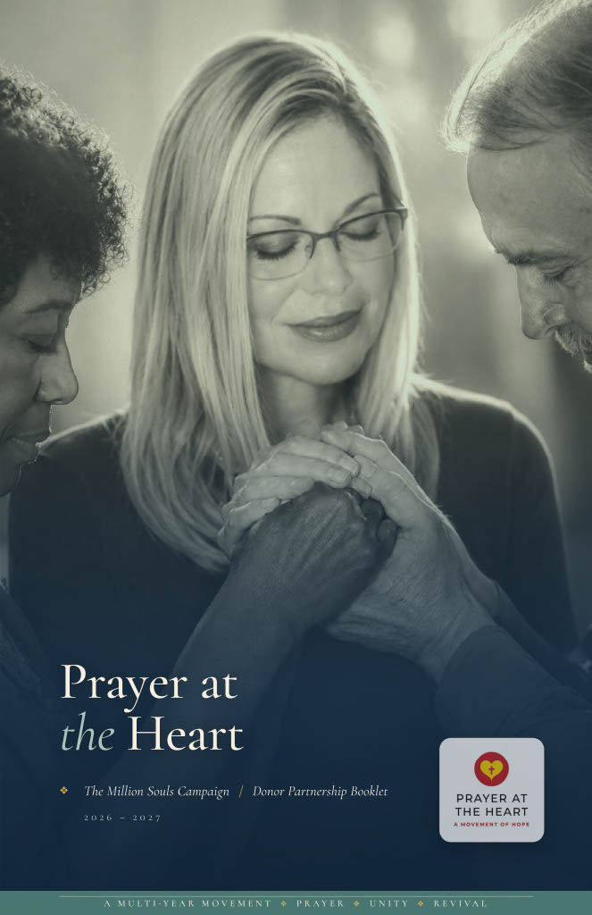

Appendix P – PATH Budget
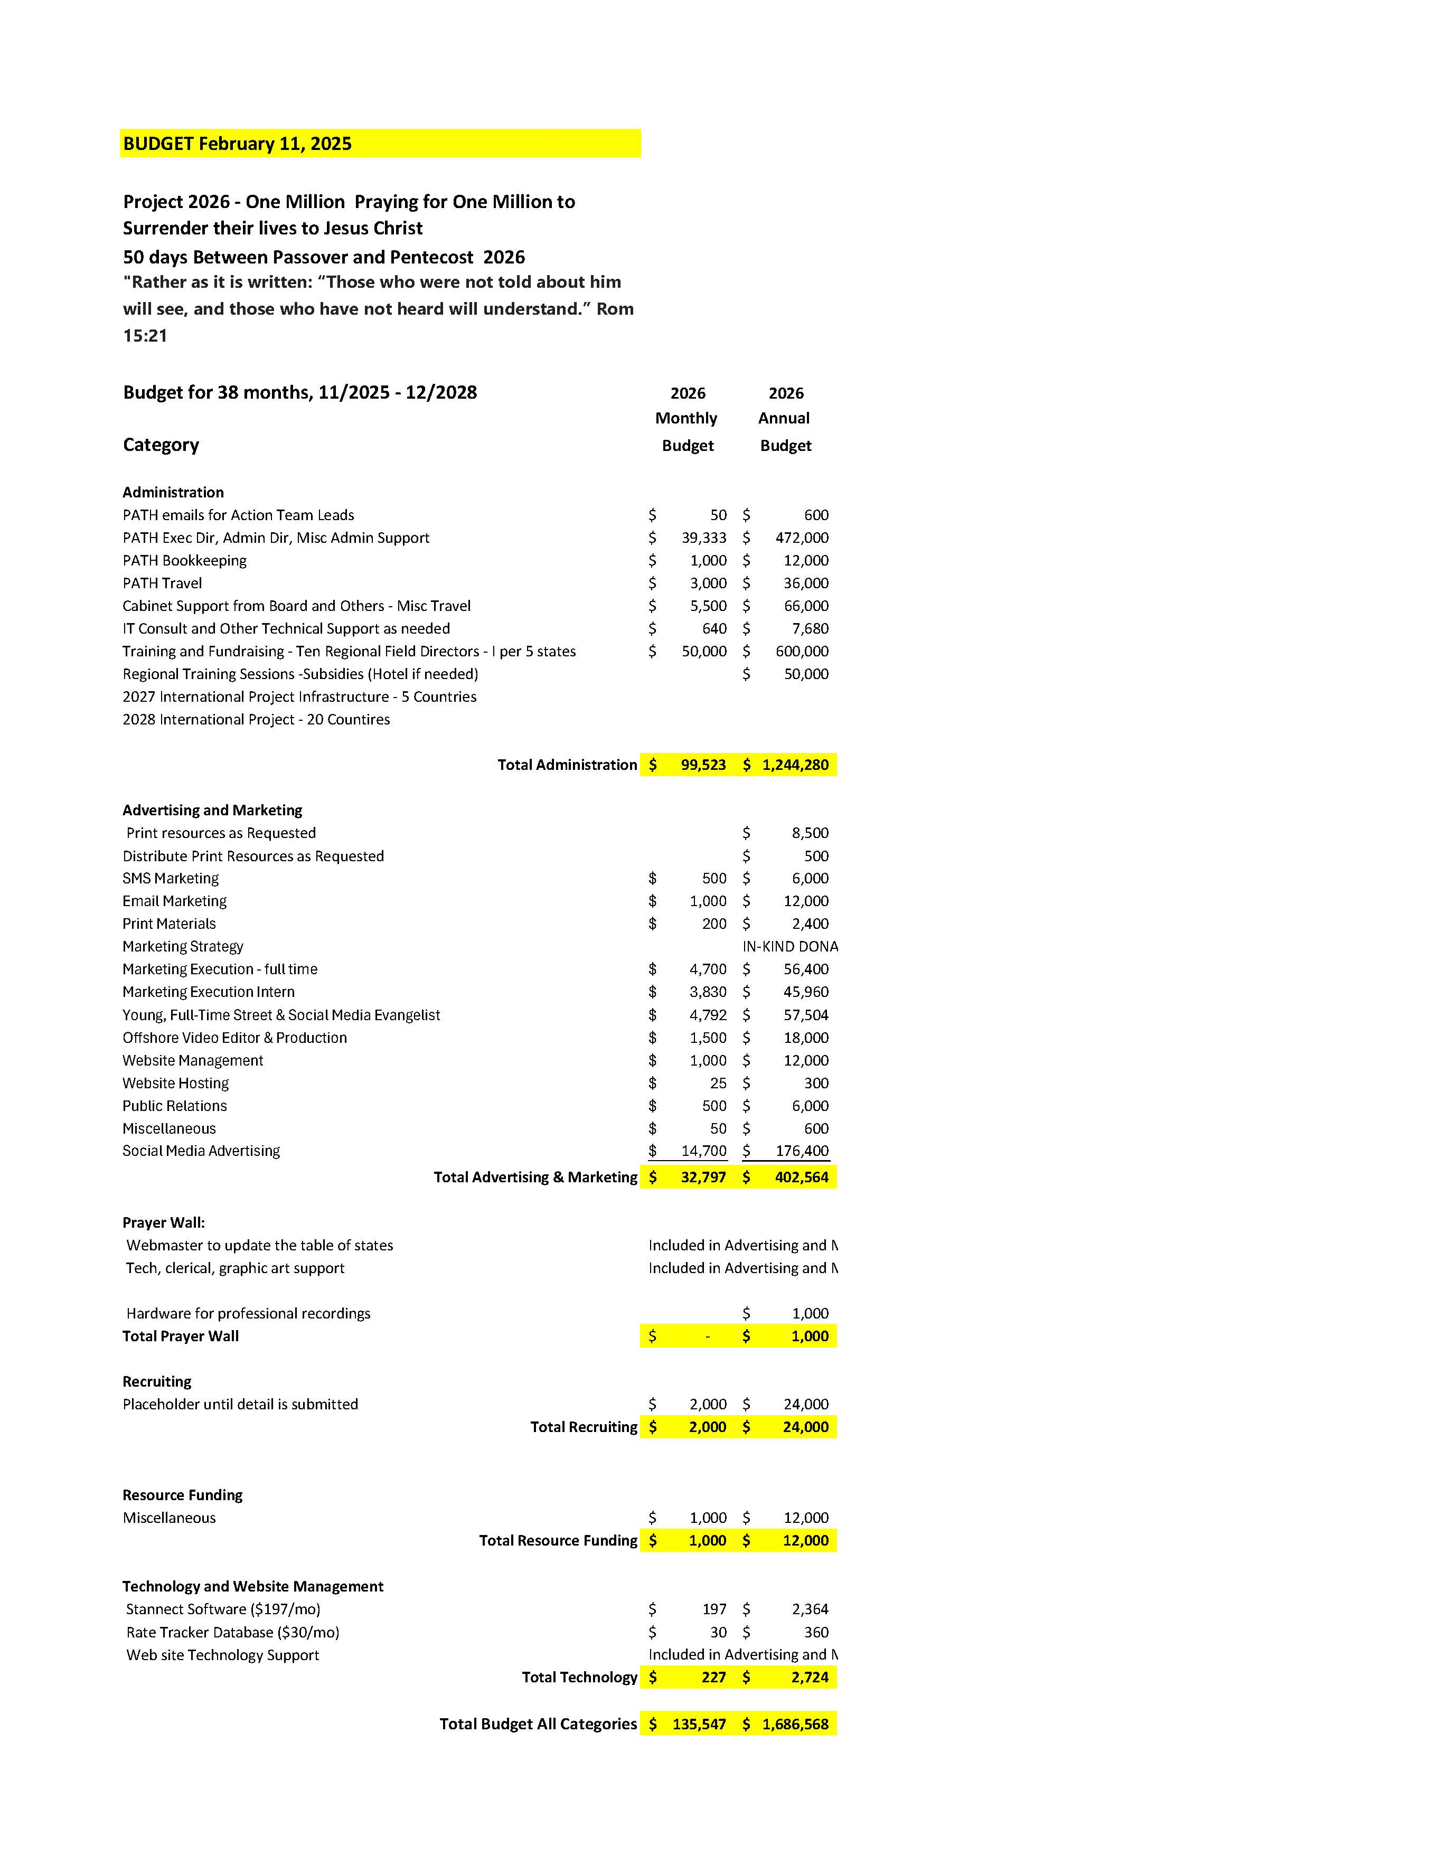

Appendix Q – Strategic Partners
Prayer at the Heart and Project 2026 are humbled to be linking arms with the following national ministries. Visit https://prayerattheheart.org/strategic-partners/ for the most current partners.
- Project Pray
- Your Prayer Team – Prayer & Crisis Referral Network
- Project Pray Publications
- That They May Be One
- A Great Awakening
- Bott Radio Network
- Around The Corner Ministries
- Bless Every Home prayer app (Luis Palau organization)
- ChristianBody.Net
- Christians in the Marketplace
- Date The Word
- Frank Shelton Global
- Hollywood Prayer Network
- Intercessors of America
- International Renewal Ministries
- IPHC Evangelism-Mission Department
- GAP 26
- America’s National Prayer Committee
- Of One Accord Ministry
- ATD
- Pray North Carolina
- Radio Training Network
- The Rooftop
- 24-7 Prayer USA
- Nehemiah Alliance
- TELPI
- Radio Chris 25
- Celebrity Evangelist
- Church of God International; Evangelism Mission Department

Appendix R – July 4th Sunrise Service
May 25th – July 5th, 2026, people were encouraged to continue praying leading up to the 250th Anniversary of our nation. A Sunrise Service Program was developed as well as promo videos to encourage people to pray. Visit: https://prayerattheheart.org/sunrise-program/ to download the program.
Video Promo 1: https://youtu.be/rW2Uk2o37ek
Video Promo 2: https://youtu.be/mF3oI7hbFPM
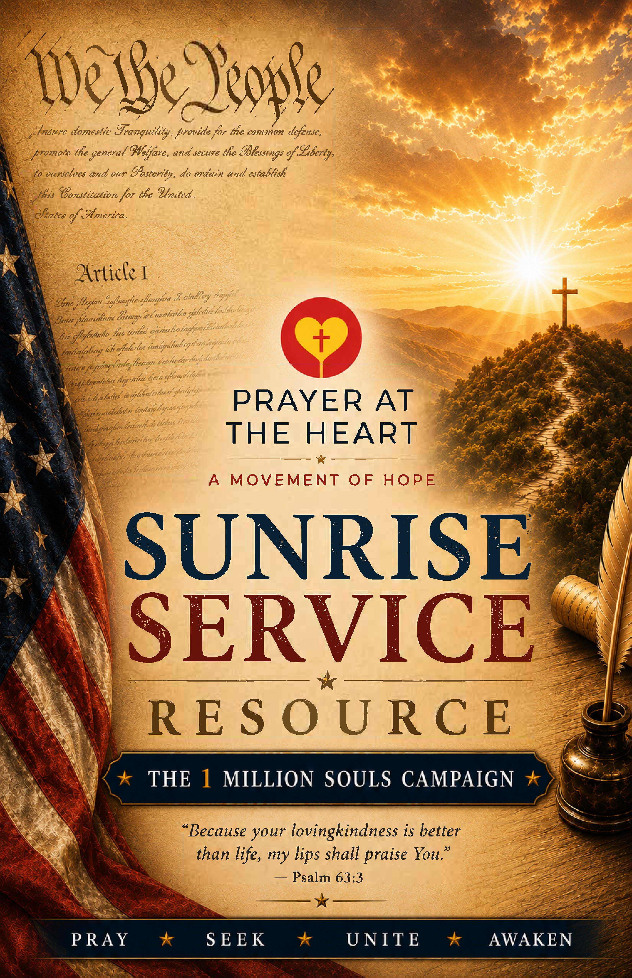
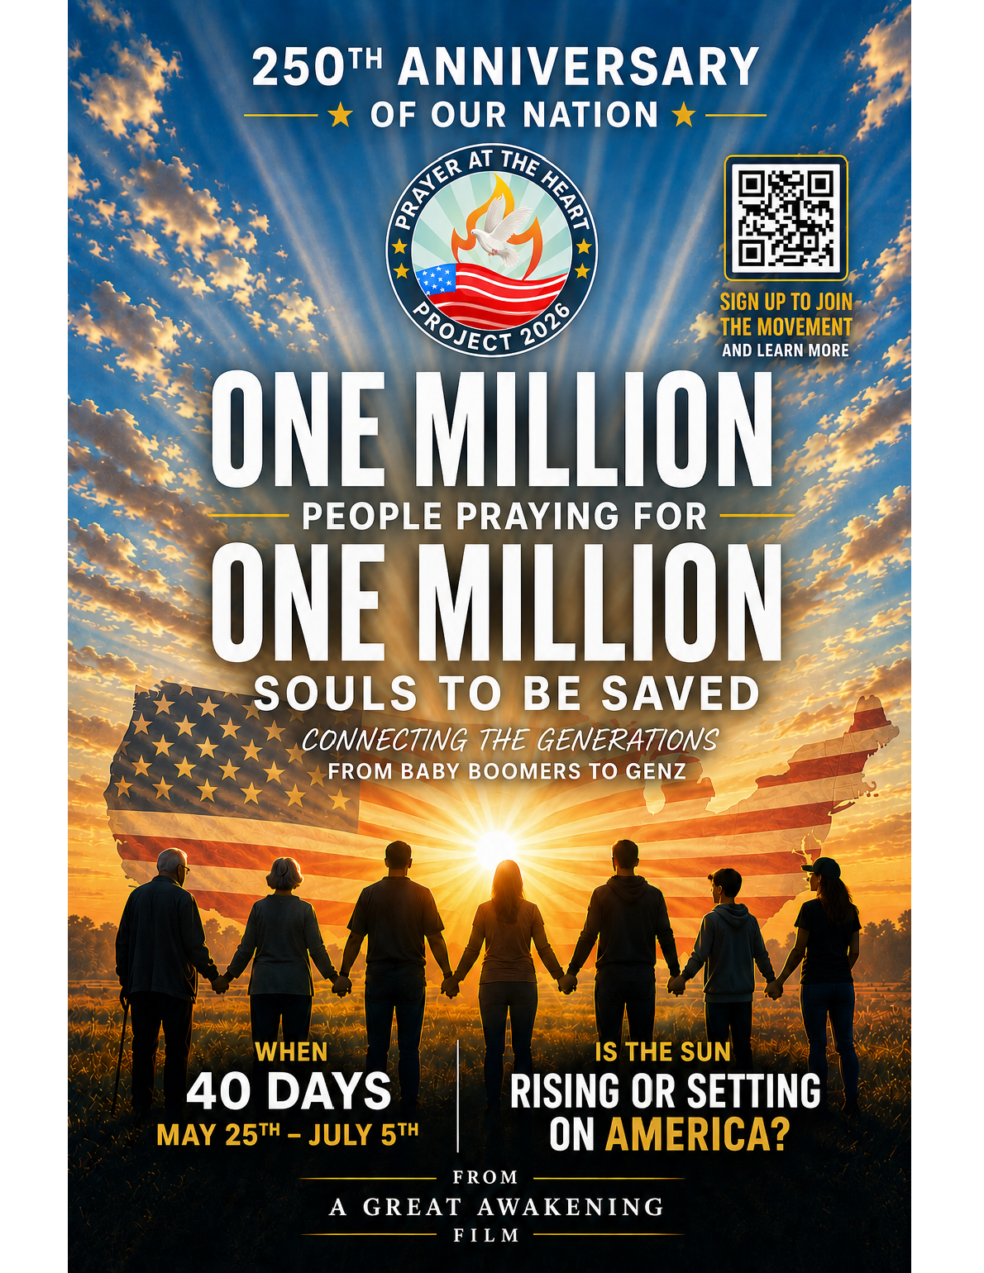

Appendix S – Infinity Concepts
Infinity Concepts handled the marketing pieces for the 50 Day and 40 Day Prayer Initiatives.
Many Podcast and Radio Appearances were scheduled as well as articles written. To view these visit: https://prayerattheheart.org/appearances-and-media/
The Digital Toolkit that shares display ads and banners, videos, the Protestant/Evangelical Influencer Toolkit as well as the Catholic Influencer Toolkit can be accessed here: https://prayerattheheart.org/toolkit/
An example of their creation is shown below.
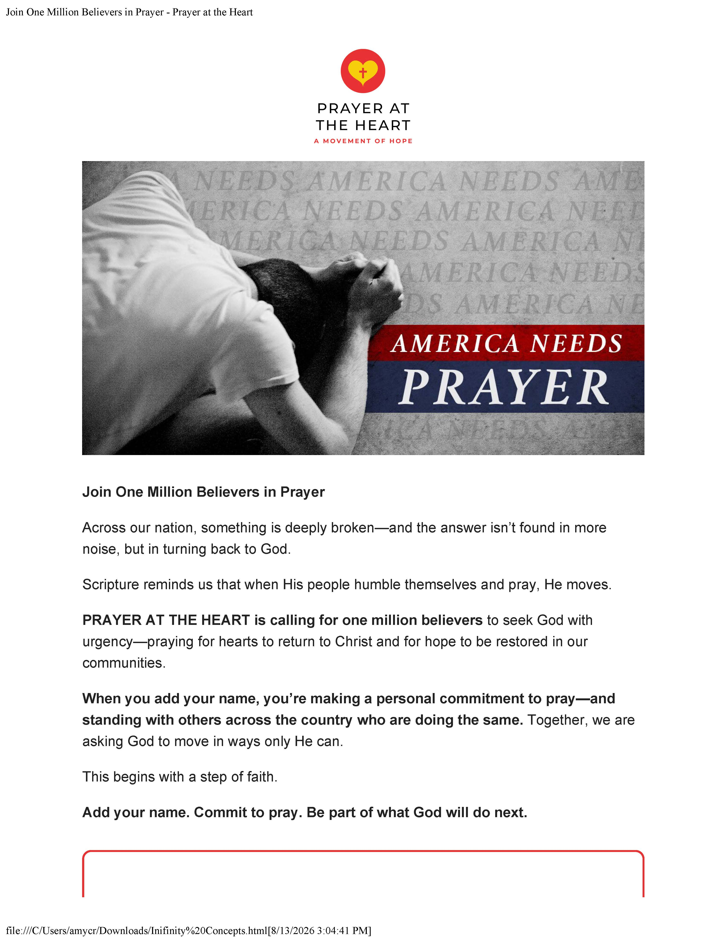

Appendix T
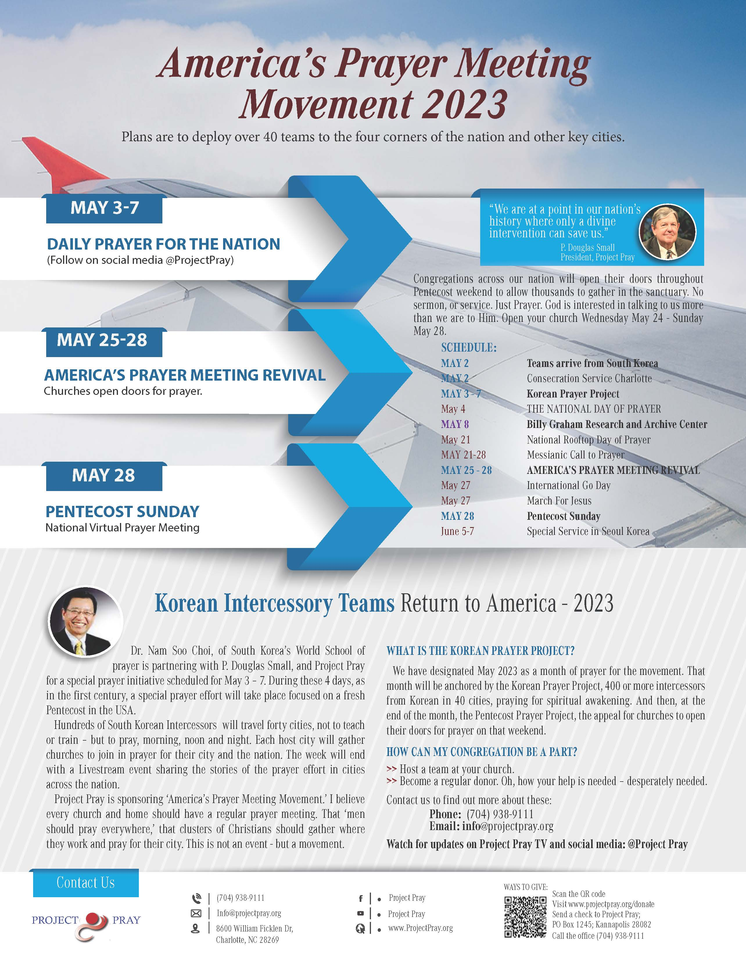

Appendix U
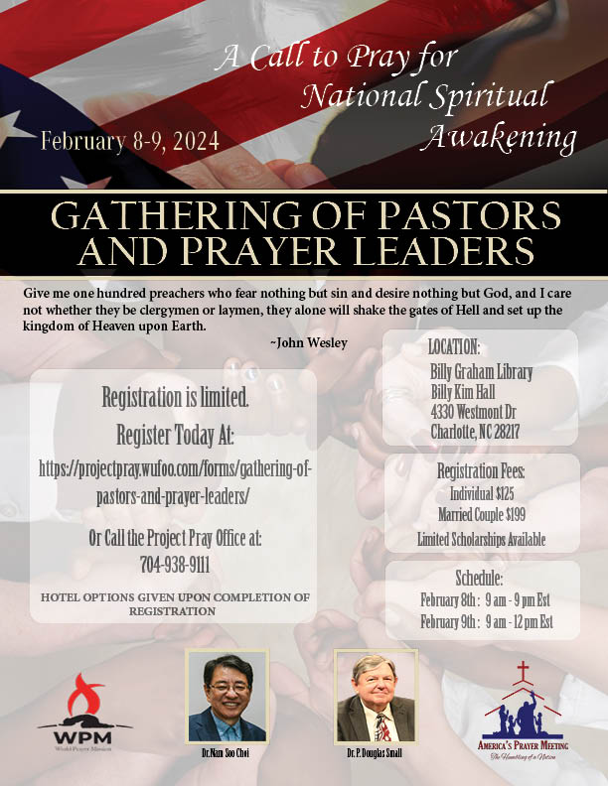

Appendix V
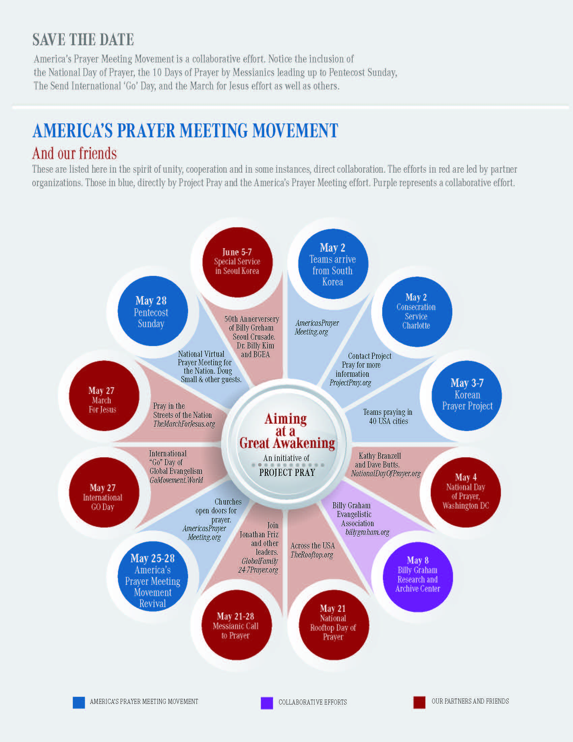

Protestants, Catholics, Pentecostals, and Evangelicals have aligned under a shared strategy to reach the unreached under such banners as Finishing the Task. The goals are aggressive. Translating the Scriptures into every language and creating an oral Bible in those languages. Every person can then read or hear the Bible read their native language. Tracking UPGs globally and sending church planting teams to every UPG on the planet. They are using a 1-in-3 Strategy: Every believer personally sharing the gospel with at least three others who do not know Christ. Using the metric of one-church per 1000, the goal is planting, healthy organic and self-replicating churches everywhere. The Army of Love effort is designed to equip ordinary church members worldwide to become active disciple makers, using programs such as the Healthy Church Teaching Network. This movement is unique in that it has intentionally created denominational collaboration networks. Catholic, Orthodox, Protestant and Pentecostal groups have signed the Commit 2033 declaration, and agreed to work openly, not in silos. To share data, technology, and resources.
This is not an appeal to a truth-less approach to evangelism. Rather, it recognizes that love is the bridge on which truth travels – and truth is heavy, it needs a strong bridge. This evangelism begins not with talking or telling, but by listening. “Tell me your story!” As they share their story and ask to hear our story, we experience an exchange of persons – that allows us to share “his story,” the story of Christ – and offer to pray with them to receive Christ as Savior and Lord. Note: There are two encounters in the Genesis narrative. In chapter 1, God blesses. In Genesis 2, God sets boundaries. Our message then is not love without truth or blessing without boundaries. It is not the delight of God’s goodness without the discipline that respects His wisdom and holiness. Violate the boundaries – lost the blessing, as Adam and Eve did. There is not blessing without boundaries, no true love without truth.
Sadly, you find upon seeking an appointment with, for example, a mayor, in a medium to a large city, that you get resistance. They are not used to people coming from the conservative faith community to support them. They are accustomed to pastors and church representatives who, like others, bring petitions and make demands. Despite their political orientation, they need friends; they need God; they need prayer. Build the bridge. Establish the relationship, then worry about the issues.
This is the blueprint for the Church in its role as an intercessory community. Prayer is to be offered for all, but specifically, for those at the top of influence pyramid. Their conversion affects a nation, a state, a city. The passage moves to the glorious goal of “God our Savior, who wants all people to be saved and to come to a knowledge of the truth.” This externally focused, missional prayer. It is “good and pleases” God. Christ joins us in this intercession, the “one mediator between God and mankind, the man Christ Jesus.” We agree with him in prayer, from the earth, he in heaven, for the salvation of kings and cities. We are called to pray, and we should do so in view of the investment he has made. He died praying – on the cross, so that we could live and pray with him He “gave himself as a ransom for all people.” Paul adds, “And for this purpose I was appointed a herald and an apostle.” Notice then, preaching and praying go together. Preaching is the release of prayer, and without prayer, there is nothing to release in preaching except our ideas about scripture. It is preaching without power. “I am telling the truth,” Paul declares, “I am not lying.” He is “a true and faithful teacher of the Gentiles,” whose first call was to go to Straight Street, and wait, and pray, and have hands laid on him to receive the fullness of the Spirit. Pray and preaching – they belong together. Then, Paul pushes prayer out into the streets, “I want the men everywhere to pray, lifting up holy hands without anger or disputing.” The lifting of hands is the posture of the priests in the act of blessing. This is our disposition toward kings, toward those of influence, toward the sinner and the city. We bless.
Four Christian television networks supported the event directly or indirectly, including CTN which parked a satellite dish at the site. CBN assigned a correspondent. Daystar offered their support. Integrity carried the event live, and the Revival Network, carried the event, cutting to it live several times during the day.
Paul also planted churches in Philippi, Thessalonica, and Corinth as well, along with Pisidian Antioch, Iconium, Lystra, and Derbe, all significant cities. John penned the Revelation to seven churches in Asia Minor: Ephesus, Smyrna, Pergamum, Thyatira, Sardis, Philadelphia, and Laodicea.
One of the standards of the First Great Awakening was the measure used for true conversion. It was not, as in later awakenings, a feeling of being converted or the mere effect of conversion. It was more theologically robust, centered in the holiness of God. True converts encountered God and were induced to a place of awe. They were captivated by the glory of God, His sovereignty. It was a conversion experience that centered around the character and nation of God, and not merely the need or crisis of the sinner. The encounter with God resulted in the reorientation of a life. Down was now up. The convert’s life was reordered due to the new reverence for God. Their orbit was around him and their life ordered to please him. The fruit of the God disclosure and the reorientation of life, conversion, was behavioral change. That change did not drive the conversion; it was the fruit of the conversion. Calvin would call this the Perseverance of the Saints. One advanced, and then perhaps stumbled – but the fascination with God, the captivity to His holiness, the attraction to His presence, drove the imperfect Christian to go forward, to not give up, to persist in following after Christ by grace. The awakening that we need today cannot be emotional or merely experiential. It must be profoundly theological.
Alabama, Arizona, California, Florida, Idaho, Illinois, Indiana, Iowa, Kentucky, Maine, Maryland, Massachusetts, Michigan, Missouri, New Mexico, New York, North Carolina, Ohio, Pennsylvania, South Carolina, Tennessee, Texas, Virginia, Washington, the District of Columbia, West Virginia.
When Dr. Nam Soo Choi came to America to meet with me and suggest the sending of Korea Prayer Teams to the USA, with my (P. Douglas Small) help, I introduced him to leaders at the Billy Graham Evangelistic Association. My friends there gave him a tour of the library, and, later, due to the precise timing of the first teams, it was clear to us that there was more than a symbolic connection to BGEA. Now, BGEA has rolled out a ten-year project working with pastors in South Korea with a focus on spiritual renewal.
There is no single comprehensive national tally for total Christian baptisms or conversions across all denominations in the United States. American churches do not share a centralized reporting system. Many do release an annual statistical report. The Southern Baptist Convention (SBC) reported 263,075 baptisms across its cooperating U.S. churches in 2025, which was a 4.96% increase from the previous year. It was also the fifth consecutive year of denominational growth. The Church of Jesus Christ of Latter-day Saints (LDS), not an orthodox Christian denomination, reported a historic high of 385,490 convert baptisms globally. There is no breakout for their movement in the USA. The Center for Applied Research in the Apostolate (CARA) and reports from various U.S. Catholic archdioceses indicated a strong surge in adult converts in 2025. They saw a major increase in individuals going through the Order of Christian Initiation of Adults (OCIA). The One movement, One country, One year effort saw 36,706 baptisms. That number came from 380 Independent Christian Churches across 39 states. The Assemblies of God saw a 10-year surge in converts. From 2014–24, the U.S. Assemblies of God saw increases of 15.3% in conversions, 27% in water baptisms, and 5.8% in Spirit baptisms. The Assemblies of God saw, in 2025, 168,000 water baptisms and 529,000 conversions. The Church of God uses a church year to measure its statistics. It is on track to see some 350,000 USA conversions, and around 3 million globally. They have set a goal to see one million saved in the USA in 2027. The Pentecostal sector of the Protestant church is seeing the greatest gains, along with Southern Baptist. But the greatest movement is in the Catholic sector. U.S. Protestantism as a whole, estimates nationwide closures between 4,000 and 10,000 buildings annually. Episcopalian churches baptized 19,624. Among Protestants generally, 1.8 people have left the church for every person who became a Protestant. Out of a significant sampling of Catholic Dioceses (71 of 196), 66 reported a 38 percent increase in baptisms. However, retention continues to be an issue. For every one person who joins Catholicism as an adult, 8.4 people who were raised Catholic choose to leave. For every person who becomes a Christian from a non-religious background, six people raised in a faith transition into becoming unaffiliated. In contrast, 82 percent of Hindus, raised in that faith, stay Hindu. Eleven percent become ‘nones.’ In Islam, the retention rate is 17 percent, with 13 percent becoming ‘nones.’ In Judaism, the rate is 76 percent, with 17 percent becoming ‘Nones.’ Among Protestants, the retention rate drops to 70 percent and 22 percent adopt no other faith. Catholics are at the bottom, retaining only 57 percent, 24 percent become ‘nones,’ and 14 percent switch to Protestantism. According to Pew Research, 85 percent of people who switch to another faith system or to a ‘none’ posture, do so before the age of 30. Almost half, 46 percent, make the turn by the age of 18. Life events trigger faith orientation decisions, leaving home and marriage, but by far, to most prominent reason, is their rejection with core religious teachings. Cultural and Social Disagreements are front and center for many young adults. The religious teachings about or the treatment of LGBTQ+ individuals is a primary driver pushing younger generations away from traditional church structures entirely.
According to the Barna Group, 23% of all Protestant churches identify as Pentecostal or Charismatic. The Hartford Institute for Religion Research places the total number of Protestant churches in America at 335,000. Using Barna’s metric, that translates to 77,000 congregations. If all these churches saw 40 saved, as with the Assemblies of God and the Church of God, the number converted in 2025 would be 3 million. The largest Pentecostal denominations are the Assemblies of God with 12,700 congregations, followed by the Church of God in Christ (COGIC) with an estimated 10,000 and 12,000 congregations (5.5 million U.S. adherents). The Church of God (Cleveland, TN) has 6,200 congregations. The United Pentecostal Church International (Non-Trinitarian) has 5,000 congregations. And the Foursquare Church, 1,800 congregations. These five denominations alone account for nearly 35,000 or more local Pentecostal churches. The Church of God of Prophecy has 1658 congregations, and they saw 16 conversions per congregation – still a significant number. If 350,000 USA churches saw 15 new converts, or baptisms the gain would be 5.25 million. There has been a massive surge in independent charismatic churches. According to Barna, 40% of all non-denominational churches in the U.S. are charismatic in their theology and style of worship. Non-denominational churches are the fastest-growing segment in American religion. These independent charismatic fellowships add tens of thousands of additional congregations to the U.S. total.
Data compiled from the U.S. Census Bureau and Federal Reserve Economic Data (FRED).
Ibid.
ChatGPT data search.
ChatGPT generated data on the question of net population gains in the last decade and net-migration numbers.
ChatGPT generated data on the question of net population gains in the last decade and net-migration numbers.
The Center of Immigration Studies.
For a decade, the USA population has grown at a cumulative 5.3% rate. From 2016 to 2016, the lowest year was the Covid year of 2021, with a growth rate of .16%, and the years before and after, with a rate of .35% and .56% respectively. In five of the ten years, the growth rate as trended above the .5% line, in during five years, it has fallen beneath it.
Data from Lifeway Research.
US Census Bureau Data.
Ibid.
Pew Research Data; Migration Policy Institute.
Note: An UPG (Unreached People Group) is an ethnic-linguistic group that is less than 5% Christian, or less than 2% evangelical.
https://www.newsweek.com/map-most-religious-states-least-religious-states-2131315; for the Southern Baptist interactive UPG USA map, go to https://imb.maps.arcgis.com/apps/dashboards/bfcc84ef53a84578a86e6c9b87dd95d0#.
The C See: https://imb.maps.arcgis.com/apps/dashboards/bfcc84ef53a84578a86e6c9b87dd95d0#.
https://www.barna.com/research/churchless-cities-where-does-your-city-rank/.
Read: Churchless, George Barna and David Kinnaman.
See: https://www.baptistpress.com/resource-library/news/ethnic-leaders-honor-minh-ha-nguyen-plan-for-enhanced-involvement-in-sbc-life/.
Information from an online inquiry: ChatGPT data. Barna Research.
This is a significant and encouraging number. Note the qualification, “practicing Christians” and those who “actively attend a church.” On any given Sunday, around 16% of the population is in church, and over the course of a quarter, than number expands to 21-25%. Arizona Christian University notes that 60-68% of the US Population still identifies as Christian, only 4-10% meet the criteria of holding to core theology and a biblical worldview. That significantly lowers the number who are both practicing the Christian faith with a biblical worldview and holding to core theology and out of that lifestyle, sharing their faith. The extrapolated number would be as low as 2 million and as high as 5 million – that’s a thin army attempting to engage a national population of 350 million.
Lifeway Research and Barna Research.
Ibid.
Oikos is the Greek word for family. It can mean family-like friend. It is the circle of close acquaintances in which you move most comfortably. It is often translated as house or household. When the gospel comes into a house, an oikos, it comes into a family, into a close circle of humans, and it is contagious. There, in the oikos, in the family circle, it has the most immediate impact.
See: https://www.christianity.com/wiki/people/who-was-peter-in-the-new-testament.html.
Lifeway Research and the Barna Group.
Barna Research.
ChatGPT conversation regarding evangelism methods by contemporary Christians.
This is the result of multiple collegiate ministry projects. Of the 27 partners directly working with PATH, five work in the youth-student sector of the harvest field. For a list of the Partners organization, See Appendix Q.
At the Universities of Texas A&M, Arkansas, and Georgia, 10,000 gathered. At the University of Oklahoma, 9,000 gathered, as did 8,000 at the University of Tennessee. Six thousand gathered at the University of Florida, as well as Florida State University and Mississippi State. At Ohio, 6,500 gathered, 5,000 at West Virginia University, and 4,500 at Purdue. Kentucky University had its biggest revival ever with over 2000 conversions. The number of conversions is not documented, but on some campuses, 10-20% of the gathered crowd made a commitment to Christ. On a Florida beach, 2000 were baptized in a single event. In California, 12,000 were baptized in a single event. Baptize America baptized 28,000 on a single Sunday nation event with 35,000 in attendance. 3200 were saved in a single event in Portland, Oregon. The total number across the country is not known.
Rooftops efforts are far more advanced overseas than they are here in the USA. In some cities and nations, their gatherings are commonly thousands.
At the Universities of Texas A&M, Arkansas, and Georgia, 10,000 gathered. At the University of Oklahoma, 9,000 gathered, as did 8,000 at the University of Tennessee. Six thousand gathered at the University of Florida, as well as Florida State University and Mississippi State. At Ohio, 6,500 gathered, 5,000 at West Virginia University, and 4,500 at Purdue. Kentucky University had its biggest revival ever with over 2000 conversions. The number of conversions is not documented, but on some campuses, 10-20% of the gathered crowd made a commitment to Christ. On a Florida beach, 2000 were baptized in a single event. In California, 12,000 were baptized in a single event. Baptize America baptized 28,000 on a single Sunday nation event with 35,000 in attendance. 3200 were saved in a single event in Portland, Oregon. The total number across the country is not known.
The Roman Empire contained over 1,500 cities, with a population of about 75 million. By the late first century, Christianity had spread to urban centers, with congregations in as many as fifty-plus cities. Paul planted churches in 14 specific cities. Of the major population centers - Alexandria, Antioch, Ephesus, and Carthage, each with 200,000 to 500,000 residents, only Carthage was without a church (that was true until the mid-second century). All three Super-Cities: Rome, Alexandria, and Antioch, were unparalleled, and all of them had a church by the end of the apostolic era. Paul also planted churches in Philippi, Thessalonica, and Corinth as well, along with Pisidian Antioch, Iconium, Lystra, and Derbe, all significant cities. John penned the Revelation to seven churches in Asia Minor: Ephesus, Smyrna, Pergamum, Thyatira, Sardis, Philadelphia, and Laodicea. By the end of the first century, out of the Empire’s 18 most significant population centers, 14 had churches. Paul alone visited or passed through at least fifty cities during his travels. The other apostles had pushed the gospel to the edges of the Empire and beyond. Early churches were functioning eastward, in the Parthian Empire (Mesopotamia), and in Armenia to the north and Ethiopia to the south. They were found as far east as the coastal trading cities of India. By the year 180 AD, comprehensive historical estimates suggest 200 cities with Christian churches, particularly in the major cities of the Empire. This was the strategy. Plant the gospel in a major city and let it marinate into the surrounding country.
See the Real Estate Roundtable. See: https://www.rer.org/wp-content/uploads/CRE-By-The-Numbers-12.19.25.pdf.
The U.S. Bureau of Labor Statistics (BLS) records roughly 292,825 distinct manufacturing establishments across the country. The U.S. Census Bureau, using a broader definition, counts up to 346,000 manufacturing establishments, which includes smaller, specialized operations and emerging industrial workshops. If you group these factories by the corporate entities that own them, the National Association of Manufacturers (NAM) notes there are about 239,000 distinct manufacturing firms. This means many corporations own and run multiple factory sites.
There are roughly 6,100 hospitals in the U.S., according to the American Hospital Association. Including all other specialized medical, diagnostic, and healthcare facilities (such as clinics, urgent care, and outpatient centers), the total rises to approximately 238,700 healthcare establishments nationwide.
There are approximately 5,760 colleges and universities in the US. (2026 Statistics & Insights). There are 27,155 secondary/high schools (Facts About American Schools across the United States). Factoring in all levels of education, including primary and elementary, the country has roughly 129,000 total K-12 schools (Education Statistics: Facts About American Schools). There some 1900 state universities and community colleges (2026 Statistics & Insights on US Educational Institutions; Fast Facts: Educational institutions). Private For-Profit Institutions, including trade and specialized schools’ number 2,270. Degree granting private institutions number about 3,900. There are 23,519 Public Secondary Schools and 3,626 private Secondary Schools. All of these are mission fields.
An estimated 2,500 to 3,000 U.S. colleges and universities have at least one formally organized, gospel-centered Christian ministry or club on campus. This represents roughly 40% to 50% of the nation’s higher education institutions, leaving the remaining half with no major national ministry presence Partnership in Innovation for Revival on College Campuses (See: The Coming Campus Awakening - AG News). Cru is present on 2,088 U.S. college campuses. It is the single largest evangelical student network in the country. Intervarsity Christian Fellowship works on 650 campuses. Chi Alpha is active on 300 campuses. The Navigators operate on roughly 150 campuses. Hundreds of campuses feature chapters of the Baptist Collegiate Ministry (BCM). Catholic Newman Centers and Reformed University Fellowship (RUF) chapters can also be found.
The Muslim Students Association (MSA) National is the largest umbrella organization, coordinating hundreds of local chapters that offer spiritual guidance, halal food coordination, and prayer space advocacy.
See: https://www.campusreform.org/article/map-communists-dictators-celebrated-college-campuses-/19160.

